**Markham Transcriptions Dictionary**

As we did research, we would come upon words that we had to look up the definition for. This especially happened in old wills and probate inventories. So, we started making a list of the words and definitions. Then we started adding little images for things when we thought something visual would help. The document then turned into this dictionary. It isn’t a formal dictionary. It just represents words that we had to look up or sometimes we added words that seemed appropriate to include. Also, there is a list of Abbreviations at the bottom.

Accompt – A colonial times word for account (mentioned in Middletown town records, page 235)

Administrator – A person appointed by a court to take care of the estate of an individual who died intestate.

Adze - A tool similar to an axe, with an arched blade at right angles to the handle, used for cutting or shaping large pieces of wood.

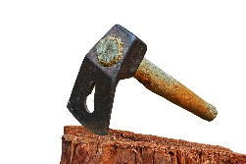

Alchemy spoon – Also called a latten spoon, was made from a brass like metal (an allow of zinc and copper).

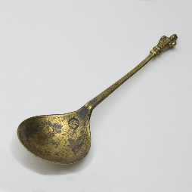

Alienate (alien) – Transfer ownership of property rights to another person.

Alms - Money or food given to poor people.

Almshouse – A house built originally by a charitable person or organization for poor people to live in.

Andiron - A metal support, typically one of a pair, that holds wood burning in a fireplace.

[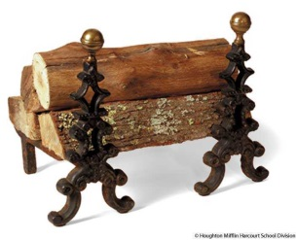](https://www.google.com/url?sa=i&rct=j&q=&esrc=s&source=images&cd=&cad=rja&uact=8&ved=2ahUKEwjCxeazi_ThAhVJAqwKHel5CJIQjRx6BAgBEAU&url=https://www.yourdictionary.com/andiron&psig=AOvVaw2nV47gzy8PDwlyo3EwQZX8&ust=1556585600424829)

Anno Domini (AD) - In the year of the Lord. From Medieval Latin. The full original phrase was “anni Domini nostri Jesu Christi”, which translates to “in the year of our Lord Jesus Christ”.

Anvil – A heavy steel or iron block with a flat top, concave sides, and typically a pointed end, on which metal can be hammered and shaped.

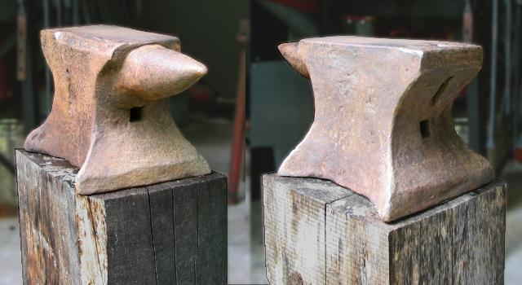

Approbation - Approval or praise. (this was used for the Selectmen in the Middletown Town Records)

Appurtenance – An accessory or other item associated with a particular item; an incidental right attached to a principal property right and passing in possession with it.

Archdeacon - Appointed by the bishop, the archdeacon was charged with the duties of preaching, supervising the deacons and their work, and supervising the distribution of alms.

Assigns (assignee) - A person appointed to act for another. Successors in interest to a property.

Auger – T shaped drill bit used to make holes in wood.

[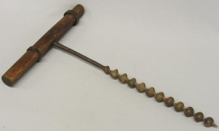](http://www.google.com/url?sa=i&rct=j&q=&esrc=s&source=images&cd=&cad=rja&uact=8&ved=0ahUKEwiX4cPP09rLAhUBfCYKHRlUCLYQjRwIBw&url=http://www.icollector.com/Antique-Barn-Auger_i9477277&psig=AFQjCNECHZcFruAxW1LrvskOFOpKXaMoWg&ust=1458954612997296)

Ax (axe) - An implement that has been used for [millennia](https://en.wikipedia.org/wiki/Millennium) to shape, split and cut [wood](https://en.wikipedia.org/wiki/Wood); to [harvest](https://en.wikipedia.org/wiki/Harvest) [timber](https://en.wikipedia.org/wiki/Lumber); as a [weapon](https://en.wikipedia.org/wiki/Battle_axe); and as a [ceremonial](https://en.wikipedia.org/wiki/Ceremony) or [heraldic](https://en.wikipedia.org/wiki/Heraldry) [symbol](https://en.wikipedia.org/wiki/Symbol). The axe has many forms and specialized uses but generally consists of an axe head with a [handle](https://en.wikipedia.org/wiki/Handle_(grip)).

[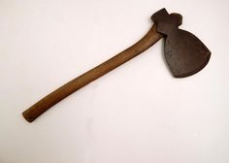](https://www.google.com/url?sa=i&rct=j&q=&esrc=s&source=images&cd=&cad=rja&uact=8&ved=0ahUKEwjElZT08N3PAhUp1oMKHWUBCZ8QjRwIBw&url=https://www.pinterest.com/gehaag/antique-tools-toolboxes/&psig=AFQjCNEBpy_c_XfATQTxsANmVF0prQhJ4Q&ust=1476657677935680)

Axeltore pins – A pin that holds an axle in place on a cart.

Bail - A scoop or pail used to throw water out.

[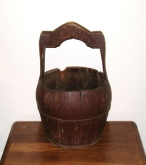](https://www.google.com/url?sa=i&rct=j&q=&esrc=s&source=images&cd=&cad=rja&uact=8&ved=0ahUKEwjwjMCf0N_PAhUk0oMKHReNDPkQjRwIBw&url=https://www.pinterest.com/pin/112871534382834364/&psig=AFQjCNH-tsfGOtzxWAKHmYYiU4wr6h7JvQ&ust=1476717539242359)

Bandoliera – A shoulder belt/bag strongly made of stout canvas cloth to hold musket shot, used by the British military.

Bason – A bowl placed on a kitchen stand used as a sink.

[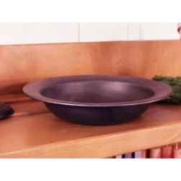](http://www.google.com/url?sa=i&rct=j&q=&esrc=s&source=images&cd=&ved=2ahUKEwiztImQ6vHiAhVPeawKHZLTClsQjRx6BAgBEAU&url=http://farmhouse-primitives.com/item_279/Colonial-Basin.php&psig=AOvVaw0QSQrvjnKxd9hBe5e7lK1z&ust=1560905996489303)

Bedsted – Bed frame, supports mattress.

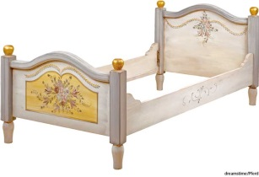

Behoove (Behooffe) - A duty or responsibility for someone to do something; it is incumbent on.

Beetle - A heavy wooden mallet for ramming, crushing, or smoothing; a maul.

[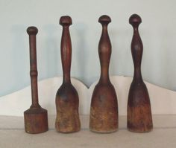](https://www.google.com/url?sa=i&rct=j&q=&esrc=s&source=images&cd=&cad=rja&uact=8&ved=0ahUKEwiAp5P6qavNAhUpw4MKHe9fChYQjRwIBw&url=https://www.pinterest.com/terrywiggers7/wood-mallets/&bvm=bv.124272578,d.amc&psig=AFQjCNExpRhgiTaWSQyaOpxL1gP3zM49fQ&ust=1466124587715209)

Beetle rings – A metal ring around a mallet to keep it from splitting.

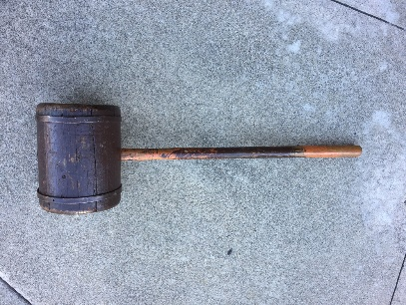

Bell strap – A leather strap with bells, used to be able to hear where an animal was (like a bull, or a horse).

[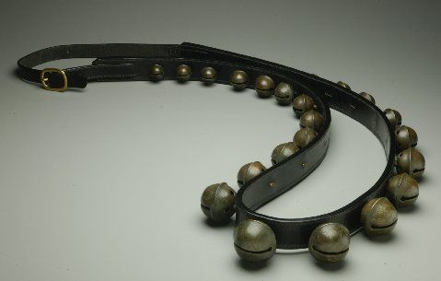](https://www.google.com/url?sa=i&rct=j&q=&esrc=s&source=images&cd=&cad=rja&uact=8&ved=0ahUKEwj1tfWZqqvNAhWl44MKHeLiCeIQjRwIBw&url=https://www.pinterest.com/pin/461830136762080329/&bvm=bv.124272578,d.amc&psig=AFQjCNFt0jPsWV45o9NaPfHVznmxAmKvOg&ust=1466124673676028)

Beseech – To implore or urgently seek.

Bickiron – Another name for anvil, a tool used by blacksmiths.

Bills of Public Credit – These fell outside the legal definition of official money. Billos of credit were backed with pledges of taxation to ensure their redemption or were loaned to individuals against security of land and property.

Birds eye coverlet/blanket - In fabrics and textiles the Bird's Eye pattern refers to a tiny/ intricate pattern that looks like a minuscule polka-dot pattern.

[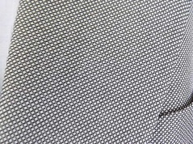](http://www.mensstyle.com.au/fashion/know-your-suit-patterns/)

Board (table board) - Table top supported on trestles but not fixed to them, they were joined by a central stretcher near the ground, which was secured by removeable pegs. After use the table would be taken to pieces and stored against the wall.

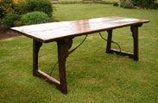

Bolster (boulster) – A cylinder of stuffed fabric, filled with feathers or flock or wool. Stretched the whole width of the bed and was covered by the lower sheet.

[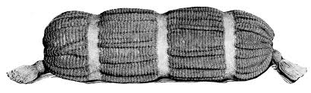](http://www.google.com/url?sa=i&rct=j&q=&esrc=s&source=images&cd=&cad=rja&uact=8&ved=0ahUKEwi6ks7FqqvNAhUh0oMKHXuCAjIQjRwIBw&url=http://vintagecraftsandmore.com/tag/bolster-pillow/&bvm=bv.124272578,d.amc&psig=AFQjCNHQNMKUplXEwYTK0HFAKiF9psP9EA&ust=1466124748790416)

Bond (administrators/executors bond for probate) - A probate bond is a type of court bond issued on the performance of an executor of the estate of a recently deceased person. It essentially acts as a guarantee that the executor of an estate will act according to laws and the terms of the trust or will of the deceased.

Box iron – A flat iron that is heated by inserting live coals in its boxlike holder, used to iron cloth or clothes.

[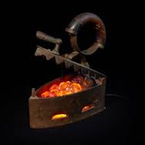](https://www.google.com/url?sa=i&rct=j&q=&esrc=s&source=images&cd=&cad=rja&uact=8&ved=0ahUKEwjwsuC8zNrLAhWG5yYKHRXAB1gQjRwIBw&url=https://www.pinterest.com/emmie5/antique-irons/&bvm=bv.117218890,bs.1,d.cWw&psig=AFQjCNEOyb-2xlCATjKrD12K_L_VtytP3g&ust=1458952657189434)

Box heater – Metal lined box used by placing hot metal or embers from a fireplace in.

[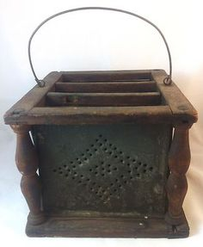](https://www.google.com/url?sa=i&rct=j&q=&esrc=s&source=images&cd=&cad=rja&uact=8&ved=0ahUKEwiE9amYqt3PAhXG4SYKHenIBUcQjRwIBw&url=https://www.pinterest.com/syllisjehane/storehouse/&psig=AFQjCNEMDKs61m_HnxrKzeNbc-g_9Xls4g&ust=1476638403758226)

Bread Trough – A bowl to knead dough in.

[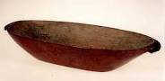](http://www.google.com/url?sa=i&rct=j&q=&esrc=s&source=images&cd=&cad=rja&uact=8&ved=0ahUKEwik2a7rl9PLAhXGWz4KHUd5BoYQjRwIAw&url=http://exhibits.museum.state.il.us/exhibits/athome/1800/objects/breadtrough.htm&psig=AFQjCNG3dp_KyBA4Qx_cGAudhXxoHT-brA&ust=1458698052694385)

Breeches/Briches - Short trousers reaching from the waist to the knees.

[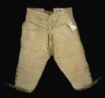](https://www.google.com/url?sa=i&rct=j&q=&esrc=s&source=images&cd=&cad=rja&uact=8&ved=0ahUKEwjY8uH2qqvNAhUJ_IMKHUJYCtMQjRwIBw&url=https://www.pinterest.com/uffnervintage/antique-vintage-men/&bvm=bv.124272578,d.amc&psig=AFQjCNHny8YvLyXM_1rBaNUdkVmWN319Cg&ust=1466124836202160)

Brewing tube – Piping used in making liquor or beer, part of a still.

Brindle heffer – Coat color pattern in animals, gray or tawny with darker streaks or spots.

[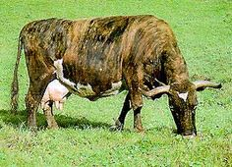](https://www.google.com/url?sa=i&rct=j&q=&esrc=s&source=images&cd=&cad=rja&uact=8&ved=0ahUKEwjzpLmgq6vNAhUE6oMKHaMeBlgQjRwIBw&url=https://www.pinterest.com/mikeswoveland/cattle/&bvm=bv.124272578,d.amc&psig=AFQjCNEFQj8ryQH8loKZzUiGw9KKZbvFjg&ust=1466124931181989)

Bucket – A roughly cylindrical open container, typically made of wood, with a handle, used to hold and carry liquids or other material.

[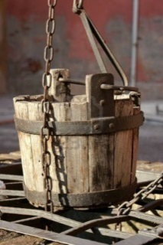](https://www.google.com/url?sa=i&rct=j&q=&esrc=s&source=images&cd=&cad=rja&uact=8&ved=0ahUKEwibxOKC393PAhUo8IMKHfC3AtkQjRwIBw&url=https://www.pinterest.com/pin/284571270176256465/&psig=AFQjCNELQI6qoVuWuZ7fXokjv931ViDHJg&ust=1476652864293345)

Budge (gown faced with budge) / boge - A skin used as a fur, consisting of a lambskin with the wool dressed outwards.

Budge bed - A lambskin bed dressed with the wood outward, formerly used as a fur or trimming.

[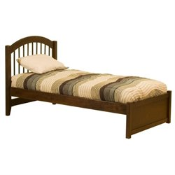](http://www.google.com/url?sa=i&rct=j&q=&esrc=s&source=images&cd=&cad=rja&uact=8&ved=0ahUKEwisneDeq6vNAhUl54MKHRcXBu8QjRwIBw&url=http://www.cymax.com/platform-beds--c331-74.htm&bvm=bv.124272578,d.amc&psig=AFQjCNGFVqEV58zzeH9FqQQXZjQXwMiFiA&ust=1466125011565223)

Bullock – A young castrated bull; another term for a steer.

Cagg – A type of barrel, sometimes used to hold beef. There were 25- and 50-pound sizes.

Calamanco/Caleminco - A glossy woolen fabric of satin weave with striped or checkered designs manufactured from the 16th to the 19th centuries.

Camlet coat – Camlet is a woolen fabric originally made of camel or goat hair in medieval times.



Card - A metal comb or wire brush, used to disentangle the fibers of wool, cotton, flax, etc.

[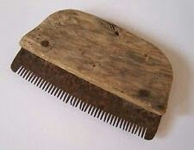](https://www.google.com/url?sa=i&rct=j&q=&esrc=s&source=images&cd=&cad=rja&uact=8&ved=0ahUKEwjrxPn9q6vNAhXLxYMKHbvnA8cQjRwIBw&url=https://www.pinterest.com/PWM742/show-me-your-cards-and-combs/&bvm=bv.124272578,d.amc&psig=AFQjCNEWsS0Ud5fcYUiaDYb41vgm_Tqt1Q&ust=1466125135890984)

Carsey/Kersey wool – A kind of coarse woolen cloth that was an important component of the textile trade in medieval England.

Case drawers – Similar to chest of drawers, case drawers had flat tops.

[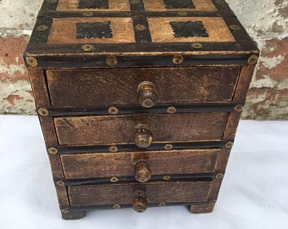](https://www.google.com/url?sa=i&rct=j&q=&esrc=s&source=images&cd=&ved=2ahUKEwi-teyp5fHiAhUJi6wKHWxkDl4QjRx6BAgBEAU&url=https://www.etsy.com/market/haberdashery_drawers&psig=AOvVaw3Tq6Til2Lye8e_5oMXVldE&ust=1560904690674742)

Cask – A large barrel like container made of wood, used for storing liquids (like alcoholic drinks).

[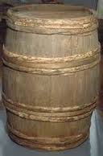](https://www.google.com/imgres?imgurl=https://s-media-cache-ak0.pinimg.com/236x/f7/80/c1/f780c15cdfcab6080358a913785a64b4.jpg&imgrefurl=https://www.pinterest.com/lanawales/barrels/&docid=Cy-oJDjhx4ddbM&tbnid=VvVvkJpMiPsq0M:&w=160&h=243&bih=600&biw=1239&ved=0ahUKEwiijICH3NzMAhWBVCYKHYseDpYQMwg6KBYwFg&iact=mrc&uact=8)

Cason/Caisson – A chest used to hold ammunition.

Casque/casqe – Helmet head covering.

[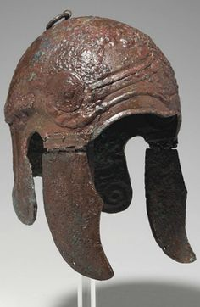](https://www.google.com/url?sa=i&rct=j&q=&esrc=s&source=images&cd=&cad=rja&uact=8&ved=0ahUKEwi66p6529zMAhUMRCYKHftND9UQjRwIBw&url=https://www.pinterest.com/lajoiealex/antique-armour/&psig=AFQjCNGa8JVMCgixRfYJrD7EubMslIHQkg&ust=1463423463413345)

Cassock – Tradition attire worn by clergy; a long, plain and flowing garment or robe; a close-fitting ankle-length garment worn especially in Roman Catholic and Anglican churches by the clergy and by laypersons assisting in services.

Chafin/Chafing dish – A kind of portable metal or brass grate or bowl raised on a tripod, originally heated with charcoal (coals from the fireplace) in a brazier, and used for foods that require gentle cooking, away from the heat of direct flames. The chafing dish could be used at the table and provided with a cover for keeping food warm.

[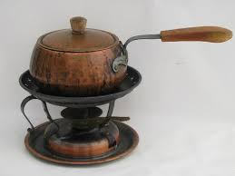](http://www.google.com/url?sa=i&rct=j&q=&esrc=s&source=images&cd=&cad=rja&uact=8&ved=0ahUKEwjiloy8rKvNAhXi64MKHcd9C1kQjRwIBw&url=http://www.laurelleaffarm.com/stockli-nestal-copper-fondue-pot.htm&bvm=bv.124272578,d.amc&psig=AFQjCNF6KgEnFUU_dydKqNb7S7LM5JJOoQ&ust=1466125241017859)

Chain (unit of measure) – 66 feet, or 100 links, or 4 about rods. There are 10 chains in a furlong, and 80 chains in one statute mile. An acre is the area of 10 square chains (or the area of one chain by one furlong).

[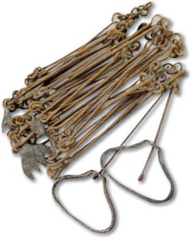](http://www.google.com/url?sa=i&rct=j&q=&esrc=s&source=images&cd=&cad=rja&uact=8&ved=0ahUKEwji7cDprKvNAhVh74MKHY33Ab4QjRwIBw&url=http://www.farmcollector.com/tools/gunters-chain-land-measurement.aspx&bvm=bv.124272578,d.amc&psig=AFQjCNFdyiDmntj1O59o-rkzvVCA0Wv_4Q&ust=1466125380193139)

Chamber – Bedroom.

[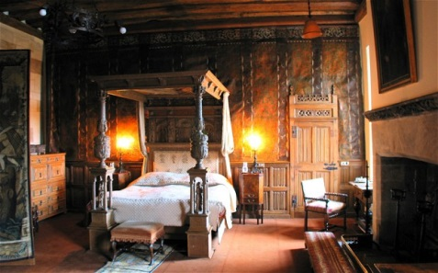](http://porch.com/advice/history-bedroom/)

Chamber pot - A portable container kept in a bedroom and used as a toilet.

[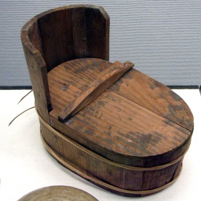](https://www.google.com/url?sa=i&rct=j&q=&esrc=s&source=images&cd=&cad=rja&uact=8&ved=0ahUKEwirg6W2ravNAhVl7IMKHWIJBVAQjRwIBw&url=https://en.wikipedia.org/wiki/Chamber_pot&bvm=bv.124272578,d.amc&psig=AFQjCNEu5PyBuw6AUIB9pN3bXgzgbiRq9Q&ust=1466125531636126)

Chamblett - A fabric which is almost incapable of definition although the word is said to have first been used of a costly eastern material, apparently made of hair from Angora goats. From transcription of Elizabeth Whatman Brooke’s will – lustrous fine woolen fabric, usually dyed red.

Chancel - The part of a church containing the altar and seats for the clergy and choir.

Charnel - Building or chamber in which bodies or bones are deposited.

Chattels – A personal possession, an item of property other than real estate. Includes furniture and domestic animals.

Chattel Mortgage – A loan extended to an individual on a movable property item, which is used as security to extend the loan.

Chauncery (Master of Chauncery from Aaron Markham land doc, Broome County v5 p316) – A court having equity (the principle of what is fair) jurisdiction.

Cheap – Old English word for market.

Cheese hoops – Wooden circles used to mold cheese in.

[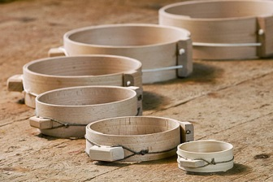](https://www.google.com/url?sa=i&rct=j&q=&esrc=s&source=images&cd=&cad=rja&uact=8&ved=2ahUKEwj31rvyzfbhAhVJd6wKHZjPCXkQjRx6BAgBEAU&url=https://www.pinterest.com/pin/118993615125359519/&psig=AOvVaw1G_bp_DZnJK9GqK4Dlq-dw&ust=1556671980133112)

Cheese press – An appliance for pressing cheese curd in a mold or hoop.

[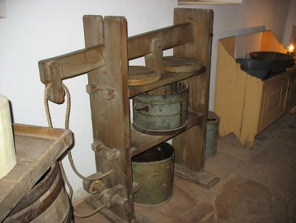](http://www.google.com/url?sa=i&rct=j&q=&esrc=s&source=images&cd=&cad=rja&uact=8&ved=0ahUKEwjer_nN0ubTAhUH7GMKHdp-Cl8QjRwIBw&url=http://imagict.com/en/words/cheese%2Bpress&psig=AFQjCNGJosjy60JHMiPQlF4ljUmyszchiQ&ust=1494551025642921)

Churn - A vessel used to make butter from milk or cream.

[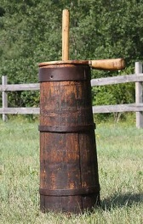](https://www.google.com/url?sa=i&rct=j&q=&esrc=s&source=images&cd=&cad=rja&uact=8&ved=0ahUKEwiGyOnNravNAhVEzoMKHa07Be4QjRwIBw&url=https://www.pinterest.com/bassnboy66/churn-it-up/&bvm=bv.124272578,d.amc&psig=AFQjCNFbJeqe5r_AQHjl8kBZxJtK9ik-HA&ust=1466125594397091)

Cider - Raw apple juice that has not been filtered to remove pulp or sediment is referred to as fresh cider. Strong or hard cider was a liquor made from the juice of fruits. With water often being unsafe to drink, cider was a common beverage in early colonial times.

Clevis - A “U” shaped piece of metal with a bold or pin passing through holes at the two end, for joining a chain or rod to another. A clevis may be used to fasten a whippletree to a wagon or plough.

[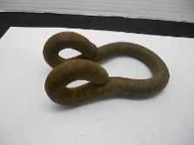](http://www.google.com/url?sa=i&rct=j&q=&esrc=s&source=images&cd=&cad=rja&uact=8&ved=0ahUKEwi599jd0N_PAhVp7IMKHSfECWAQjRwIBw&url=http://www.terapeak.com/worth/vintage-antique-clevis-wagon-hitch-farm-wrought-iron-horse-d-ring-metal/262112048604/&psig=AFQjCNFjT3kpcUVdOdkLdf4NaaHcN4Y1qA&ust=1476717825142387)

Clews - A metal ring to which lines are attached; clew iron.

[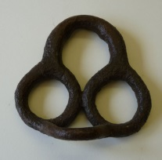](https://www.google.com/url?sa=i&rct=j&q=&esrc=s&source=images&cd=&cad=rja&uact=8&ved=0ahUKEwjP4NLV0d_PAhUj7oMKHV7VC1cQjRwIBw&url=https://ehive.com/collections/3408/objects/7722/clew-iron&psig=AFQjCNFuhopUMvV6bzrS_Ys3SVGFM2hO-Q&ust=1476718076573993)

Cobiron/Cob irons - An andiron of the simplest form, the upright portion of which is small and undecorated.

Codicil – An addition or supplement that explains, modifies or revokes a will or part of one.

Codiscend – Putting yourself at a lower level, or seeing something as beneath you.

Cofer - A strong box or small chest in which money or valuable objects are kept.

Colander - A perforated bowl used to strain off liquid from food, especially after cooking.

Collar – Collar beam – a horizontal member between two rafters.

[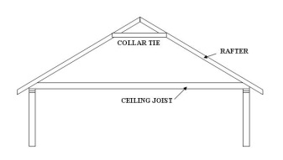](http://www.google.com/url?sa=i&rct=j&q=&esrc=s&source=images&cd=&cad=rja&uact=8&ved=0ahUKEwiogreL0t_PAhUI6IMKHaUSCGQQjRwIBw&url=http://www.diychatroom.com/f9/overdecking-weight-108470/&psig=AFQjCNEEmRN6RU55qeeI6MHQM4R28Iuu5A&ust=1476718161741186)

Collar needle – Type of pin used in collar on animal to keep animal’s head straight.

[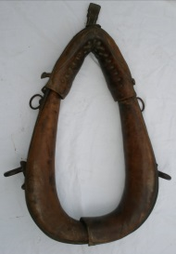](http://www.google.com/url?sa=i&rct=j&q=&esrc=s&source=images&cd=&cad=rja&uact=8&ved=0ahUKEwiEwdy109_PAhXk6oMKHd0cD_oQjRwIBw&url=http://www.lovettartillery.com/Bavarian%20Field%20Artillery%20Saddle%20and%20Harness.html&psig=AFQjCNE9k471RZ-tDrv_aJnEj1KzpUcu1g&ust=1476718471124339)

Convey – The transfer of the title of land from one person to another.

Colter – A blade or disc attached to a plough so that it cuts through the soil vertically in advance of the ploughshare.

[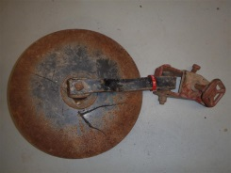](http://www.google.com/url?sa=i&rct=j&q=&esrc=s&source=images&cd=&cad=rja&uact=8&ved=0ahUKEwi88a7c09_PAhWh5IMKHT8CCgwQjRwIBw&url=http://www.ihpartsandequipment.com/implement-parts/plows/coulters/farmall-cub-plow-coulter.html&psig=AFQjCNEY0ZTOThsfCHwC2CmDiENwwyqODg&ust=1476718623911269)

Colyer – Coal seller.

Cooper - A maker or repairer of casks and barrels (in 1920 Edward Markham worked at a Cooperage Works in Galena).

Coopers ware – The tools of trade for a Cooper.

Copyhold land – Land held from a manor. It was technically owned by the Lord or Lady of the Manor. The people who lived on and farmed manorial lands were tenants of the manor.

Coram – In presence of. Coram non judice, Latin for "not before a judge", is a legal term typically used to indicate a legal proceeding that is outside the presence of a judge (or in the presence of a person who is not a judge), with improper venue, or without jurisdiction.

Counterfeiting (in colonial times) – The making of illegal money, usually by making plates with an impression of a real paper bill, and then using plain paper and ink to make a copy of a bill, then perhaps using an ink pen to finish it. The plate was made of metal, an object like a copper kettle could be melted down to form a plate.

Coulter - A vertical cutting blade fixed in front of a plowshare; the part of a seed drill that makes the furrow for the seed.

Counterpane – Bedspread, especially for looks or design.

Country pay – Rural commodities used in lieu of money in transactions; often valued at needing to be 20% more than the currency value.

Covenant – Agree, especially by lease, deed, or other legal contract. An agreement which brings about a relationship of commitment between God and his people.

Coventer (from Church records) – A person who owns the covenant.

Coverlet (coverled) – Quilt that doesn’t cover the pillow; a lightweight bed topper that is designed more for decoration.

[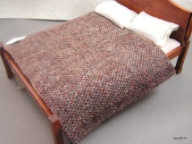](http://www.google.com/url?sa=i&rct=j&q=&esrc=s&source=images&cd=&cad=rja&uact=8&ved=0ahUKEwiBw6uL1N_PAhXl5oMKHR0vDPgQjRwIBw&url=http://studebakerminiatures.com/index.php?main_page%3Dindex%26cPath%3D26_28&psig=AFQjCNFC2J8vfRrZtcTWKC-XWy5eAIfE7Q&ust=1476718693190863)

Crane and Hook – Used in fireplace to hold a kettle or pot over a flame.

[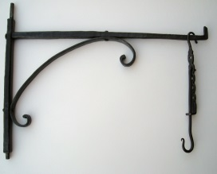](https://www.google.com/url?sa=i&rct=j&q=&esrc=s&source=images&cd=&cad=rja&uact=8&ved=2ahUKEwiMs-DfjfThAhVEKawKHQ0GCJ4QjRx6BAgBEAU&url=https://www.pinterest.com/pin/446560119273643801/&psig=AOvVaw1O9EMlOxwi2Kxp3d_v4ZM9&ust=1556586224077422)

Creel – A rack holding bobbins or spools for spinning.

[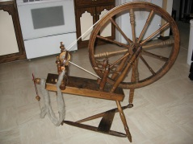](http://www.google.com/url?sa=i&rct=j&q=&esrc=s&source=images&cd=&cad=rja&uact=8&ved=0ahUKEwi1_cPf1d_PAhXJ7IMKHXNQBB4QjRwIBw&url=http://www.umn.edu/~macew001/spinningwheel/index.html&psig=AFQjCNHj8jua99RM6qHIeepDEDX4YS5PvQ&ust=1476719116155834)

Crier - A person employed by a town to make public announcements or proclamations, usually by shouting in the streets.

[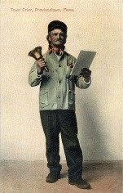](https://en.wikipedia.org/wiki/File:Town_Crier,_Provincetown,_MA.jpg)

Croft – A small enclosed field usually adjoining a house. A small farm worked by a tenant.

Crown - English currency. Equal to 5 shillings (12 pence = 1 shilling, 20 shilling = 1 Pound).

Cultivator - A farm implement equipped with shovels, blades, etc, used to break up soil and remove weeds. Note: In Joshua Markham’s probate inventory in 1878, a cultivator was appraised at $1 and sold for 25 cents.

[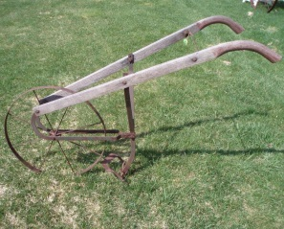](https://www.google.com/url?sa=i&rct=j&q=&esrc=s&source=images&cd=&cad=rja&uact=8&ved=2ahUKEwjxxdf934bcAhVTyYMKHdUzA9UQjRx6BAgBEAU&url=https://www.pinterest.com/tnreb/horse-drawn-farm-equipment/&psig=AOvVaw3JNBp6BnynOK_B-9rH7Lza&ust=1530838477585305)

Curate – A minister with pastoral responsibility; a member of the clergy engaged as an assistant to the vicar or parish priest.

Current money (Currant) – It is employed to describe money which passes from hand to hand, from person to person, and circulates through the community, and is generally received. Money is current when received as cash in common business transactions, and is the common medium in barter and trade.

Cutlash - A short curving sword formerly used by sailors on warships.

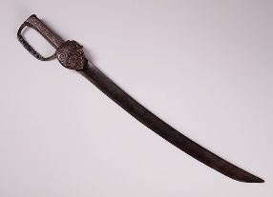

Damaske (demaske jacket) - A firm lustrous fabric (as of linen, cotton or silk) made with flat patterns in a satin weave on a plain-woven ground on jacquard.

Demicastor (demicastor hat) – A hat made from beaver pelt.

Demise - To convey by Will or lease an estate either in Fee Simple (see Fee) or Fee Tail (See entail) or for a term of life or years.

Demised premises – Generally the parts of the premises that the leaseholder or tenant is permitted to occupy.

Despot – Heir apparent.

Diaper/Dyaper (dyaper napkins and dyaper towel) - A patterned fine white linen.

Divers – Indicates many; more than one.

Dog Iron – A short bar of iron having its ends bent at right angles for use as a cramp or joggle, as to hold together timbers or stones.

Double covered buggy – A horse and carriage, a light carriage drawn by one or two horses. Covered means it had a top that could typically be folded down. A double buggy had two seats. Note: In Joshua Markham’s probate inventory in 1878, a double covered buggy was appraised at $10 and sold for $12.55.

[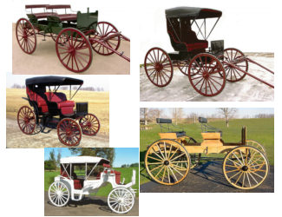](http://www.google.com/url?sa=i&rct=j&q=&esrc=s&source=images&cd=&cad=rja&uact=8&ved=2ahUKEwi_kNyB3obcAhVj4oMKHaZPAawQjRx6BAgBEAU&url=http://www.awagonwheel.com/horse_drawn_wagons.htm&psig=AOvVaw2e4iphTXS0JmyTLnpSpmjr&ust=1530837797558699)

Doublet - A man's short close-fitting padded jacket, commonly worn from the 14th to the 17th century; “a serge doublet”.

Dowry - The property in land or money that a wife brought to her husband at their marriage. This may have been given her by her father, or it may have been property already in her possession by inheritance.

Dutch oven (baking pot) – Used in fireplace to bake food.

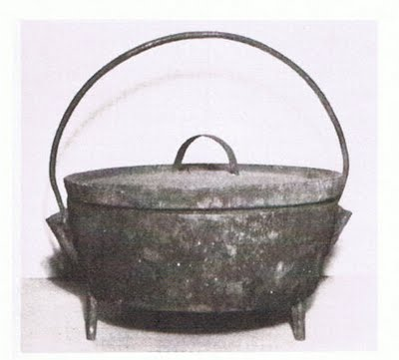

Dram cup – A small cup used to drink small amounts of liquids such as wine, only about one ounce in size.

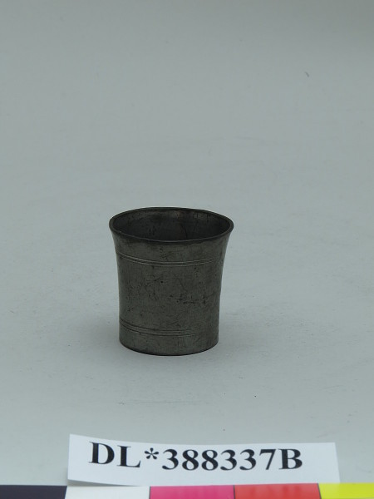

Dragoon – Mounted calvary.

Draper - A person who sells cloth and may design and make cloth items.

Drawing knife - A traditional woodworking hand tool used to shape wood by removing shavings. It consists of a blade with a handle at each end.

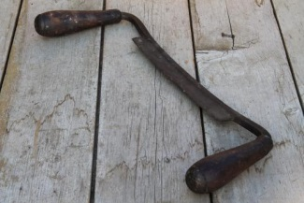

Drugget - A woolen or mixed fabric used for clothing.

[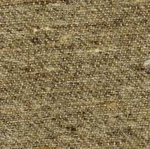](http://www.google.com/url?sa=i&rct=j&q=&esrc=s&source=images&cd=&cad=rja&uact=8&ved=0ahUKEwjB0dzB84DOAhUE8IMKHWH9B2IQjRwIBw&url=http://www.wmboothdraper.com/Wool/wools_index.htm&bvm=bv.127521224,d.amc&psig=AFQjCNH35BvVpjcSdHnbk88Bslf9OR0Cxw&ust=1469064881168344)

Duck wheel – Made of cotton or canvas, used to polish.

Duffle – Coarse wool cloth with a thick nap; also called shag and trucking cloth.

[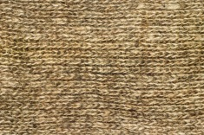](https://www.colourbox.com/image/closeup-of-woolen-cloth-useful-as-texture-image-4194140)

Dung fork – A pitch fork like tool used to move manure. Fields were fertilized with manure spread on the soil with these long pitchforks called dung forks.

[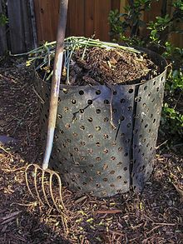](https://www.google.com/url?sa=i&rct=j&q=&esrc=s&source=images&cd=&cad=rja&uact=8&ved=2ahUKEwihuKqXyYXiAhXlzlQKHaPHDC0QjRx6BAgBEAU&url=https://en.wikipedia.org/wiki/Pitchfork&psig=AOvVaw2FTZJ-jjJjiCVEKDZbvYM6&ust=1557185979669355)

Dutch wheel – A spinning wheel is a device for spinning thread or yarn from fibres.

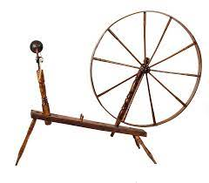

Earthenware - Ware made of slightly porous opaque clay fired at low heat.

[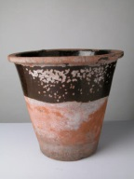](http://www.google.com/url?sa=i&rct=j&q=&esrc=s&source=images&cd=&cad=rja&uact=8&ved=0ahUKEwiAifDl6t_PAhUM64MKHZ05D6UQjRwIBw&url=http://www.nationaltrustcollections.org.uk/results?ObjectType%3Dpancheon&psig=AFQjCNG_-LGvXxe7btyclwTYcqplVORtgA&ust=1476724801406313)

Elese (elise) – Pledge to God.

Ell – An old measure of length (equivalent to six hand breadths) used mainly for textiles, locally variable but typically about 45 inches.

Egress – A place or means of going out; the action or right of going or coming out.

Enfeoff – Give property or land in exchange for a pledged service.

Ensealing – Affixing a seal to.

Entail - A settlement of the inheritance of property over a number of generations so that it remains within a family or other group.

Esquire - An unofficial title of respect, having no precise significance.

Ewer – A pitcher or jug used to hold water to pour into a bason.

Executor - A person or institution appointed by a testator to carry out the terms of their will.

Executrix - A female executor of a will.

Exion – Legal abbreviation for Execution, for example at the end of a court case is Exion Issued (see Berkshire Co, Mass court cases in 1800-1810 timeframe).

Fanning mill – A machine for cleaning grain by using screens and air. Note: In Joshua Markham’s probate inventory in 1878, a fanning mill was appraised at 50 cents and sold for 85 cents.

Farthing - Crown - English currency. Equal to one quarter of a pence (12 pence = 1 shilling, 20 shilling = 1 Pound).

Feast of St. Michael the Archangel – Also called Michaelmas. A Christian festival observed in Western calendars on 29 September. In Christian angelology, the Archangel Michael is the greatest of all the angels and is honored for defeating Lucifer in the war in heaven.

Feast of the Annunciation - Also called Lady Day, the Feast of the Incarnation (Festum Incarnationis), or Conceptio Christi (Christ’s Conception), commemorates the visit of the archangel Gabriel to the Virgin Mary, during which he informed her that she would be the mother of Jesus Christ, the Son of God. It is celebrated on 25 March each year.

Featherbed - A “quilt” fabric bag (tick) filled with feathers. Often accompanied by a matching bolster.

Fee simple – Land owned is owned completely, without any limitations or conditions, but are still subject to taxation and debt obligations on a mortgage; the highest possible ownership interest that can be had in real property.

Felling ax – Used to trim branches off of a tree.

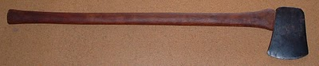

Fetter (iron fetter) – Rings connected to chain to place around the ankles to restrict movement, or an iron collar ring.

[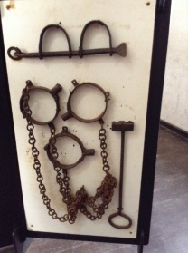](https://www.google.com/url?sa=i&rct=j&q=&esrc=s&source=images&cd=&cad=rja&uact=8&ved=0ahUKEwjxtrCgsM3WAhXGv1QKHcKqBrMQjRwIBw&url=https://ghanakhazana.wordpress.com/2015/05/01/slave-trade-the-dark-ages-of-africa/&psig=AOvVaw1BMjz5Uo3uEnGNwNR4LJBD&ust=1506876921713199)

Feudalism - The dominant social system in medieval Europe, in which the nobility held lands from the Crown in exchange for military service, and vassals were in turn tenants of the nobles, while the peasants (villeins or serfs) were obliged to live on their Lord's land and give him homage, labour, and a share of the produce, notionally in exchange for military protection.

Fire plain – A type of fireplace mantle or shelf in the fireplace.

Firkin (also as ferckyn) - A small cask used for liquids, butter, or fish.

Flask – Vessel to hold liquids or powder.

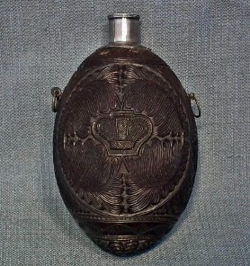

Flasket - A long, shallow basket with two handles, to hold food. Can also refer to a small flask to hold liquids or powder.

Fodder – Dried hay or feed for cattle or other livestock.

Fowling gun – Flintlock fowlers in Colonial America armed our forefathers with the first truly “made-in-America” guns. Doing double-duty as hunting guns and firearms for defense, they were used to put food on the table and defend against enemy soldiers. By comparison, the musket, which was made for war, consisted of a sturdy stock and a heavy barrel fitted for a bayonet, built to withstand the rigors of combat.

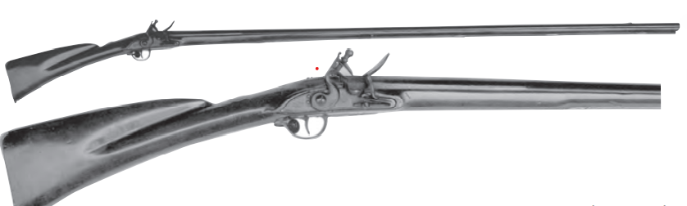

Fifer – Person who plays a fife, which is small high pitched flute similar to a piccolo.

[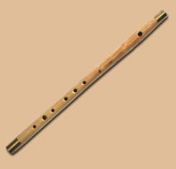](https://www.google.com/url?sa=i&rct=j&q=&esrc=s&source=images&cd=&cad=rja&uact=8&ved=0ahUKEwiyqqPRsM3WAhWLwlQKHW09AcAQjRwIBw&url=https://www.historylives.com/music.htm&psig=AOvVaw1pGTW88INbhY5NLyE5Nobe&ust=1506877031093882)

Fine - Not a penalty as in modern English but refers to a sum of money paid or due; for example, to the Lord of the Manor.

Firkin – A volume of liquid equal to about 9 gallons, about ¼ of a barrell.

Fishmonger - A person or store that sells fish for food.

Flagon – A large container in which drink is served, typically with a handle and spout.

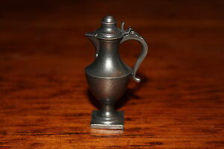

Flax – Plant used to make linen thread.

[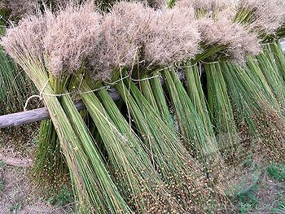](https://www.google.com/url?sa=i&rct=j&q=&esrc=s&source=images&cd=&cad=rja&uact=8&ved=0ahUKEwjc1YfOwt_PAhWM1IMKHWtfBioQjRwIBw&url=https://www.decktowel.com/pages/how-linen-is-made-from-flax-to-fabric&psig=AFQjCNEx_b3FWRLS4BzOenq0jtSey1D4kw&ust=1476659725601186)

Flesh fork – A large long handled fork used to lift meat (as from the pot from which it was cooked).

[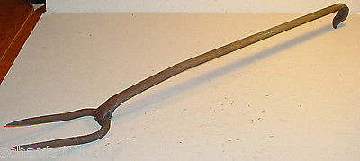](http://www.google.com/url?sa=i&rct=j&q=&esrc=s&source=images&cd=&cad=rja&uact=8&ved=0ahUKEwiMyeWF69_PAhUm5YMKHQ-YCr0QjRwIBw&url=http://www.terapeak.com/worth/antique-19th-century-forged-flesh-fork-huge-2-tine-fork-cooking-butcher-iron-old/231964160988/&psig=AFQjCNFLARmpuPmwjxjjaMaRUD1BQ3Vl7Q&ust=1476724886402363)

Flock bed – A bed with a mattress stuffed with flock; flock is bits and pieces of wool.

Fodder - Food, especially dried hay or feed, for cattle and other livestock.

Forenoon – In the morning, before noon, typically refers to late morning.

Fork ferrill (ferrule) – Short metal sleeve to strengthen a tool handle.

[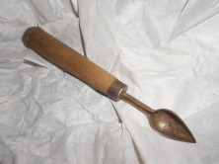](https://www.google.com/url?sa=i&rct=j&q=&esrc=s&source=images&cd=&cad=rja&uact=8&ved=0ahUKEwiLve7f7t_PAhWm7oMKHbzwCF0QjRwIBw&url=https://www.etsy.com/listing/277880126/oyster-knife-antique-coastal-primitive&psig=AFQjCNEIl0zFkHfZN78uSdJwzrMCgfs6Fw&ust=1476725767934352)

Forme – A type of bench seat to use with a long table (like the kitchen table). Held more than one person.

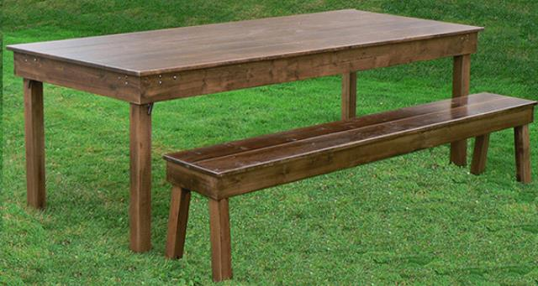

Fortnight – 14 nights.

Freehold land (or fee simple) – Provides the most complete form of ownership in perpetuity. It allows the land holder to deal with the land including selling, leasing, licensing or mortgaging, subject to compliance with applicable local laws.

Freeman – A man who was a church member and had the right to vote; a person having full rights of a citizen.

Frow – A cleaving tool having a wedge shapped blade, with a handle set at a right angle to it.

[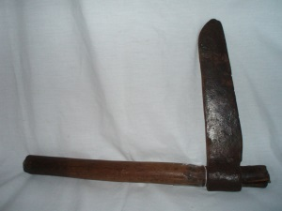](https://www.google.com/url?sa=i&rct=j&q=&esrc=s&source=images&cd=&cad=rja&uact=8&ved=0ahUKEwjNnb_r1ubTAhVL_WMKHckNBS0QjRwIBw&url=https://www.pinterest.com/pin/394065036116353432/&psig=AFQjCNFwT8tSQ7DUYSZPS5mLrpI4tBjrzg&ust=1494552148557311)

Fulled cloth - Fulling, also known as tucking or walking, is a step in woollen clothmaking which involves the cleansing of cloth (particularly wool) to eliminate oils, dirt, and other impurities, and making it thicker. The worker who does the job is a fuller, tucker, or walker, all of which have become common surnames.

[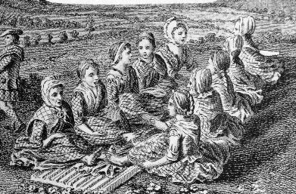](https://www.google.com/url?sa=i&rct=j&q=&esrc=s&source=imgres&cd=&cad=rja&uact=8&ved=0ahUKEwj20_C_k9PLAhXGGT4KHZu8CIUQjRwIBw&url=https://en.wikipedia.org/wiki/Fulling&psig=AFQjCNE9FcPcJveUJGr63_RpAmRSGHZx3g&ust=1458696886856302)

Fuller - A cloth worker who cleansed and thickened the cloth, called a tucker in the west country.

Fulling mill - From the medieval period, the fulling of cloth often was undertaken in a water mill, known as a fulling mill. In these, the cloth was beaten with wooden hammers, known as fulling stocks or fulling hammers. Fulling stocks were of two kinds, falling stocks (operating vertically) that were used only for scouring, and driving or hanging stocks. In both cases the machinery was operated by cams on the shaft of a waterwheel or on a tappet wheel, which lifted the hammer. Driving stocks were pivotted so that the foot (the head of the hammer) struck the cloth almost horizontally. The stock had a tub holding the liquor and cloth. This was somewhat rounded on the side away from the hammer, so that the cloth gradually turned, ensuring that all parts of it were milled evenly. However, the cloth was taken out about every two hours to undo plaits and wrinkles. The 'foot' was approximately triangular in shape, with notches to assist the turning of the cloth.

Furlong – 40 rods, or 1/8 mile.

Futing - a calculation, subtotal.

Gallipot (Gally pot) – A small earthenware pot used as a container for ointments or medicines.

[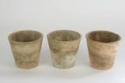](http://www.google.com/url?sa=i&rct=j&q=&esrc=s&source=images&cd=&cad=rja&uact=8&ved=0ahUKEwiVgLTSot3PAhVMOj4KHRivBjIQjRwIBQ&url=http://www.craftberrybush.com/2015/01/antique-terracotta-pots-diy.html&psig=AFQjCNHHhGYcADLKFg6icu49rF5TGUHixA&ust=1476636736553617)

Gaole – Jail.

Garnish – Chief serving vessel.

Garret – A small room at the top of a house, like an attic, often small, dismal, and cramped, with sloping ceilings. Might be used for the kids or guest sleeping room.



Garrison - The term garrison refers to the military or defensive character of a building or house. Garrisons, or fortified houses, were built in almost all New England towns.

Gentleman – By courtesy this title is generally accorded to all persons above the rank of common tradesmen or yeoman/farmer when their manners are indicative of a certain amount of refinement and intelligence. Should have a coat of arms. A gentleman is below Esquire in the social status. For some this could be a self-assigned title of status.

Gentry - People of good social position, specifically (in the UK) the class of people next below the nobility in position and birth, entitled to a coat of arms, especially those owning large tracts of land. The state or condition of being a gentleman.

Gild/gilded – A decorative technique for applying a very thin coating of gold or silver to solid surfaces such as metal (most common), wood, porcelain, or stone. A gilded object is also described as "gilt".

Gilling – A process of evening out carded or combed top fiber making it suitable for spinning, done along with combing.

[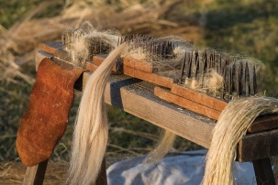](http://www.google.com/url?sa=i&rct=j&q=&esrc=s&source=images&cd=&cad=rja&uact=8&ved=0ahUKEwj72qvxsM3WAhWHh1QKHf1VAlYQjRwIBw&url=http://www.history.org/foundation/journal/Winter15/hemp.cfm&psig=AOvVaw2YLXWtia1NMSM-r3mTBcEC&ust=1506877124737429)

Gimlet - A small tool with a screw point on one end and a cross handle on the other, for boring holes, usually in wood.

[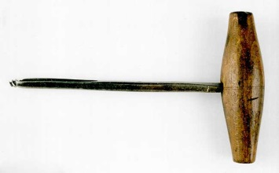](http://www.google.com/url?sa=i&rct=j&q=&esrc=s&source=images&cd=&cad=rja&uact=8&ved=0ahUKEwiKo_ve3NzMAhVHOSYKHVo8CeYQjRwIBw&url=http://www.history.org/almanack/life/tools/tlaug.cfm&bvm=bv.122129774,d.eWE&psig=AFQjCNGH8LK_yk1Y1qgiu2abs66U8k1ulQ&ust=1463423799675774)

Glover – A person who makes gloves (Richard Hovey).

Grain cradle - A grain cradle or cradle, is a modification to a standard scythe to keep the cut grain stems aligned. Note: In Joshua Markham’s probate inventory in 1878, a grain cradle was appraised at 25 cents and sold for 10 cents.

[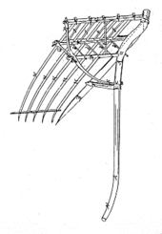](https://www.google.com/url?sa=i&rct=j&q=&esrc=s&source=imgres&cd=&cad=rja&uact=8&ved=2ahUKEwjAuOj82obcAhUH2oMKHQwOCF0QjRx6BAgBEAU&url=https://en.wikipedia.org/wiki/Grain_cradle&psig=AOvVaw2ajPd6vRwUkeCcEcRNyeu0&ust=1530837164622832) [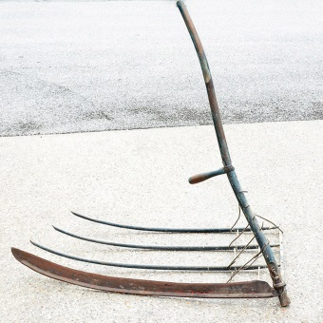](https://www.google.com/url?sa=i&rct=j&q=&esrc=s&source=images&cd=&cad=rja&uact=8&ved=2ahUKEwjFntiU24bcAhWDyIMKHQ7eD_8QjRx6BAgBEAU&url=https://www.ebth.com/items/3943126-primitive-grain-cradle-scythe&psig=AOvVaw11p7hYywWMW8TS_lq-9CqU&ust=1530837213670137)

Great wheel – A large wheel, especially in an apparatus.

[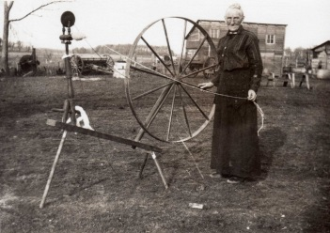](http://www.google.com/url?sa=i&rct=j&q=&esrc=s&source=images&cd=&cad=rja&uact=8&ved=0ahUKEwirut6Go93PAhUB4yYKHTpACkcQjRwIBw&url=http://wildfernacres.blogspot.com/2010/05/restoring-my-antique-heirloom-great.html&psig=AFQjCNFJUiw7g925dwWLls-d3zi3ljN0PQ&ust=1476636828549408)

Gridiron (grid iron) - A frame of parallel bars or beams, typically in two sets arranged at right angles, in particular. For keeping skillets directly over heat for a long period of time, also called a spider.

[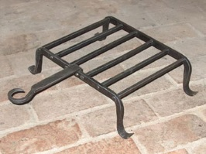](http://www.google.com/url?sa=i&rct=j&q=&esrc=s&source=images&cd=&cad=rja&uact=8&ved=0ahUKEwj64bLznOPPAhVJbK0KHcIbAQwQjRwIBw&url=http://keepthehearthfiresburning.blogspot.com/2012_05_01_archive.html&psig=AFQjCNG2OOzJRyUWeCobQesYaHvdSd4jHw&ust=1476841244926014)

Grindstone – A large circular stone used to sharpen knives and axes, powered by hand or by foot.

[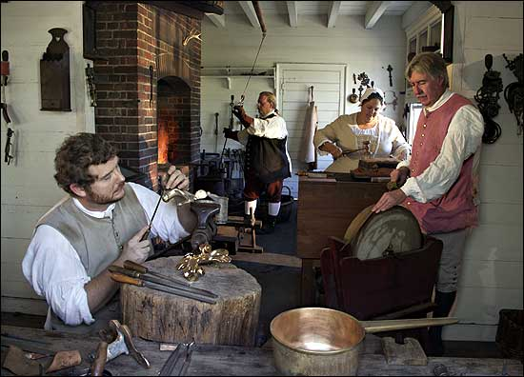](http://www.google.com/url?sa=i&rct=j&q=&esrc=s&source=images&cd=&cad=rja&uact=8&ved=2ahUKEwiCm8mgwoXiAhV5JTQIHbENBE8QjRx6BAgBEAU&url=http://www.history.org/foundation/journal/Winter03-04/foundry.cfm&psig=AOvVaw2I0EZtm4ZCW_ZN4hXOBmtA&ust=1557184366209048)

Grist mill – A grist mill grinds [grain](https://en.wikipedia.org/wiki/Food_grain) into [flour](https://en.wikipedia.org/wiki/Flour). The term can refer to both the [grinding mechanism](https://en.wikipedia.org/wiki/Mill_(grinding)) and the building that holds it.

[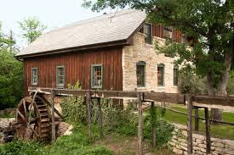](https://www.google.com/maps/uv?hl=en&pb=!1s0x864f9c697989d1a5:0xb2edf6f1ce0756ad!2m10!2m2!1i80!2i80!3m1!2i20!16m4!1b1!2m2!1m1!1e1!3m1!7e115!4shttp://www.keyword-suggestions.com/Z3Jpc3RtaWxs/!5sgrist+mill+-+Google+Search&imagekey=!1e1!2shttp://precyclebin.files.wordpress.com/2013/08/homestead-gristmill.jpg&sa=X&ved=0ahUKEwiLr6iQjuPPAhXk7IMKHag3BwgQoioIiwEwDg)

Grogram – A type of fabric that is a mix of silk and wool, used to make clothes.

Habendum (haberidum) – Real estate clause in a deed or lease that defines the type of interest and rights to be enjoyed by the grantee. Usually starts with “to have and to hold”. Called a “fee simple absolute” clause, grants complete ownership of a property, subject to government laws and powers.

Haberdasher – A ancient merchant guild of London associated with the silk and velvet trade.

Hakes – A larger ocean fish such as cod.

Halberd – A long handled tool or weapon with an ax blade and a type of spike on opposite sides.

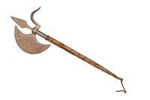

Half-pike – A spear-headed weapon with a shaft about half the length of a typical spear or pike.

Hanger – Also called a trammel hook, was used to hang a pot in a fireplace.

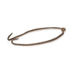

Hames (haimes) – Horse collar or harness.

[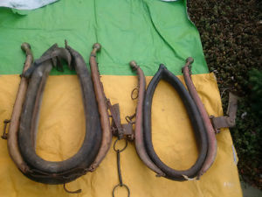](http://www.google.com/url?sa=i&rct=j&q=&esrc=s&source=images&cd=&cad=rja&uact=8&ved=0ahUKEwjr5-_zo93PAhUBVyYKHXxkB8oQjRwIBw&url=http://www.kijiji.ca/b-buy-sell/ontario/antique-horse-collar/k0c10l9004&psig=AFQjCNEhlIOxBUF61swNUqzY2uerCRjdFA&ust=1476637004405620)

Hand mill – A small grinder used to grind grain by hand.

Harrow – A type of plow, wooden frames with iron spikes or wooden teeth to break down and comb the soil surface.

[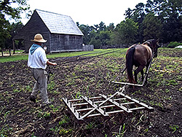](https://www.history.org/Almanack/life/trades/images/Harrowing-with-Lancer.jpg)

Hatchit - A small one-hand axe used for chopping.

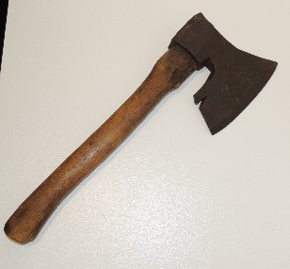

Heater – Slabs of metal used that were put in fireplace, then put in box iron (or other uses for heat).

Heirs – Recipients of an inheritance from a deceased owner.

Hereditament – Any kind of property that can be inherited (Latin hereditare, to inherit, from heirs).

Hetchel/hatchel - Heckle – Type of comb for flax.

[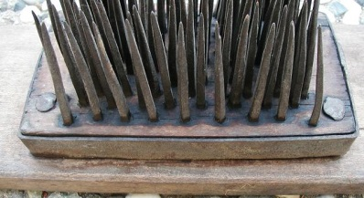](http://www.google.com/url?sa=i&rct=j&q=&esrc=s&source=images&cd=&ved=0ahUKEwjXtMvUqOHLAhUIJiYKHU9HBKMQjRwIBw&url=http://www.fanaticscountryattic.com/store/WsDefault.asp?One%3D214&bvm=bv.117868183,d.eWE&psig=AFQjCNHPQZRvjFvjFY7PWnfgm7CpPk5exg&ust=1459183587959285)

Hoe - English agricultural historian named William Tatham discussed three varieties of hoe used in tobacco production: the grubbing hoe or mattock, the narrow or hilling hoe, and the broad or weeding hoe. The first of these, the grubbing hoe or mattock, was used to break up ground. The hilling hoe is used to break up the ground and throw it into shape. The broad or weeding hoe is used during the cultivation of the crop, to keep it clean from the weeds.

Hoggsheads (hogshed, hogset) – (in Dan III inventory) A large cask, a measure of capacity for beer (63 gallons) or wine.

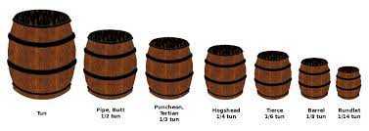

Holland shirt or cloth – Another way to describe linen. It is plainwoven or dull-finish linen. Can also refer to cloth or clothing imported from Europe or Holland/Netherlands. A kind of smooth hard wearing linen fabric imported from Amsterdam in huge quantities by merchants. The definition given in The New and Complete Dictionary of the English Language published by John Ash in 1775 states 'A fine substantial sort of linen cloth".

Hops - Hops are the hanging flowers of the Humulus lupulus plant. They're a climbing perennial, and tucked inside each cone are tiny yellow pods called lupulin which contain resin and essential oils — the driving source of bitterness, aroma, and flavor in beer.

Hourglass - An invertible device with two connected glass bulbs containing sand that takes an hour to pass from the upper to the lower bulb.

[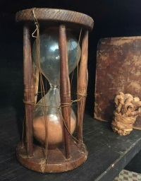](https://www.google.com/url?sa=i&rct=j&q=&esrc=s&source=images&cd=&cad=rja&uact=8&ved=2ahUKEwiWqNL72o7nAhVNb60KHakACq4QjRx6BAgBEAQ&url=https://www.pinterest.com/pin/456552480965423481/&psig=AOvVaw3lBSsuYzo0BgkUhyqX0N4i&ust=1579490543559458)

Hueugnot - A French Protestant of the 16th–17th centuries. Largely Calvinist, the Huguenots suffered severe persecution at the hands of the Catholic majority, and many thousands emigrated from France (the Merrill’s went to England).

Husbandman – A farmer. A tenant farmer or small-holder who might also have to work on the land of larger landowners to maintain himself, below the rank of Yeoman. As such they were sometimes included in tax returns, eg hearth tax, or annual rates levied for the repair of the highways etc. An indicator of their status in these returns would be that they are contributing only small amounts compared to the main landowners.

Imprimis – In the first place; above all else.

Indenture – A formal legal agreement, contract or document. Also, bind (someone) by an indenture as an apprentice or laborer.

Indian basket – Baskets made by Native Americans, who were often skilled at weaving various items. They were often sold or traded to colonists.

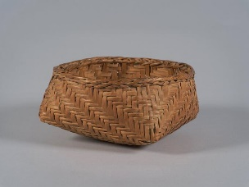

Intestate – The condition of dying without having made a valid will.

Ironmonger - A person or store selling hardware such as metal tools and household implements.

Issue (also without issue) - A person's lineal descendants - all genetic descendants of a person, regardless of degree. Issue is a narrower category than heirs, which includes spouses, and collaterals (siblings, cousins, aunts, and uncles). This meaning of issue arises most often in wills and trusts.

Joiner – A person who constructs the wooden components of a building.

Jointure - An estate settled on a wife for the period during which she survives her husband.

Journeyman - A journeyman is an individual who has completed an apprenticeship and works for wages. The term comes from the French for “day man.”

[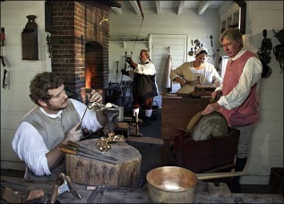](http://www.google.com/url?sa=i&rct=j&q=&esrc=s&source=images&cd=&cad=rja&uact=8&ved=0ahUKEwim_sDTr83WAhWO-VQKHbvaCmoQjRwIBw&url=http://www.history.org/foundation/journal/winter03-04/foundry.cfm&psig=AOvVaw33_d_d5PowH_g0wd_lB4oE&ust=1506876784224079)

Joynt stool – A type of stool to sit on.

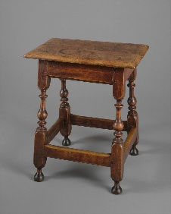

Kaffa (caffa) - A rich silk cloth with printed or woven designs popular in the 16th century.

Keeler – A large tub. A broad shallow tub (as for a liquid or washing something).

[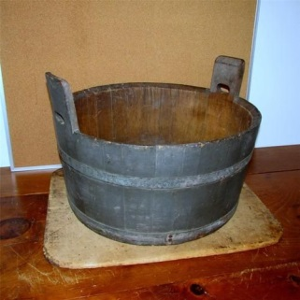](https://www.google.com/url?sa=i&rct=j&q=&esrc=s&source=images&cd=&ved=2ahUKEwiFw6Ps6_HiAhVH7qwKHQyYCnMQjRx6BAgBEAU&url=https://www.pinterest.co.uk/pin/462744930432629209/&psig=AOvVaw3yUEhjWkln2dkYb6bsjgkc&ust=1560906448189540)

Kettle – Often made of brass, a container in which water is boiled, having a lid, spout and handle. Often used as a teakettle.

[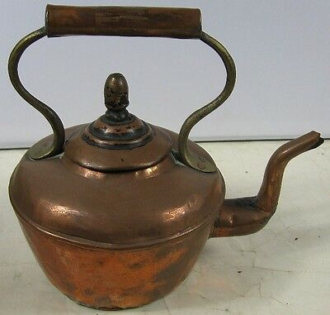](https://www.google.com/url?sa=i&rct=j&q=&esrc=s&source=images&cd=&ved=2ahUKEwiLo_3f7fHiAhUMbKwKHe4WAREQjRx6BAgBEAU&url=https://picclick.com/Antique-Copper-Brass-Tea-Pot-273577658369.html&psig=AOvVaw10pw_FXNwywdoR2wvlabzy&ust=1560906952426989)

Kine/Kyne – Cows (archaic old English word).

Kilderkin – A dutch word for small cask, is equal to two firkens.

Kirtle (Silk kirtell) - A woman's gown or outer petticoat.

Kneading trough – A vessel in which dough, after being mixed and leavened was left to swell or ferment. This is for making bread.

Knight – In Medieval times, a man given a rank of honor by a British king or queen because of his special achievements, and who has the right to be called "Sir".

Lamp trammel – Used for supporting lighting, saw-toothed to permit height adjustment.

[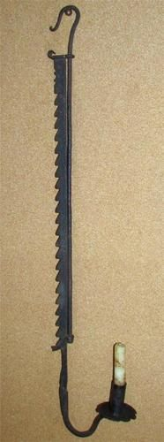](https://www.google.com/url?sa=i&rct=j&q=&esrc=s&source=images&cd=&cad=rja&uact=8&ved=0ahUKEwigk7qFpd3PAhUG5iYKHa01A1YQjRwIBw&url=https://www.pinterest.com/imroad/early-primitive-wrought-iron-and-tin-lighting/&psig=AFQjCNGvSff-GZAXK3X_LQfB4rfkqE7xzg&ust=1476637360081595)

Lancet - A sharp-pointed and commonly 2-edged surgical instrument used to make small incisions.

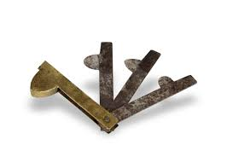

Lantorn/Lantern – A lamp with a transparent case protecting the flame, and typically having a handle by which it can be carried or hung.

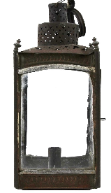

Latten – An allow of copper and zinc resembling brass, hammered into thin sheets to make items.

Lawde – To give honor and praise.

Lead bullets – Were round and cast in a mold.

[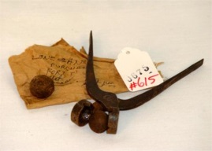](http://www.google.com/url?sa=i&rct=j&q=&esrc=s&source=images&cd=&cad=rja&uact=8&ved=0ahUKEwj8qLKKm-PPAhXFDqwKHVM6BhoQjRwIBw&url=http://www.icollector.com/BULLET-MOLD-REVOLUTIONARY-WAR-FROM-FT-TICONDERO_i5173116&psig=AFQjCNEXdz2DNV-OUEEZTMYWlJNZGbkYng&ust=1476840791002097)

Leatherseller – One of the livery companies of the City of London, established in 1444 with authority to control the sale of leather within the City.

Liber - A book of records (as of deeds or wills), i.e. recorded in said Bureau in Liber 25, at page 56.

Lime - Lime is a calcium-containing inorganic mineral composed primarily of oxides, and hydroxide, usually calcium oxide and/ or calcium hydroxide. When the term is encountered in an agricultural context, it usually refers to agricultural lime used to reduce the acidity of soil to fertility or oxygen levels. Lime is also used in the process of tanning leather.

Linchpin (Linch pin) – A pin that holds a wheel on an axle on a cart.

Linen - Cloth made of flax and noted for its strength, coolness, and luster.

Link – 100 links make a chain, which is 66 feet (also about 4 rods).

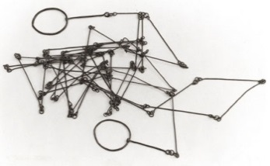

Lickey – Term used for liquor where liquor is banned.

Lis pendens – A written notice that a lawsuit has been filed which concerns the title to real property.

Looking glass – A mirror.

[](https://www.google.com/url?sa=i&rct=j&q=&esrc=s&source=images&cd=&ved=2ahUKEwjv8IKJy87iAhWEFzQIHeVmDvYQjRx6BAgBEAU&url=https://www.ebay.com/itm/Friedman-Brothers-Colonial-Williamsburg-Chippendale-Looking-Glass-Mirror-/182203513241&psig=AOvVaw0pAdNQuB7fiH5qtPtdiAMd&ust=1559695063452599)

Loom – A device used to make fabric or cloth by weaving yarn or thread. The basic purpose of any loom is to hold the warp threads under tension to facilitate the interweaving of the weft threads.

[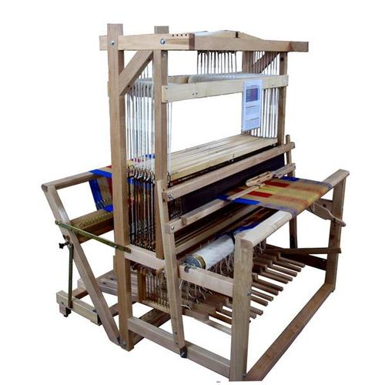](https://www.google.com/url?sa=i&rct=j&q=&esrc=s&source=images&cd=&ved=2ahUKEwju3IOr4PHiAhUROa0KHVH6AgwQjRx6BAgBEAU&url=https://woolery.com/leclerc-colonial-v2-traditional-loom.html&psig=AOvVaw2SxjRyqPTcnYvMhXS7iql1&ust=1560903360760328)

Mark – A measure of value that was not an actual coin, but rather an amount used for accounting. Worth 13 shilling 4 pence, or two thirds of a pound.

Marriage bond - A form of guarantee that there wasn’t any legal bar to the marriage. Enforcing the guarantee was a pledge by the groom and a bondsman — usually a relative — to pay a sum of money,

Martyrs (Book of Martyrs) - Published in 1563 and written by historian and martyrologist John Foxe, the book is a survey of Christian martyrs throughout history and is considered the most widely read book in English during the reign of Elizabeth I (1558–1603, during a period often called the Elizabethan Age). It described the suffering of Protestants under Mary's (first queen to rule England, from 1553–1558) rule, and reached English readers at a time when they needed guidance and support. The book helped them feel justified in their struggle to remain loyal to what they believed to be the true religion.

Mattock - An agricultural tool shaped like a pickax, with an adze and a chisel edge as the ends of the head.

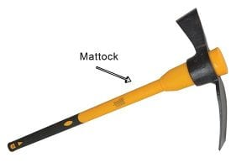

Meal sieve – A type of strainer to sift meal through to make it fine and light.

[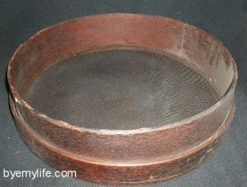](http://www.google.com/url?sa=i&rct=j&q=&esrc=s&source=images&cd=&cad=rja&uact=8&ved=0ahUKEwjg04eCpt3PAhUEKiYKHUa9B2UQjRwIBw&url=http://skavenjernova.tripod.com/id26.html&psig=AFQjCNGHiTxQJNlCM8m9ItZfIwDAnzgINA&ust=1476637608087916)

Meat tub – Tub used to salt meat in.

[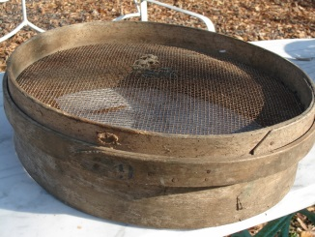](https://www.google.com/url?sa=i&rct=j&q=&esrc=s&source=images&cd=&cad=rja&uact=8&ved=0ahUKEwiCv7fgwOLMAhWHWCYKHbXfCQAQjRwIBw&url=https://www.pinterest.com/pin/61080138668086051/&psig=AFQjCNEby0aXohbkuDnTKb3Oh83u8jr6xg&ust=1463622476556799)

Mercer - A dealer in textile fabrics, especially silks, velvets, and other fine materials.

Merchant Guild (Ancient Merchant Guild) – Associated with the silk and velvet trade.

Merchantable – Suitable for purchase or sale, marketable.

Messuage – A dwelling house with outbuildings and land assigned to its use.

[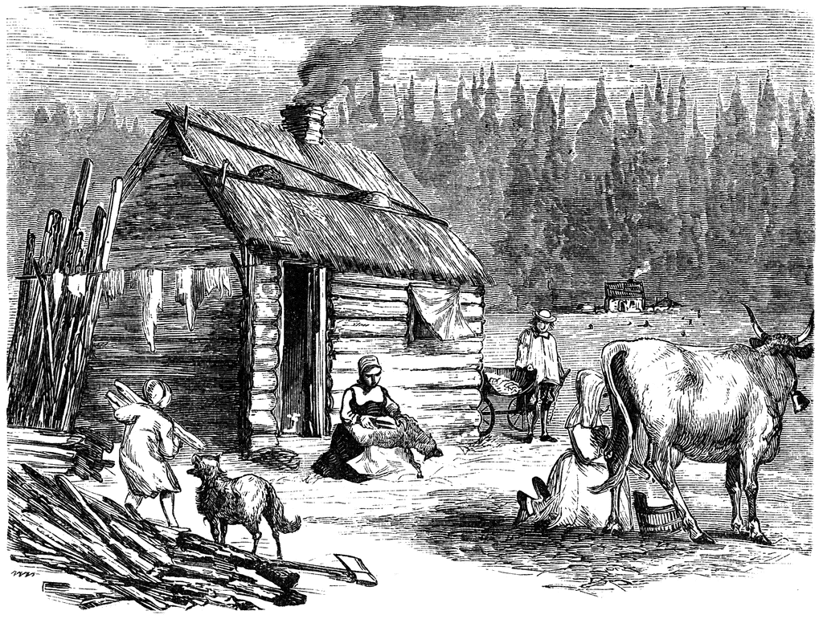](http://www.google.com/url?sa=i&rct=j&q=&esrc=s&source=images&cd=&cad=rja&uact=8&ved=0ahUKEwj4mpKFpZTXAhVHQCYKHSfhBXcQjRwIBw&url=http://etc.usf.edu/clipart/55300/55308/55308_log-cabin.htm&psig=AOvVaw2gy32yFDoUe3S4KzGZeXPQ&ust=1509313443193510)

Metheglin – A flavored mead, predates wine made from grapes. An alcoholic drink of fermented honey and water.

Mislin/meslin – Mixture of wheat & rye.

Money exchange rate – In the year 1802 the currency of English Pounds changed to U.S. dollars at a rate of 3.33 dollars to 1 pound.

Money scales – Set of balance scales used to weigh money. Balance scales are a device for weighing things. When the two pans contain exactly the same mass the beam is in balance. You can place an object in one pan (such as gold or silver coins) and standard weights in the other to find what the object (coins) weighs.

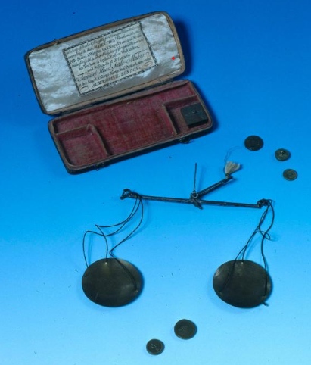

Mortor/Morter – Bowl device used to prepare substances by crushing and grinding; a bowl made of very hard material, such as brass, hardwood, glass or porcelain, in which substances may be pounded to a powder using a pestle (which is a tool, a stick like object with a rounded handle).

[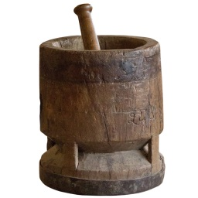](https://www.google.com/url?sa=i&rct=j&q=&esrc=s&source=images&cd=&cad=rja&uact=8&ved=0ahUKEwilyI7qpt3PAhWB4yYKHYpgB2wQjRwIBw&url=https://www.1stdibs.com/furniture/decorative-objects/vases-vessels/jars/antique-mortar-pestle/id-f_1534232/&psig=AFQjCNFx8hxnIYP9RGzjMwIM_zWEUuS9sw&ust=1476637838667636)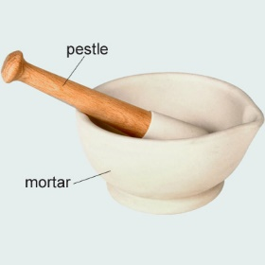

Moveable estate – Items in an estate that are physical belongings, like furniture, but not real estate or buildings.

Moyty (moiety) - Each of two parts into which a thing is or can be divided; a part or portion, especially a lesser share.

Mulley bull – Mulley, or polled livestock are livestock without horns in species which are normally horned​.

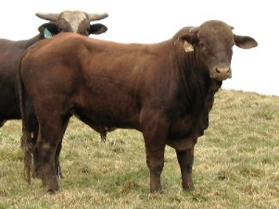

Musket – A muzzle loaded long gun that appeared as a smooth bore weapon in the early 16th century, at first as a heavier variant of the arquebus, capable of penetrating heavy armor

[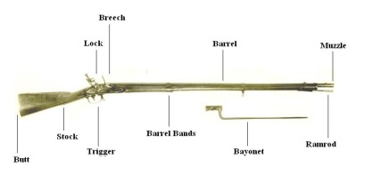](https://www.google.com/url?sa=i&rct=j&q=&esrc=s&source=images&cd=&ved=2ahUKEwj5p6et06bjAhVLZc0KHY3BAEEQjRx6BAgBEAU&url=https://allthingsliberty.com/2013/07/the-inaccuracy-of-muskets/&psig=AOvVaw1ovDV9vw7tEj0UCpKh8kto&ust=1562720947581150)

Mustard pot – A small vessel used to hold mustard. Mustard was used in a dry state until the change to the currently known wet form was made in the mid-1700’s.

[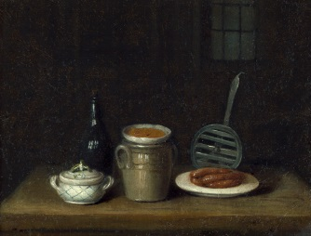](https://www.google.com/url?sa=i&rct=j&q=&esrc=s&source=images&cd=&ved=0ahUKEwjIxs-jpJTXAhVHYiYKHfacCh0QjRwIBw&url=https://www.pinterest.com/pin/415246028112718871/&psig=AOvVaw3GfoJbc9skX8sVafHpp4ZI&ust=1509313235366733)

Nails – Nails were made by hand.

[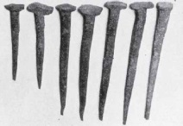](https://www.google.com/url?sa=i&rct=j&q=&esrc=s&source=images&cd=&cad=rja&uact=8&ved=0ahUKEwi1l8ORnOPPAhVEK6wKHVkcCQwQjRwIBw&url=https://www.realorrepro.com/article/Nails-as-clues-to-age&psig=AFQjCNGD-hWTneE5r0sayrK6_zW7XoyLpg&ust=1476841072685631)

Nail hammer – Used to hammer nails.

[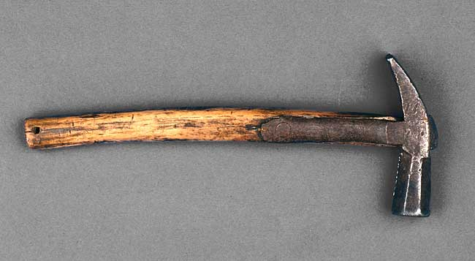](http://www.google.com/url?sa=i&rct=j&q=&esrc=s&source=images&cd=&ved=2ahUKEwj6xoSW0M7iAhUxFjQIHcIgD8EQjRx6BAgBEAU&url=http://www.history.org/Almanack/life/tools/tlham.cfm&psig=AOvVaw089lh8Z3Cvyqf8b759u3qz&ust=1559696442540923)

Neat cattle – Oxen or heifer.

[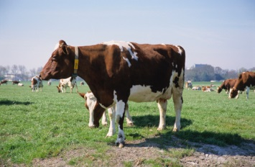](https://www.google.com/url?sa=i&rct=j&q=&esrc=s&source=images&cd=&cad=rja&uact=8&ved=2ahUKEwia_pvkib7cAhUFL6wKHYqNCD8QjRx6BAgBEAU&url=https://en.trend.az/scaucasus/armenia/1917016.html&psig=AOvVaw1tac5nNUGnXblKMK_oPmMS&ust=1532739486120740)

Neck cloth (neck handkerchief) – Informal sort of neckware generally work by sporting gentlemen and working tradesmen. Commonly a square folded and tied around the neck.

Neck yoke - A neck yoke is a bar (usually wooden) fastened to the collars of a pair of horses. It has a wide leather collar or ring fixed around its center to support the pole of the vehicle to which they are harnessed. A tapered metal fitting (tongue) on the end of the pole is inserted into the neck yoke collar. Note: In Joshua Markham’s probate inventory in 1878, a neck yoke was appraised at $1.00 and sold for 72 cents.

[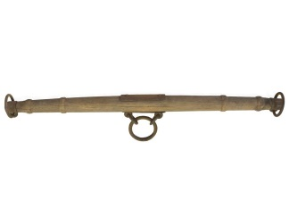](http://www.google.com/url?sa=i&rct=j&q=&esrc=s&source=images&cd=&cad=rja&uact=8&ved=2ahUKEwiikoHH14bcAhUM74MKHYwaAAIQjRx6BAgBEAU&url=http://www.hansenwheel.com/store/wagon-parts-supplies/hitch-equipment/neck-yokes-doubletrees-singletrees.html&psig=AOvVaw20bQ2wwT0TlFDkCd7FXpih&ust=1530836245393815)

Nibs – A type of small pointed tool.

Nippers – Used to cut sugar down.

[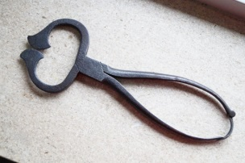](https://www.google.com/url?sa=i&rct=j&q=&esrc=s&source=images&cd=&cad=rja&uact=8&ved=0ahUKEwimhuuJp93PAhVMSiYKHfTCA00QjRwIBw&url=https://www.etsy.com/uk/listing/233643879/antique-sugar-cutter-sugar-nippers-sugar&psig=AFQjCNF0qxuYo6IflBEAmShXG7E4I0PXDA&ust=1476637909898567)

Noble – A former English gold coin. Minted from 1344 to 1470.

Nuncupative will – A will given verbally as opposed to have been written by the testator in advance. It is spoken to witnesses during sickness or right before death. A trusted person would write the words and submit it to court for acceptance as a will.

Palm - Nedlet (needle) & Palm – A tool for anyone repairing or making heavy or thick cloth (or rope, or sails) is a sailmaker's palm. The palm is used to push the needle through the cloth.

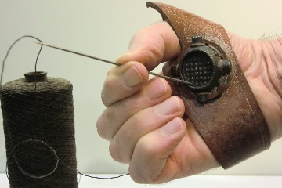

Pantaloons – Long trousers that were sometimes tight fitting and sometimes wide at the top and tight at the bottom that were worn by men in the 1800’s.

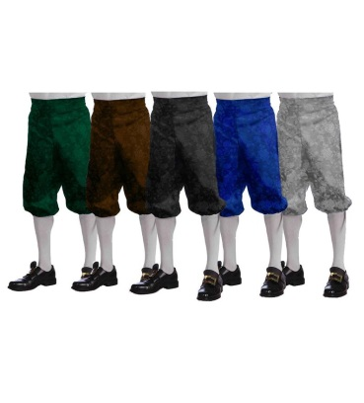

Parlour - A smaller room, usually created by putting up a wall in a formerly one room house, it was a private room and usually contained a bed. The larger room created was the hall room. This is the colonial times definition, this changed over time.

Payle maker – A maker of pails or buckets used to store food. Payle is the middle English spelling of pail.

Peal – A small type of shovel to remove something being baked/cooked in a hearth.

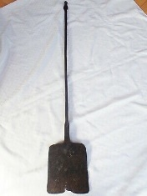

Peas (pease) hook – Small weight and hook to be used on scale for weighing hay, tobacco, etc.

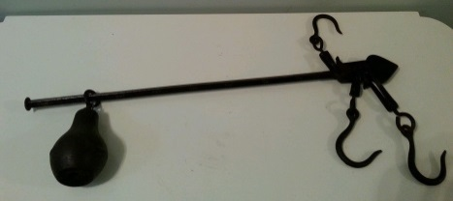

Petticoat - A woman's light, loose undergarment hanging from the shoulders or the waist, worn under a skirt or dress.

Piggin - A small wooden pail with one stave extended upward as a handle.

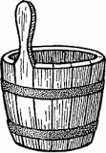

Pillory - A wooden framework with holes for the head and hands, in which an offender was imprisoned and exposed to public abuse.

[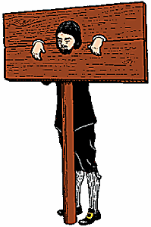](https://www.google.com/url?sa=i&rct=j&q=&esrc=s&source=images&cd=&cad=rja&uact=8&ved=2ahUKEwid8s3nwYzfAhUIXKwKHQJBBDkQjRx6BAgBEAU&url=https://www.merriam-webster.com/dictionary/pillory&psig=AOvVaw2RmyDQ7Z1bs2XxjIf2eQnR&ust=1544230688207076)

Porringer (parringer) – A small bowl, typically with a handle, used for soup, stew or similar dishes.

[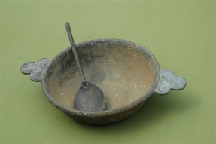](http://www.google.com/url?sa=i&rct=j&q=&esrc=s&source=images&cd=&cad=rja&uact=8&ved=0ahUKEwjqmZqRy-DPAhXFYyYKHVj5BCMQjRwIBw&url=http://www.suggest-keywords.com/Y29sb25pYWwgcG9ycmluZ2Vy/&psig=AFQjCNGIMzrTm6aO9fphv3NwcZ9Agsx0pA&ust=1476750574977498)

Peel – A long handled, shovel-like tool that permitted the cook to safely put breads and baked dishes into the oven and remove them,made of wood or sheet iron.

[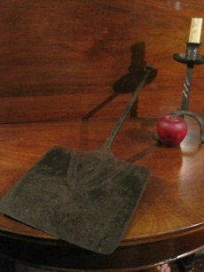](https://www.google.com/url?sa=i&rct=j&q=&esrc=s&source=images&cd=&cad=rja&uact=8&ved=0ahUKEwiA7bLtp93PAhWCQCYKHbLRDPIQjRwIBw&url=https://www.pinterest.com/pin/130604457917124430/&psig=AFQjCNE7s6kwPfhgw7DAcKY9pksInQG9OQ&ust=1476638119911121)

Peck – Two gallons, or ¼ of a bushel.

Pecuniary – Relating to or consisting of money.

Pence (d) – English currency. 12 pence = 1 shilling, 20 shilling = 1 Pound.

[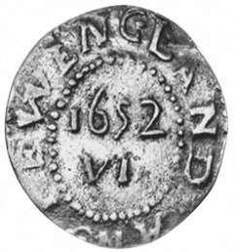](https://www.google.com/url?sa=i&rct=j&q=&esrc=s&source=images&cd=&cad=rja&uact=8&ved=0ahUKEwjcwai5luPPAhUDMawKHTJcCBEQjRwIBw&url=https://www.ngccoin.com/price-guide/world/us-colonial-america-massachusetts-6-pence-km-13-1652-cuid-1096-duid-11615&psig=AFQjCNE_ae7WO-eWWyqadf8rzeLbc2AJlw&ust=1476839582101347)

Penistone - A kind of coarse woolen cloth formerly used for making clothes (such as a penistone petticoat).

Peppercorn - A metaphor for a very small cash payment or other nominal consideration.

Perch – One square rod in measurement.

Pestle - A heavy tool with a rounded end, used for crushing and grinding substances such as spices or drugs, usually in a mortar.

[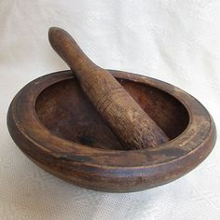](https://www.google.com/url?sa=i&rct=j&q=&esrc=s&source=images&cd=&cad=rja&uact=8&ved=0ahUKEwiaiNPLqt3PAhVMRSYKHQjtBxgQjRwIBw&url=https://www.pinterest.com/theodora51263/mortar-and-pestle/&psig=AFQjCNE1eC7lH78jS4kfvpzaVgiBlgfRgw&ust=1476638864353005)

Pewter – A gray alloy of mostly tin with copper and lead.

Pewter cup – A cup made of pewter, for drinking from.

[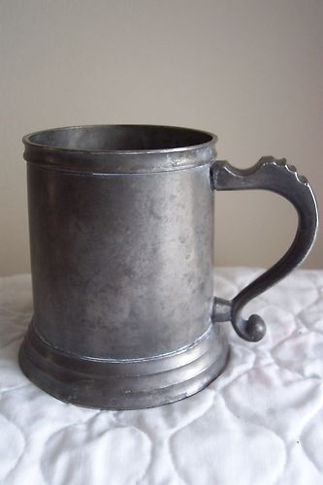](https://www.google.com/url?sa=i&rct=j&q=&esrc=s&source=images&cd=&ved=2ahUKEwi4zJ_S6PHiAhVERa0KHU7TBYwQjRx6BAgBEAU&url=https://www.pinterest.com/pin/2040762308388470/&psig=AOvVaw0zUuxEkkpSSAO4JGOTkSS3&ust=1560905585491875)

Pewter pitcher – A pitcher for water or other drinks made of pewter.

[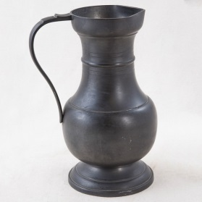](http://www.google.com/url?sa=i&rct=j&q=&esrc=s&source=images&cd=&cad=rja&uact=8&ved=0ahUKEwj_id_dzNrLAhUCNSYKHWf1BhQQjRwIBw&url=http://frenchmetro.com/products/10a030-pewter-barrel&bvm=bv.117218890,bs.1,d.cWw&psig=AFQjCNF5eANEjapumcq_iGp9K3FIeTsztQ&ust=1458952750694344)

Pewter plate – A plate made of pewter, for eating off of.

[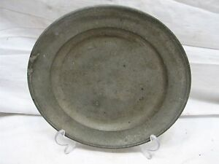](https://www.google.com/url?sa=i&rct=j&q=&esrc=s&source=images&cd=&ved=2ahUKEwiqhOmQ6PHiAhVNRK0KHbolDjwQjRx6BAgBEAU&url=https://www.ebay.com/itm/Antique-Colonial-Pewter-9-Salad-Plate-W-B-G-B-Triple-Hallmark-/293024212081&psig=AOvVaw1RJNzK8QIUdI4Ktzjk1sos&ust=1560905460825349)

Pigeon net – A net used to trap and then kill pigeons.

Pillar (pilliar) – A person or thing regarded as reliably providing essential support for something; a person in an important position.

Pillibers - Pillowbeers –

Pillion – A padded cushion with straps which sometimes had on one side a sort of platform stirrup, probably used behind a saddle on a horse so two could ride.

[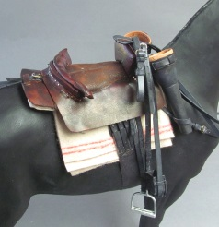](http://www.google.com/url?sa=i&rct=j&q=&esrc=s&source=images&cd=&cad=rja&uact=8&ved=0ahUKEwig0djMq93PAhUEKiYKHUa9B2UQjRwIBw&url=http://www.onesixthwarriors.com/forum/sixth-scale-action-figure-news-reviews-discussion/813771-british-dragoon-1743-a.html&psig=AFQjCNHTRT4B42POfSYhArpDmYoQZEP4iQ&ust=1476639113555423)

Pincers - An instrument having two short handles and two grasping jaws working on a pivot and used for gripping things.

[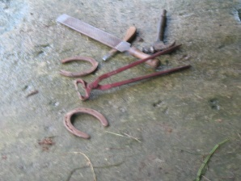](https://www.google.com/url?sa=i&rct=j&q=&esrc=s&source=images&cd=&cad=rja&uact=8&ved=2ahUKEwjMsYLQk9HiAhXiPn0KHclsBx0QjRx6BAgBEAU&url=https://www.pinterest.com/pin/513340057498619710/&psig=AOvVaw38TUOrNLJmGhAkF8JqeI79&ust=1559783206467104)

Plate – Flat sheet of metal, could be gold or silver, or a flat, round coin.

Plow (hand plow) – A type of plow pushed by hand for turning soil.

[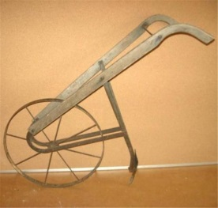](http://www.google.com/url?sa=i&rct=j&q=&esrc=s&source=images&cd=&cad=rja&uact=8&ved=0ahUKEwiXsezK4t3PAhVn1oMKHfpsCiMQjRwIBw&url=http://www.terapeak.com/worth/primitive-old-vintage-antique-walk-behind-push-plow-cultivator-oak-wood-handles/371353861871/&psig=AFQjCNF24uKVURKDz2VqmoTDYIC0CZrJnQ&ust=1476653898900364)

Plow cleaver – A type of plow for turning soil, drawn by animals. A barshear plow was for turning over new soil.

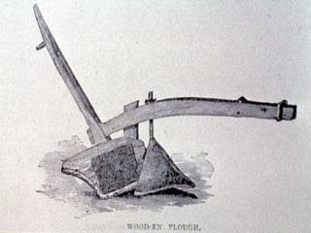

Plow sheer - The “shear” or cutting “knife” part of the plough is the part that cuts the soil.

Pole – A pole or rod or perch is a surveyor’s tool and unit of length equal to 5 ½ yards, or 16 ½ feet, and one-fourth of a surveyor’s chain. One acre is 160 poles.

[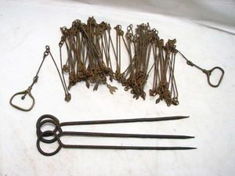](https://www.google.com/url?sa=i&rct=j&q=&esrc=s&source=images&cd=&ved=0ahUKEwjZ84K-5d3PAhUB7IMKHcGaDyIQjRwIBw&url=https://www.pinterest.com/pin/313281717801591663/&psig=AFQjCNH0q2D9w0O-Bnm3i_EtBuKaKaxIIw&ust=1476654668217038)

Portmanteau – A large trunk, usually made of leather and opening in two equal parts.

Potinger - A bowl or pot, usually of metal, earthenware, or wood, used to hold soup, stew, or the like; may also be called a porringer.

Pound (£) – English currency. 12 pence = 1 shilling, 20 shilling = 1 Pound.

[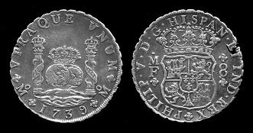](http://www.google.com/url?sa=i&rct=j&q=&esrc=s&source=images&cd=&cad=rja&uact=8&ved=0ahUKEwiwsqKul-PPAhWGLqwKHUVjAzAQjRwIBw&url=http://www.learnnc.org/lp/editions/nchist-colonial/6.5&psig=AFQjCNE4TZBb3517k1JgrTC2kcwMxqQ6Pg&ust=1476839791844294)

Porringer – A shallow bowl, made of wood, ceramic, pewter or silver, had flat, horizontal handles; used for soup or porridge.

[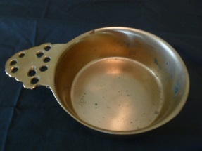](https://www.google.com/url?sa=i&rct=j&q=&esrc=s&source=images&cd=&cad=rja&uact=8&ved=0ahUKEwj8wLHGp93PAhXL4CYKHcaxDKgQjRwIBw&url=https://www.etsy.com/market/porringer_bowl&psig=AFQjCNFXH_njXS9OaAuhUO41KFCFguessA&ust=1476638039024987)

Pottage – A thick meat or vegetable soup.

[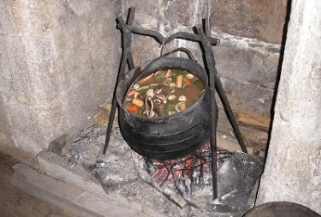](http://www.google.com/url?sa=i&rct=j&q=&esrc=s&source=images&cd=&cad=rja&uact=8&ved=0ahUKEwjY04_u5d3PAhXE6IMKHRyTBE0QjRwIBw&url=http://www.plymouthfarmersmarket.org/pottage-taste-plimoth-kathleen-wall/&psig=AFQjCNGGDkkFf4xYLcadBmBubBhHYpXXpw&ust=1476654771542625)

Powdering tub – Tub for salting meat.

[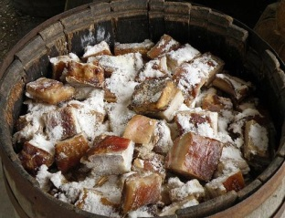](https://www.google.com/url?sa=i&rct=j&q=&esrc=s&source=images&cd=&cad=rja&uact=8&ved=0ahUKEwj2wPem5t3PAhXo3YMKHXouDMwQjRwIBw&url=https://www.pinterest.com/pin/365917538444060349/&psig=AFQjCNFp8dvjV5OIhD5GsuIqOa2I4Z7XDw&ust=1476654880746352)

Prejudicial - harmful to someone or something; detrimental.

Premised – To state or assume as a premise in an argument (used in court cases).

Presents – Signifies the writing then actually made and spoken of; as, these presents; know all men by these presents, to all to whom these presents shall come. Says that the document is a legal declaration of the facts contained in it.

Psalter – A copy of the biblical psalms, a book.

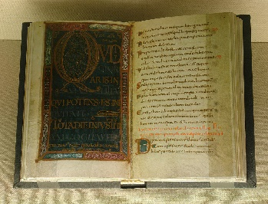

Qnire – An end of the church.

Quit claim – Deed that is a legal instrument which is used to transfer interest in real property. The entity transferring its interest is called the grantor, and when the quitclaim deed is properly completed and executed it transfers any interest the grantor has in the property to a recipient, called the grantee. Can be used for transferring property when an issue of ownership might not be clear, essentially a quit claim deed says “I hereby relinquish (quit) any interest I may have in this property”.

Raiser – Holder for an oil lamp.

[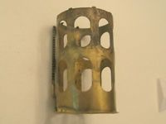](http://www.ebay.com/itm/Brass-Wick-Riser-Raiser-for-an-Oil-Kerosene-Lamp-burner/232110859134?_trksid=p2047675.c100011.m1850&_trkparms=aid%3D222007%26algo%3DSIC.MBE%26ao%3D1%26asc%3D39856%26meid%3Deb1a44edb9df4d449dd33ba8bb96fea1%26pid%3D100011%26rk%3D1%26rkt%3D1%26sd%3D201642141353)

Rayzor – A sharp blade used by men to shave. Early in colonial times, water or perhaps a type of oil was used on the face, in the 1700’s the use of a type of soap was used as a form of shaving cream.

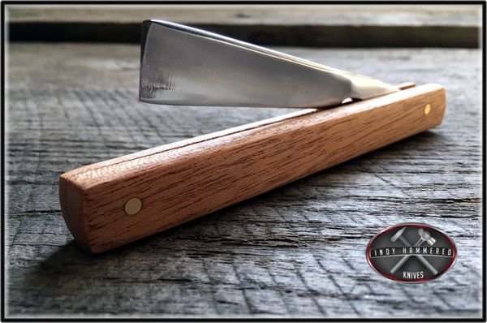

Ready money – Funds for immediate use.

Reaper – A farm machine that cuts grain.

[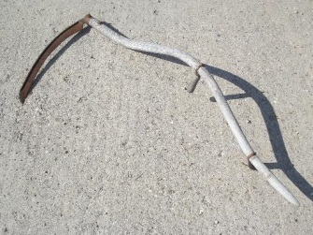](http://www.google.com/url?sa=i&rct=j&q=&esrc=s&source=images&cd=&cad=rja&uact=8&ved=2ahUKEwj3gemZib7cAhVCb60KHXkHAL0QjRx6BAgBEAU&url=http://www.laurelleaffarm.com/item-pages/sickle-blade-reaper-scythe.htm&psig=AOvVaw1OZ0izctKIrlkhGYaT5z8m&ust=1532739330747851)

Recompense – Compensate someone for a loss.

Regress – An act or privilege of going or coming back; movement backward to a previous and especially worse or more primitive state or condition.

Relict – Widow of the deceased.

Remised - To give, grant, or release a claim to such as in a deed.

Reversion (revertion) – In property law is a future interest that is retained by the grantor after conveyance of an estate of a lesser quantum that he has (such as the owner of a fee simple granting a life estate or a leasehold estate).

Revestre – A door in a church.

Rick - A large stack of hay, corn, peas, etc, built in the open in a regular-shaped pile, especially one with a thatched top.

Riddle – A coarse sieve, used to clean grain by passing it through the holes.

Roan (horse) – A horse coat color characterized by an even mixture of colored and white hairs on the body while the head, tail and lower legs are mostly solid.

Rod – Same as pole. A pole or rod or perch is a surveyor’s tool and unit of length equal to 5 ½ yards, or 16 ½ feet, and one-fourth of a surveyor’s chain. One acre is 160 poles.

Rood - An English unit of area, equal to one quarter of an acre or 10,890 square feet. A rectangle that is one furlong (i.e. 10 chains, or 40 rods) in length and one rod in width is one rood in area, as is any space comprising 40 perches (a perch being one square rod).

Room – When referred to as “in room”, means in place of.

Run of yarn – A measurement used in the creation of yarn. For wool yarn, a run is 1600 yards.

Rundlet – A small barrel or keg.

Sad iron – Also called a flat iron or smoothing iron; sad came from solid, and can mean a bigger and heavier iron; usually 2 were used, one was kept on the stove to be hot while the other was being used.

[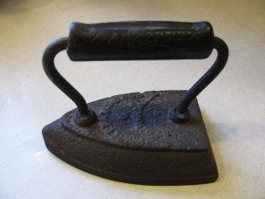](http://www.google.com/url?sa=i&rct=j&q=&esrc=s&source=images&cd=&cad=rja&uact=8&ved=2ahUKEwiS25G5j_ThAhUEWa0KHeAbDIcQjRx6BAgBEAU&url=http://catherinescorner.net/?p%3D146&psig=AOvVaw3xn7JQ2eT6AuwQG-x4KpIz&ust=1556586668096452)

Salt (Salt Cellar or Silver salt) – Ornamental vessel for holding salt. Usually placed on the table for dining to show the persons level of wealth. Those seated “above the salt” (near the end of the table where the host and hostess sat) were the guests of honor. Children and less important guests sat in the middle or at the other end of the table, or “below the salt.”

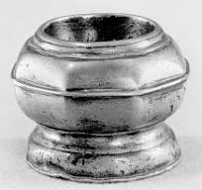

Sattinisco (as in a gown) – A satin, a thick closely textured silk fabric, with a glossy surface.

Scabbard/Scabord – A sheath or holder for a sword, typically made of leather or metal.

Scain (Skein) (of thread) – A bundle of a type of thread that is 8 yards long.

Score – 20 years.

Scrivener – Person who writes wills.

Scythe (syth) – Like a sickle, tacking used to adjust the blade.

[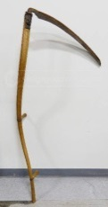](https://www.google.com/url?sa=i&rct=j&q=&esrc=s&source=images&cd=&cad=rja&uact=8&ved=0ahUKEwjQz_a66N3PAhUL5oMKHWxHDa4QjRwIBw&url=https://www.pinterest.com/pin/541065342709568951/&psig=AFQjCNGotoNaDtWHR3jGOAQRJjrHtqWG_Q&ust=1476655461419115)

Scythe (cradle scythe) – Used for reaping crops.

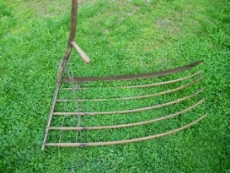

Seating the People in the Meeting-House - "The selectmen and the deacons or a committee appointed by the selectmen, determined the order in which the seats in the meeting-houses in New England, in the early settlement, should be occupied, Ability and general regard, as well as wealth, had much to do with the order of selection. The women, as a rule, do not appear to have been assigned to particular seats, but occupied, in another part of the house, such as suited their own preferences. The lists still preserved, which give the order of seating the men and boys in Springfield, do not indicate any great regard for those having the largest possessions. At Northampton, ‘age and estate’ determined the order, and to some extent that might have prevailed here." From: The Official Records from 1636 to 1736 with an Historical Review and Biographical Mention of the Founders, by Henry S. Burt, 1898-1899; page 126, vol. 1.

Seine (fishing seine) – A fishing net that hangs vertically in the water with floats at the top and weights at the bottom edge, the ends being drawn together to encircle the fish.

[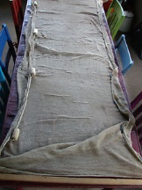](http://www.google.com/url?sa=i&rct=j&q=&esrc=s&source=images&cd=&cad=rja&uact=8&ved=0ahUKEwjo3Naq3u7PAhWE3SYKHdywDlMQjRwIBw&url=http://www.ebay.com/itm/Vintage-Genuine-Fishing-Seine-Net-Minnows-Smelt-Fishing-8-x-42-Floats-Weights-/201433062153&psig=AFQjCNEda1tvqkXLptsjA3yOGirqHXEe0w&ust=1477236873008290)

Seised – Having ownership; take hold of. That the party has legal title to and possession of the land in question.

Seith (scythe) – A tool used for cutting crops, with a long-curved blade at the end of a long pole attached to which are one or two short handles.

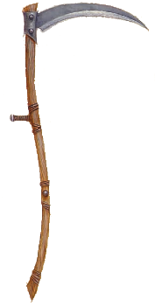

Seisen/seizen (seixen) - Possession of either land or chattel.

Serge - A durable twilled woolen or worsted fabric; "a heavy serge coat". Fine woolen cloth used extensively for clothing.

Share - The part of a plow that cuts through the soil; plowshare. A heavy piece of pointed wood.

[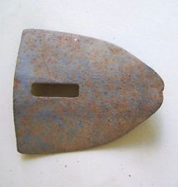](http://www.google.com/url?sa=i&rct=j&q=&esrc=s&source=images&cd=&cad=rja&uact=8&ved=0ahUKEwj-0fj-6N3PAhWh6YMKHR3rAFoQjRwIBw&url=http://www.zeppy.io/discover/us/antique-plow&psig=AFQjCNFVuGZZ2FRlPg-e1o-jyFHh7L44IA&ust=1476655605902488)

Shave (Spikeshave) - A tool used to shape and smooth woods in woodworking jobs such as making wheel carts, wheel spokes, chair legs, paddles, bows, and arrows.

[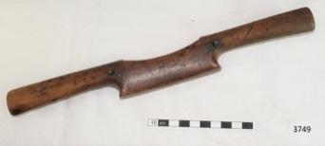](https://www.google.com/url?sa=i&rct=j&q=&esrc=s&source=images&cd=&cad=rja&uact=8&ved=2ahUKEwjI9M2ixIXiAhWFJzQIHQ8RDecQjRx6BAgBEAU&url=https://victoriancollections.net.au/items/5b95e5fd21ea6a058c746c5b&psig=AOvVaw0LWJP6lpcQk0qbWyQLZ70t&ust=1557184929497987)

Shilling (s) – English currency. 12 pence = 1 shilling, 20 shilling = 1 Pound

[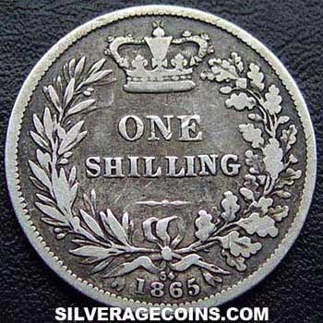](http://www.google.com/url?sa=i&rct=j&q=&esrc=s&source=images&cd=&cad=rja&uact=8&ved=0ahUKEwjV3urBmOPPAhVCCKwKHdZSBgoQjRwIBw&url=http://www.silveragecoins.com/en/details.php?item%3D6497&psig=AFQjCNFdY7NFEdFb2eEMc_bdJAqtwfAbvw&ust=1476840112448036)

Shote – Young pig.

[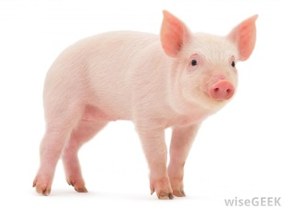](http://www.google.com/url?sa=i&rct=j&q=&esrc=s&source=images&cd=&cad=rja&uact=8&ved=0ahUKEwjT4_iC593PAhXC5YMKHa2CDzAQjRwIBw&url=http://www.wisegeek.com/what-is-a-suckling-pig.htm&psig=AFQjCNFmPYZhCpgoNnu3wmq2kYpapGPZ6w&ust=1476655066774724)

Sieve - A utensil consisting of a wire mesh held in a frame, used for straining solids from liquids, for separating coarser from finer particles, or for reducing soft solids to a pulp.

[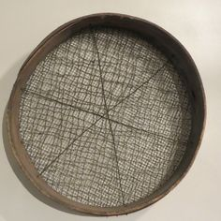](https://www.google.com/url?sa=i&rct=j&q=&esrc=s&source=images&cd=&cad=rja&uact=8&ved=0ahUKEwiWysG2593PAhUr1oMKHcXNB5wQjRwIBw&url=https://www.pinterest.com/pin/23714335511073411/&psig=AFQjCNEnWAX3VtHXoOzStrdsKWQG4iQBLw&ust=1476655131425089)

Signet – A ring. For wealthy and important men, a signet ring was a powerful tool akin to a signature. A signet ring is set apart from other rings based on an engraved or raised symbol, series of words or letters, or image on the top half of the ring that was representative of its wearer in some way. Traditionally, signet rings were worn on the pinky finger and used by gentlemen as a seal to sign important documents.

Skillet – Used in fireplace for cooking.

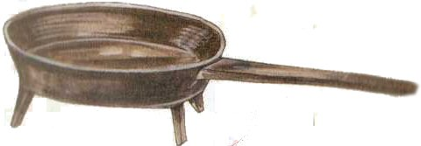

Skimming dish – Used in cheese making, to separate the coagulation/curd from the liquid whey.

Sleigh - Pulled behind a horse over snow, with runners. Sometimes used for travel in the winter. (Lemule Hurlbut had one in his probate inventory)

[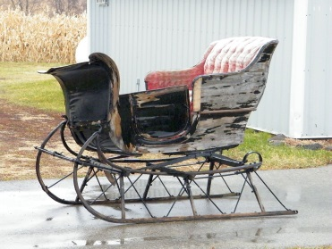](http://www.google.com/url?sa=i&rct=j&q=&esrc=s&source=images&cd=&cad=rja&uact=8&ved=2ahUKEwi3_eLAwIXiAhXDMn0KHZqHAlIQjRx6BAgBEAU&url=http://antiquesleighs.blogspot.com/&psig=AOvVaw2YngIZIv3GQC6-b-cYnUm3&ust=1557183969483178)

Skimmer - A perforated spoon.

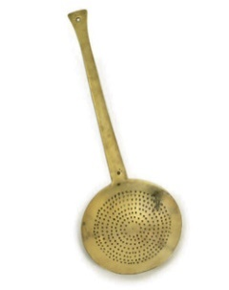

Smoothing Iron – An iron made of iron metal that was heated in the fireplace and used to smooth cloth or clothes. For colonial irons with a metal handle, a piece of cloth was used around the handle to be able to hold it without burning your hands. Were also called flat irons or sad (which meant solid) irons.

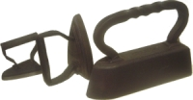

Snaffle - A snaffle bit is the most common type of bit used while riding horses. It consists of a bit mouthpiece with a ring on either side and acts with direct pressure. A bridle utilizing only a snaffle bit is often called a "snaffle bridle", particularly in the English riding disciplines.

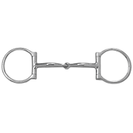

Snibills – A type of hinge; one use is to fasten the body of an ox cart to the axle, could also be used for a cupboard door.

[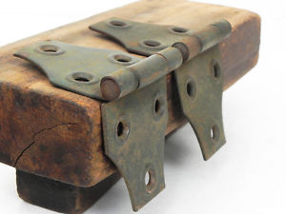](http://www.ebay.com/itm/2-Vintage-Iron-Door-Cabinet-Hinges-Rustic-Hardware-Farmhouse-Industrial-/282196714760)

Sollor/Soller – A loft.

Sorrel horse - A reddish-brown horse.

[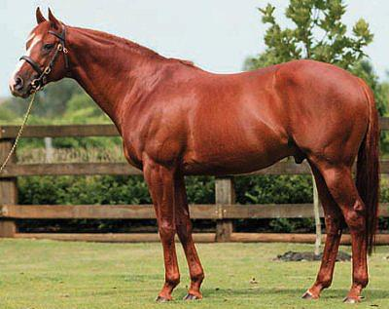](https://www.google.com/url?sa=i&rct=j&q=&esrc=s&source=images&cd=&cad=rja&uact=8&ved=0ahUKEwi7gfO87N3PAhUG34MKHcBVApgQjRwIBw&url=https://www.studyblue.com/notes/note/n/horse-colors/deck/7711132&psig=AFQjCNHAQ5D5RBageb1H8Z-V4az1Lj8siw&ust=1476656519263991)

[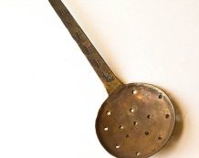](https://www.google.com/url?sa=i&rct=j&q=&esrc=s&source=images&cd=&cad=rja&uact=8&ved=0ahUKEwimiJbU593PAhUo4YMKHZ3bAb4QjRwIBw&url=https://www.etsy.com/search/vintage?q%3Dhand%2Bforged%2Bcookware&psig=AFQjCNEixW3T4myjp8SlTYX-sp1UURhVxg&ust=1476655259120354)

Spetia (specie) – Hard monies, usually gold or silver, bullion coins.

[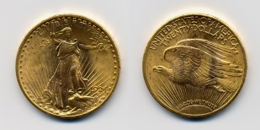](https://www.google.com/url?sa=i&rct=j&q=&esrc=s&source=imgres&cd=&cad=rja&uact=8&ved=0ahUKEwjVleKfkuPPAhVHYK0KHelpDg0QjRwIBw&url=https://en.wikipedia.org/wiki/Hard_money_(policy)&psig=AFQjCNEUqkLKteWVIZ2JfxiQXWtEKvASxA&ust=1476838493311858)

Spider - A frame of parallel bars or beams, typically in two sets arranged at right angles, in particular. For keeping skillets directly over heat for a long period of time, also called a gridiron.

[](http://www.google.com/url?sa=i&rct=j&q=&esrc=s&source=images&cd=&cad=rja&uact=8&ved=0ahUKEwj64bLznOPPAhVJbK0KHcIbAQwQjRwIBw&url=http://keepthehearthfiresburning.blogspot.com/2012_05_01_archive.html&psig=AFQjCNG2OOzJRyUWeCobQesYaHvdSd4jHw&ust=1476841244926014)

Spider swivel pot rack –

[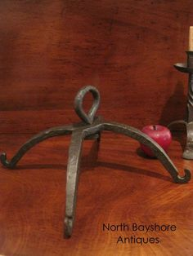](https://www.google.com/url?sa=i&rct=j&q=&esrc=s&source=images&cd=&cad=rja&uact=8&ved=0ahUKEwjjupOu393PAhWH4IMKHVHIAdsQjRwIBw&url=https://www.pinterest.com/pin/399553798166830509/&psig=AFQjCNELQI6qoVuWuZ7fXokjv931ViDHJg&ust=1476652864293345)

Spindler – A rod or pin, tapered at one end and usually weighted at the other, on which fibers are spun by hand into thread and then wound.

[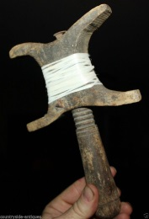](https://www.google.com/url?sa=i&rct=j&q=&esrc=s&source=images&cd=&cad=rja&uact=8&ved=0ahUKEwj6laL07N3PAhXk44MKHftWA-EQjRwIBw&url=https://www.pinterest.com/pin/537969117960815051/&psig=AFQjCNFVfCL4xKgaaonxhIC0UFvcmi1XEw&ust=1476656638448657)

Spinning wheel – A spinning wheel is a device for spinning thread or yarn from fibres. It was fundamental to the cotton textile industry prior to the Industrial Revolution.

[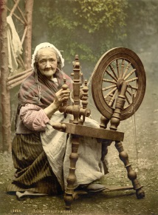](https://www.google.com/url?sa=i&url=https://en.wikipedia.org/wiki/Spinning_wheel&psig=AOvVaw0GZJgclNq_UF4WHePo4zg9&ust=1582680696826000&source=images&cd=vfe&ved=0CAIQjRxqFwoTCPjqhtXH6-cCFQAAAAAdAAAAABAD)

Spit—A long rod to stick through a piece of meat in order to cook it over a fire.

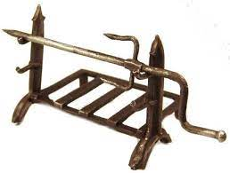

Staddle – A base, or lower part or supporting frame, of a stack of hay or straw.

[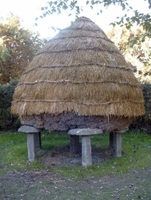](http://www.google.com/url?sa=i&rct=j&q=&esrc=s&source=images&cd=&cad=rja&uact=8&ved=0ahUKEwjz4LCj7t3PAhVJ0YMKHVGyBbQQjRwIBw&url=http://www.juniperhillfarmnh.com/2013/03/staddle-stones.html&psig=AFQjCNHDWe35yATe3w_WgvUeO9VFVmnzjA&ust=1476656972308245)

Staddle stone – a stone, especially one resembling a mushroom in shape, supporting a framework or rick.

[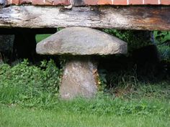](https://www.google.com/url?sa=i&rct=j&q=&esrc=s&source=images&cd=&cad=rja&uact=8&ved=0ahUKEwiPrqvA7t3PAhVG8IMKHThCBG0QjRwIBw&url=https://www.pinterest.com/bramblewood2/stone/&psig=AFQjCNEW1cJqFOQccQ6uNTUQtn0P3BLsDQ&ust=1476657082789916)

Stagg – A male animal castrated after sexual maturity, or a large adult male red deer.

Stake & stones – A small pile of stones with a stake in the center to mark a land boundry.

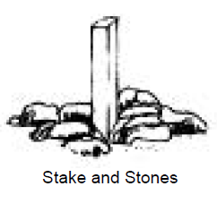

Stave - One of the narrow strips of wood that form the sides, covering, or lining of something (such as a barrel).

Still – An apparatus used to distill liquid mixtures by heating to selectively boil and then cooling to condense the vapor. A still uses the same concepts as a basic distillation apparatus, but on a much larger scale. The alcohol (ethanol) is separated from the base liquid.

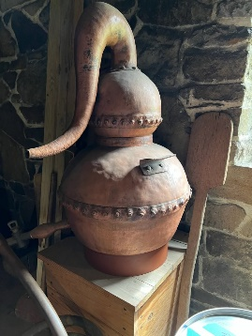

Stillart (stillard, stilyard) – Balance tool to weigh things.

[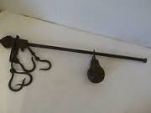](http://www.google.com/url?sa=i&rct=j&q=&esrc=s&source=images&cd=&ved=0ahUKEwjimM-A6N3PAhXipYMKHQ20AZQQjRwIBw&url=http://www.ebay.ie/sch/Antiques/20081/i.html?_sop%3D19%26_nkw%3Dscales&psig=AFQjCNGNjJmDQu9Dh9b8z_teF4DDx5Xv9Q&ust=1476655306591233)

Stock cards – A pair of cards, wooden paddles with metal teeth, used on a device to comb wool. This is to make sure all the fibers are untangled and aligned in one direction, making it easier to spin smoothly.

Stockings – Socks, typically knee high. Usually were made my knitting. Also called hose.

STR - Section - Township – Range. In U.S. land surveying under the Public Land Survey System, a section is an area nominally one square mile, containing 640 acres, with 36 sections making up one township on a rectangular grid. Townships are the horizontal rows and ranges are the vertical rows in the PLSS. Also known as the township range system or the rectangular survey system. This system used to identify and locate a parcel of land.

Sundial - An instrument showing the time by the shadow of a pointer cast by the sun onto a plate marked with the hours of the day.

[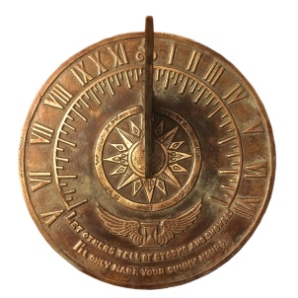](https://www.google.com/url?sa=i&rct=j&q=&esrc=s&source=images&cd=&cad=rja&uact=8&ved=2ahUKEwjx5fD9wozfAhVHOKwKHY04AjgQjRx6BAgBEAU&url=https://www.bellacor.com/productdetail/rome-industries-1820-brass-colonial-sundial-with-patina-finish-2059877.htm&psig=AOvVaw1-zbp1RD2W_uVe1oRmidyh&ust=1544231021155515)

Sugar tongs – Used to pick up a piece of sugar at the dinner table. Sugar was in the form of a sugarloaf or cone, where sugar nips or tongs were used to break off a piece.

[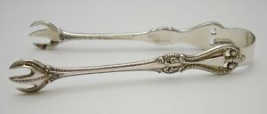](https://www.google.com/url?sa=i&rct=j&q=&esrc=s&source=images&cd=&ved=2ahUKEwjJ6rvh0M7iAhVUIjQIHTq_DR4QjRx6BAgBEAU&url=https://www.ebay.com/itm/VINTAGE-TOWLE-OLD-COLONIAL-STERLING-SILVER-SUGAR-TONGS-4-/252462740646&psig=AOvVaw2MIqpGhXzaufjfvrOd2G_n&ust=1559696583672809)

[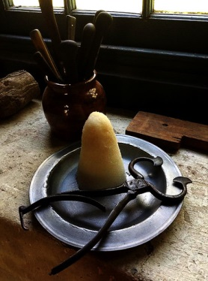](https://www.google.com/url?sa=i&rct=j&q=&esrc=s&source=images&cd=&ved=2ahUKEwjF6Mu01M7iAhVxLH0KHRj_CRgQjRx6BAgBEAU&url=https://worldturndupsidedown.blogspot.com/2013/05/how-to-make-colonial-era-sugar-cone-or.html&psig=AOvVaw0IyXJZiK4dvUPj4zcdEjZP&ust=1559697578412019)

Sulter – A civilian merchant who sold provisions to an army in the field, in camp, or in quarters, they sold wares from the back of a wagon or a temporary tent, traveling with the army or to remote military outposts. Orsman was a sulter in the Civil War, per his obituary.

[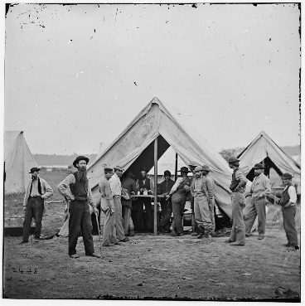](https://www.google.com/url?sa=i&rct=j&q=&esrc=s&source=imgres&cd=&cad=rja&uact=8&ved=0ahUKEwi1spKZ5-PSAhXD1IMKHfBMAXEQjRwIBw&url=https://en.wikipedia.org/wiki/Sutler&psig=AFQjCNG51BArdJcLv5ywDM-WgaIZXsvlCw&ust=1490055409486608)

Surety – A three party agreement that legally bonds together a principal who needs the bond, an oblige who requires the bond and a surety company (a third party) that sells (or holds) the bond; if the principal fails to perform in this manner, the bond will cover resulting damages or losses.

Swingle tree - A wooden or metal bar used to balance the pull of a draught horse or other draught animal when pulling a vehicle.

Tackling – An assemblage of ropes and pulleys arranged to gain mechanical advantage for hoisting and pulling.

Taffeta (also taffety or taffata) - A crisp, smooth, plain woven fabric made from silk

Tallow – Animal fat, used to make soap and candles, used in butter and as a lubricant.

[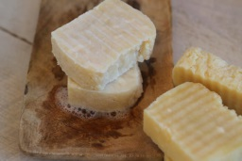](http://www.google.com/url?sa=i&rct=j&q=&esrc=s&source=images&cd=&cad=rja&uact=8&ved=0ahUKEwjiuPfW793PAhVF7YMKHT-dD6oQjRwIBw&url=http://www.theprairiehomestead.com/2016/01/tallow-soap-recipe.html&psig=AFQjCNFUOYd9OsaEqgmrwpRGa_9hIjETaA&ust=1476657394008664)

Tallow chandler – Person who makes and sells candles.

Tame hay – A type of grass used for hay, usually for feeding cattle.

[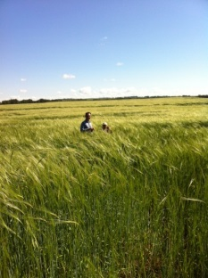](http://www.google.com/url?sa=i&rct=j&q=&esrc=s&source=images&cd=&cad=rja&uact=8&ved=0ahUKEwiI7vDayJrQAhVnyFQKHY01CuEQjRwIBw&url=http://www.agthings.com/listing/514/30%20quarters%20of%20Farm%20and%20tame%20hay%20land%20for%20sale.html&psig=AFQjCNHPtKXgARRFAL4OrRltJkWDCcJqhA&ust=1478742876520627)

Tammy - A plain-woven often glazed cloth of fine worsted or woolen and cotton formerly used for dresses, curtains, and linings.

Tankard – A mug for drinking a beverage from.

[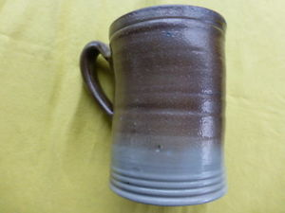](https://www.google.com/url?sa=i&rct=j&q=&esrc=s&source=images&cd=&ved=2ahUKEwi149286fHiAhVIiqwKHS8wCr4QjRx6BAgBEAU&url=https://www.ebay.com/itm/Williamsburg-Restoration-Colonial-Mug-Tankard-5-Tall-/152971752687&psig=AOvVaw1ZE-HgHQLyYDotvZW3hN-U&ust=1560905816128264)

Temporal – Relating to worldly as opposed to spiritual affairs (used as temporal estate).

Tenements - A piece of land held by an owner.

Tenor notes – Paper currency printed in Massachusetts Bay colony in 1704.

[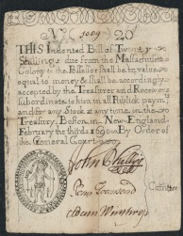](http://www.google.com/url?sa=i&rct=j&q=&esrc=s&source=images&cd=&cad=rja&uact=8&ved=0ahUKEwjXt5fy793PAhVl54MKHQIZAmkQjRwIBw&url=http://www.worldbanknotescoins.com/2014/10/colonial-currency-20-shillings-massachusetts-note-1690.html&psig=AFQjCNFXCnddGfoYaTTTe4meKZbnDv1ahg&ust=1476657467759840)

Testator – A person who has made a will.

Tick (bedding) - A simple sack, called a tick, is a mattress cover. Canvas woven from hemp, also called hurden or tow, was a likely choice for the tick.

[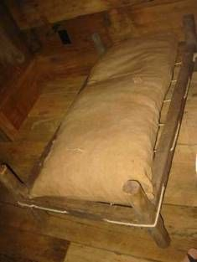](https://www.google.com/url?sa=i&rct=j&q=&esrc=s&source=images&cd=&cad=rja&uact=8&ved=2ahUKEwi8u7ezv4nnAhUP7awKHfZSDBcQjRx6BAgBEAQ&url=https://www.pinterest.com/pin/11610911509004070/&psig=AOvVaw10RXyhChO0ceZ8ERO3QRec&ust=1579311292909675)

Timber chain – Chain used wrap around a log so as to be able to drag it.

[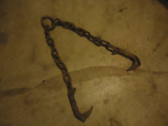](http://www.google.com/url?sa=i&rct=j&q=&esrc=s&source=images&cd=&ved=0ahUKEwi2oq2r993PAhUq04MKHVB4CbcQjRwIBw&url=http://www.ebay.tv/sch/Collectibles-/1/i.html?_sop%3D21%26_nkw%3Dlogging%2Bhook%26_frs%3D1&psig=AFQjCNFxTcFEL9SknUFvdotgpRLyuwUKGA&ust=1476659390214514)

Timothy – A grass like plant, basically a form of hay. Good for feeding horses. (Orsman grew this, he had 3 acres in 1895)



Tines (fork tines) –

[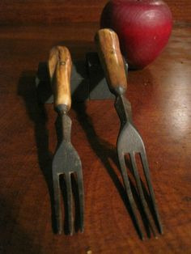](https://www.google.com/url?sa=i&rct=j&q=&esrc=s&source=images&cd=&cad=rja&uact=8&ved=0ahUKEwinxMD_8t3PAhVm8IMKHYHXDVIQjRwIBw&url=https://www.pinterest.com/stevenjebo/wrought-iron-primitives/&psig=AFQjCNE4umuAQAuvirFM-8jKp8lW86G-5w&ust=1476658294282762)

Tithing man – A church officer elected to preserve good order in the church, to make complaint of any disorderly conduct, and to enforce the observance of the Sabbath; collector of the tithes.

Toasting iron – Long handled iron utensil with brackets on the end to hold bread or other food to be toasted in the fireplace.

[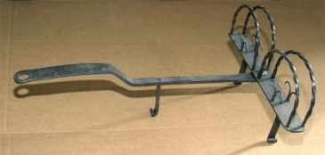](http://www.google.com/url?sa=i&rct=j&q=&esrc=s&source=images&cd=&cad=rja&uact=8&ved=2ahUKEwj_6OWsyfbhAhVBYKwKHY2HDZoQjRx6BAgBEAU&url=http://www.mtforge.com/Catalog/page1/pages/toaster.htm&psig=AOvVaw2TCAHkht30LorflJ1oQwid&ust=1556587369506110)

Tobacco tongs – Tongs used to grab an ember from the fireplace and then use it to light tobacco in a pipe.

[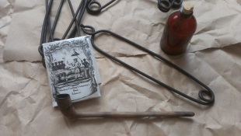](https://www.google.com/url?sa=i&rct=j&q=&esrc=s&source=images&cd=&cad=rja&uact=8&ved=0ahUKEwip2Obc1uXPAhUG7SYKHZ41CTIQjRwIBw&url=https://hautejuice.wordpress.com/2015/05/22/18th-century-tobacco-pipe-tongs/&psig=AFQjCNHe_G_nH8AXmc63KOwuK4OWUZYEUw&ust=1476925578216587)

-ton – The suffix of -ton is an Old English word meaning a farm or settlement.

Tough flax – Means it has a lot of water in it.

[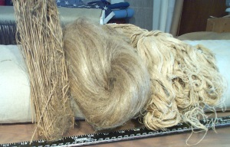](https://www.google.com/url?sa=i&rct=j&q=&esrc=s&source=images&cd=&cad=rja&uact=8&ved=0ahUKEwjhi42s-N3PAhUlxoMKHddDAmQQjRwIBw&url=https://www.pinterest.com/mustardseed/linen-n-flax/&psig=AFQjCNEx_b3FWRLS4BzOenq0jtSey1D4kw&ust=1476659725601186)

Tow yarn – Short or broken fiber, used for under layer or stuffing. Tow can also refer to short fibers of cotton or flax, used to make sheets or other cloth or linen items.

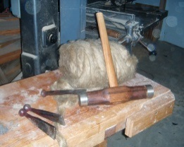

Tramill and hook – Used to hang a pot in a fireplace, an adjustable pothook.

[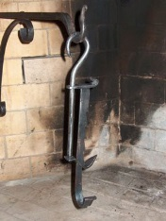](http://www.google.com/url?sa=i&rct=j&q=&esrc=s&source=images&cd=&ved=0ahUKEwjUs5zFyd_PAhVl44MKHVcCC4oQjRwIBw&url=http://www.rumford.com/store/cranes.html&psig=AFQjCNH9RU6yveMFD44iD_ryME4ISWEHXg&ust=1476715882585509)

Trammel – A shackle used to teach a horse to amble; something that restricts activity, expression, a restraint.

[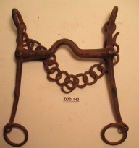](https://www.google.com/url?sa=i&rct=j&q=&esrc=s&source=images&cd=&cad=rja&uact=8&ved=0ahUKEwjH7ougy9_PAhXH6YMKHXNKAkAQjRwIBw&url=https://www.pinterest.com/jsoldwest/antique-unusual-western-horse-riding-bits/&psig=AFQjCNEuqqW-po-jww8HyuHIHRBa-wQIMg&ust=1476716270733665)

Treen/Treene – Wood, an item made of wood.

Trencher – In medieval cuisine, was originally a flat round of bread used as a plate, upon food was placed to eat. At the end of the meal, the trencher could be eaten but was frequently given as alms to the poor. Later, the trencher evolved into a small plate of metal or wood, typically circular and completely flat, without the lip or raised edge of a plate.

[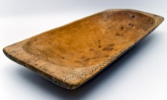](https://www.google.com/url?sa=i&rct=j&q=&esrc=s&source=images&cd=&cad=rja&uact=8&ved=0ahUKEwiUk4LFy9_PAhXl64MKHRXiCioQjRwIBw&url=https://www.pinterest.com/rosemaryjames/primitive-trenchers/&psig=AFQjCNFZ_F2aAPR_0AMfxDrN08zwNk2SeA&ust=1476716414096056)

Trevit - An iron tripod or bracket for a cooking pot or kettle to stand on.

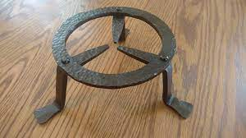

Trundle bed - A low bed that can be stored under a larger bed.

[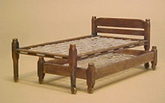](http://www.shakerworkswest.com/StandardLine.htm)

Turkey stone (in ring) – Turquoise.

Turkey work – A form of knotted embroidery practiced in England from the 16th century to the mid-18th century, but especially in the 17th century. Used for upholstery and table covers, it was worked in imitation of Turkish carpets, which are known from paintings to have been imported to England from the 16th century.

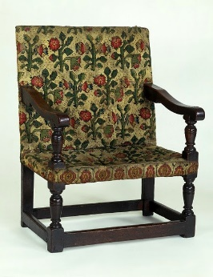

Upland – Land on higher elevation or perhaps hilly, lands that weren’t flood prone.

Vallaines – Variation of valance. A length of decorative drapery hung above a window to screen the curtain fittings.

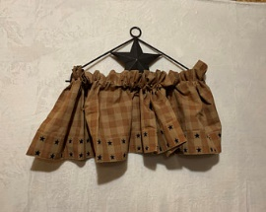

Vassal - A holder of land by feudal tenure on conditions of homage and allegiance.

Vessel – A heat resistant pot or bowl used for cooking or for boiling clothes.

[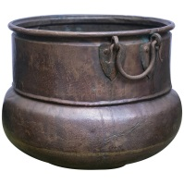](https://www.google.com/url?sa=i&rct=j&q=&esrc=s&source=images&cd=&cad=rja&uact=8&ved=0ahUKEwirkKubzN_PAhWs1IMKHd1IB9MQjRwIBw&url=https://www.1stdibs.com/furniture/building-garden/fireplace-tools-chimney-pots/material/copper/&psig=AFQjCNH_rk2xGQOxT7QTh_jyqlEx7GFsnQ&ust=1476716569693290)

Vinegar cruet – A vessel to hold vinegar.

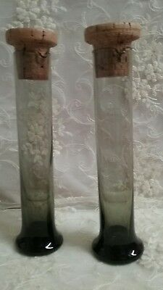

Viz – Namely; that is to say; as follows. Introduces examples, lists or items.

Wainscot - An area of wooden paneling on the lower part of the walls of a room.

Warming pan – Pan with handle used to hold hot embers or coals from fireplace, put into bed to keep bed warm.

[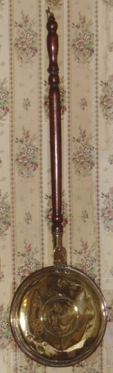](http://www.oldandinteresting.com/photocredit.aspx#beds)

Weir - a fence or enclosure set in a waterway for taking fish.

[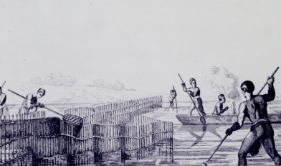](http://www.google.com/url?sa=i&rct=j&q=&esrc=s&source=images&cd=&cad=rja&uact=8&ved=0ahUKEwip-_Wyl83WAhUO4GMKHZ96AOYQjRwIBw&url=http://www.joyharriscooks.com/a-culinary-history-of-florida/&psig=AOvVaw2I6DXHSfVHRjP6D7o7fW9c&ust=1506870176317399)

Waescote (waistcoat) - A sleeveless upper-body garment. It is usually worn over a dress shirt and necktie and below a coat as a part of most men's formal wear. Also can be called a vest.

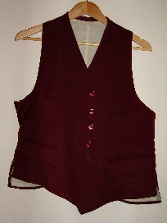

Whipletry (whipletree) – A pivot mechanism used to distribute force evenly; one use is a chain assembly for a team of horses; the swinging bar of a carriage or wagon, to which the traces of a harness are fastened, (to move quickly to and fro).

[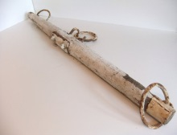](https://www.google.com/url?sa=i&rct=j&q=&esrc=s&source=images&cd=&cad=rja&uact=8&ved=0ahUKEwjQjLCgzt_PAhVG44MKHXR9BmgQjRwIBw&url=https://www.etsy.com/uk/listing/75584508/on-sale-antique-whipple-tree-wood-horse&psig=AFQjCNEddrb33pSo2pa2gJmjiiPP0Mfwkw&ust=1476717153036960)

Wimble - A long tool, like a great gimlet, with a cross handle, with which you turn it like a screw to make or drill a hole.

Winnowing cloth – Cloth used to filter something or to separate heavier/larger pieces from lighter/smaller pieces.

Whippletree chain – A whippletree is a pivoted or swinging bar to which the traces, or tugs, of a harness are fastened, and by which a carriage, a plow, or the like, is drawn. A single-tree can be a whipple-tree if the item being drawn is a one-horse implement, e.g. shay, sleigh, etc.

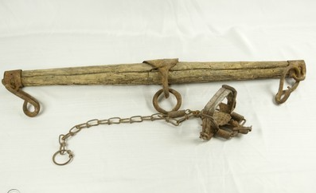

Wooling wheel - A small stick used for winding wool around when spinning.

[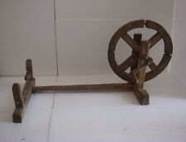](http://www.google.com/url?sa=i&rct=j&q=&esrc=s&source=images&cd=&cad=rja&uact=8&ved=0ahUKEwjit-WHz9_PAhVBw4MKHdYGDBsQjRwIBw&url=http://www.ebay.com/bhp/yarn-spinning-wheel&psig=AFQjCNFQPpoRZOSoLhjV-v33_ykvYDexhQ&ust=1476717215559750)

Wooling card - Most colonists didn’t have access to (or couldn’t afford) pre-made fabric, so they made their own, often from sheep’s wool. A key part of this process was carding, which involved pulling the wool fibers back and forth between two thin, rectangular boards (cards) covered with wire teeth. Carding removed tangles and ensured that all the wool faced the same direction, making it easier to spin it into thread.

Wooling yarn – Yarn made from wool.

Worsted comb – Comb used in preparing worsted wool. Worsted wool has the short fibers removed by combing and top preparation by gilling.

[](https://www.google.com/url?sa=i&rct=j&q=&esrc=s&source=images&cd=&cad=rja&uact=8&ved=0ahUKEwivrpGuoeHLAhUBaCYKHTZtCxUQjRwIBw&url=https://www.pinterest.com/PWM742/show-me-your-cards-and-combs/&bvm=bv.117868183,d.eWE&psig=AFQjCNHCCl4SgzEUukLFLLZLJoI0H5U5iw&ust=1459181591164761)

Wort – The sweet infusion of ground malt or other grain before fermentation, used to produce beer and distilled malt liquors.

Yearling - An animal (especially a sheep, calf, or foal) that is a year old or that is in its second year.

Yeoman – A person who owns and cultivates a small farm; one belonging to a class of English freeholders below the gentry.

Yoke staple & ring – A wooden beam used between a pair of oxen to enable them to pull together.

[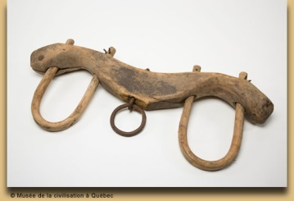](http://www.google.com/url?sa=i&rct=j&q=&esrc=s&source=images&cd=&cad=rja&uact=8&ved=0ahUKEwi5zOvQpd3PAhXDQCYKHYwECmYQjRwIBw&url=http://www.lewis-clark.org/article/3105&psig=AFQjCNEz57MhjP5Zmsm174OAVjQQ8Qoj0A&ust=1476637502524271)

**Abbreviations**

&c – etcetera, and so forth

do – ditto

gt – great

p – sometimes used as ‘per’ or ‘pre’, such as psonal (personal) or psents (presents)

pd – paid

pr – per or pair

pt – part, pint

qt – quart

sd – Said

Ss – *supra scriptum*, as written above, aforementioned.

towd – toward

Viz - The abbreviation viz. (or viz without a full stop) is short for the Latin videlicet, which itself is a contraction of the Latin phrase videre licet, meaning "it is permitted to see". It is used as a synonym for "namely", "that is to say", "to wit", "which is", or "as follows".

wch – which

wt – what

wth – with

Xt (Church of Xt) – Church of Christ

yds – yards

ye – the

ym – them

yn – than

yr – there

ys – this

yt - that

accot – account

comtee – committee

defendt – defendant

degr – degrees

hond – honored

no – number

pltf – plaintiff

rect – receipt