**Haplogroup L-161**

⚫ ⚫ ⚫ ⚫

The long history of DNA Haplogroup L-161.1

Isles A, Isles B, Isles C, Isles D

⚫ ⚫ ⚫ ⚫ ⚫

Tracing history from our pre-human ancestors down to the present time

A speculative extrapolation of the currently known facts

by J Danel

January 2019

(ver. 2019.1)

(This is a work in progress. Please send corrections and suggestions to jack@danel.us

**Introduction**

When someone gets back the results of a DNA test that shows L-161.1 as the haplogroup, one of the first questions is what does it mean. One quickly discovers that it means he is in a subgroup of Haplogroup I, the main group defining Germans and Scandinavians. That is probably a surprise because the subject’s male ancestors have probably been in Britain or Ireland as far back as is known.

Well, Scandinavians in Britain, eh? That means Viking ancestry, doesn't it? Sorry to disappoint. While for some subgroups of Haplogroup I it may mean that, but in the specific case of L-161, probably not. The L-161 group is very small. It is less than 1% of the population in general. So how did a tiny group of Germanic ancestry get to be widely dispersed throughout Great Britain and Ireland? I will try to answer that question.

**Who were these people?**

The original humans began almost 2 million years ago, eventually evolving into Neanderthals in Europe, Denisovans in Asia and early humans in Africa. About 250,000 years ago, people like us emerged and thrived in Africa. Their descendants spread out into Europe and Asia until the Mt. Toba eruption changed everything.

**They survived the Mt. Toba volcanic eruption**

The Mt. Toba eruption was the largest in the past 25 million years. It caused a centuries long "winter" and an enduring ice age that killed almost all the humans on earth. The survivors were a few modern humans, a few Neanderthals in Europe and a few Denisovans in Asia. Some humans in Europe and Asia held on for a while, but then later went extinct. The surviving haplogroups were A, BT, and CT, all located in Africa

**They migrated Out of Africa to Europe and became the Cro-Magnons**

The ice age after Mt. Toba lowered sea levels enough to allow Haplogroup CT to lead a small migration Out of Africa about 60,000 years ago. The track went across southern Arabia to the Tigris/Euphrates river and the Persian Gulf. There they found a well-watered paradise. The population expanded and more haplogroups emerged:, CT led to CF which led to F which led to IJ and I. Haplogroup I migrated north re-populating Europe and interbreeding with the Neanderthals. They came to be known as the Cro-Magnons. These people produced the famous cave paintings in Lascaux, France and the "Venus" figurines found from Spain to Siberia.

They are our ancestors. We are descendants of the Cro-Magnons and of the Neanderthals.

**They survived the ice ages and migrated northwest to Doggerland**

The Cro-Magnons flourished until driven out of northern Europe by the Late Glacial Maximum ice age about 25,000 years ago. Some haplogroup I took refuge in Ukraine. When the ice retreated, they migrated northwest to the productive lakes and marshes in Doggerland, an area three times the size of Ireland. Sometime before or during this migration, the SNP called L-161 developed.

  They enjoyed a comfortable mesolithic life in Doggerland for about 2,000 years. Then suddenly, with no warning, it was all over and most of them were dead. Three immense tsunamis wiped out most of the population in Doggerland and left it almost completely submerged. Other simultaneous events caused the climate to turn cold, sea level to abruptly rise 4 meters (13 ft.), and the food chain to collapse. There were only a few survivors. The whole catastrophe is called the "8.2 kiloyear event"

**They washed up on the shorelines and spread to Ireland and Scotland**

The few survivors of L-161 were split. One small group washed up on the shores of England becoming Isles A. They have remained in the British Isles ever since. Another group, Isles B washed up on the eastern shore and later migrated to Britain with the Bell Beaker folk. Isles B has since generated Isles C and D in Ireland.

  Isles A, Isles C, and Isles D are found almost exclusively on the northern and western fringes of Ireland and Great Britain, while Isles B is scattered more evenly across the whole area. This paper presents an explanation for that very peculiar distribution.

That is the very brief and over-simplified history of L-161.1

For more detail, I will start much further back, with the development of a creature called Proconsul.

**Table of Contents**

1. [Cover](http://s168543378.onlinehome.us/z/L-161_Cover.html)
2. [Introduction](http://s168543378.onlinehome.us/z/L-161_Introduction.html)
3. Table of Contents
4. [Pre-Humans](http://s168543378.onlinehome.us/z/L-161_pre-humans.html)
5. [Archaic humans](http://s168543378.onlinehome.us/z/L-161%20Archaic%20humans.html)
6. [Modern Humans](http://s168543378.onlinehome.us/z/L-161_modern%20humans.html)
7. [Early migration from Africa](http://s168543378.onlinehome.us/z/L-161%20early%20migration%20from%20africa.html)
8. [Out of Africa](http://s168543378.onlinehome.us/z/L-161_out%20of%20africa.html)
9. [Haplogroups F to I](http://s168543378.onlinehome.us/z/L-161_haplogroup%20f.html)
10. [Cro-Magnons](http://s168543378.onlinehome.us/z/L-161_cro-magnon.html)
11. [Neanderthals](http://s168543378.onlinehome.us/z/L-161_Neanderthal.html)
12. [Gravettian Culture](http://s168543378.onlinehome.us/z/L-161_gravettian.html)
13. [P37 and the Oldest Dryas](http://s168543378.onlinehome.us/z/L-161_p37%20dryas.html)
14. [M423](http://s168543378.onlinehome.us/z/L-161_m423.html)
15. [L-161, our ancestral haplogroup](http://s168543378.onlinehome.us/z/L-161_L161.html)
16. [Doggerland disaster](http://s168543378.onlinehome.us/z/L-161_Doggerland.html)
17. [Recovery from disaster](http://s168543378.onlinehome.us/z/L-161_recovery.html)
18. [Isles haplogroups in Albion](http://s168543378.onlinehome.us/z/L-161_Isles.html)
19. [The Bell Beaker invasion](http://s168543378.onlinehome.us/z/L-161_Bell%20Beakers.html)
20. [500 years of catastrophe](http://s168543378.onlinehome.us/z/L-161_500%20yrs.html)
21. [Current situation](http://s168543378.onlinehome.us/z/L-161_Current.html)
22. [Climate, Culture, and Volcanic events](http://s168543378.onlinehome.us/z/L-161_Climate%20etc.html)
23. [Haplogroup list](http://s168543378.onlinehome.us/z/L-161_Hg%20list.html)
24. [Timeline](http://s168543378.onlinehome.us/z/L-161_timeline.html)

**Our Pre-Human Ancestors**

Our oldest known ancestor

25 million years ago, there was a small primate known as Proconsul. There is wide, but far from unanimous, agreement that Proconsul may be our oldest yet known ancestor. Proconsul was very apelike and it was also very small - about 10 kg. or 22 lbs.

Branching off of the apes.

Proconsul survived and evolved slowly* into larger primates. Now and then a group would branch off and go on a separate evolutionary path of their own. Monkeys branched off about 40 million years ago, long before Proconsul existed. We did not descend from monkeys. We all descended from Proconsul or from another creature very much like him.

16 million years ago - The first to go (and survive) were the Hylobates that have evolved into modern gibbons.

14 million years ago - The Pongo group left, evolving into modern orangutans.

12 million years ago - The gorillas separated.

7 million years ago - The Pan group - evolving into chimpanzees and bonobos - separated.

5.5 million years ago - Founding of Ardipithecus ramidus

Ardipithecus was the first bipedal hominin and the first to begin to develop language abilities.

5 million years ago - Founding of the Australopithecenes

Australopithecus generated several dead-end branches, but Australopithecus anamenis seems to have evolved into the A. afarensis that left us the famous fossil "Lucy".

3.2 million years ago: "Lucy", the famous Australopithecus afarensis

It is thought the A. afarensis lived over a wide area in East Africa. Fossils and footprints have been found many places, but the best fossils were found in the Afar Region of Ethiopia. Some of them may have used the Lomekwi culture of stone tools found near Lake Turkana, Kenya. There is debate as to whether A. afarensis is actually a different species from the preceeding A. anamensis. If they are the same, then the date is pushed back to about 5 million years.

Lucy was about 1,300 mm tall or roughly four feet. Evolution has very, very slowly increased the height of these creatures by about 1,000 mm over a span of 20,000,000 years. That is about one millimeter every twenty thousand years.

2.5 million years ago: Australopithecus africanus lived in southern Africa.

Until recently, there has been no consensus that A. africanus is a human ancestor except for the convenient time located about halfway between A. afarensis and Homo habilis, but a very recent discovery of A. africanus fossils seems to support that placement.

2.5 million years ago: Australopithecus garhi lived in Afar, Ethiopia.

A. garhi fits neatly into a time slot located about halfway between A. afarensis and Homo habilis and is from the same area.

**Archaic Humans**

2.8 million years ago: Homo habilis, an ancestor of Homo sapiens lived.

Homo habilis developed the Oldowan technology for making stone tools. Habilis lived in Africa and was possibly descended from Australopithecus africanus or A. garhi.

1.9 million years ago: Homo erectus (1.9ï¿½0.07 Ma) emerged in Africa and spread widely.

He was an ancestor of Homo sapiens. This was a very successful creature surviving for almost 2 million years over a broad range in Asia (Java Man, Peking Man), Europe, and Africa until as recently as 70,000 years ago. That date suggests the Mt. Toba eruption may have caused the demise of the Erectus.

Erectus developed the Acheulian stone tool technology and used it for about 1.7 million years. They used spoken language and the ability to use fire. They had dark hairless skin, rich in melanin, and abundant sweat glands that evolved about 1.2 million years ago to regulate body temperature.

800,000 y.a. __Footprints left by H. antecessor

Footprints left by a group of people, including several children and one adult male, have been found at Happisburgh on the coast of Norfolk, England.

700,000 y.a. __Homo heidelbergensis

Heidelburg Man emerged in Europe from H. erectus. Heidelburgensis lived in a wide range across Europe from England to Asia and into Africa where a more recent form is known as H. rhodesiensis. Modern man emerged in Africa, so our ancestor was H. rhodesiensis. The European H. heidelburgensis developed the Mousterian technology that was later used by the Neanderthals who then taught it to the early Cro-Magnons after they arrived in Europe. (Modern science holds that H. heidelburgensis and H. rhodesiensis are the same. The two names are geographical and do not refer to different species.)

500,000 y.a. __Proto-Neanderthals branched off from H. heidelburgensis in the Middle East.

400,000 y.a. __The Proto-Neanderthals split into two groups during the severe Saale ice age.

The western group became the Neanderthals who later shared Europe with, and learned the Mousterian stone tool technology from, Heidelburgensis. The eastern group migrated into Asia where they became the Denisovans.

270,000 y.a. __Perry's DNA suggests modern humans were emerging 270,000 years ago

This discovery has caused the geneticists to assign new names to the early haplogroups. Haplogroup A used to be the oldest, but now A00, A0-T, and A0 have been added to accommodate the Perry findings. Haplogroup A00 probably developed from Rhodesiensis which is the same as Heidelburgensis.

Intelligence of the Archaic humans: Homo erectus is estimated to have had an IQ of between 50 and 60, based on brain size and on tool making abilities. Modern humans have an IQ around 100. Over the past 2,000,000 years, we have gained 40 points. That is about 1 point each 50,000 years. That means we are only 6 points smarter than Neanderthals, only 4 points smarter than the Omo people - the first AMH - and only one single point smarter than the Cro-Magnons. A difference that small is very hard to measure.

**Modern Humans**

270,000 y.a. __Perry's DNA suggests modern humans were emerging before 270,000 years ago.

Anatomically Modern Humans, abbreviated AMH, developed. These may have now been classified as Haplogroup A00.

There were two enormous volcanic eruptions over a span that includes the AMH emergence. The eruptions were Haroharo, 280,000 y.a. and Whakamaru, 254,000 y.a. Two such enormous eruptions had worldwide effects on the flora and fauna and on the evolution of humans. The "volcanic winter" lasting centuries would have pruned the family tree back to a few especially hardy and well-situated bands, so 'founder effects', the driver of evolution, was a major factor in the emergence of the AMH.

195,000 y.a. __The Omo Kibish people were living in Africa.

Fossils 195,000 years old have been found at the Omo Kibish site in Ethiopia. These are the oldest AMH fossils found so far. Eventually it may be proven that these the founding Haplogroup A0 fossils. (Perhaps there should be a term Homo sapiens omo for these people).

190,000 y.a. __The first(?) of several migrations of modern humans from Africa

They took the northern route across the Sinai. These modern humans colonized much of Eurasia during several of the long wet periods in the 20,000 year long North African climate cycle, leaving fossils that present intriguing questions about interbreeding and development of these early modern humans.

185,000 y.a. __Modern(ish) humans were living in Misliya cave near Haifa, Israel.

160,000 y.a. __Homo sapiens idaltu , modern humans, developed.

The fossilized remains of H. s. idaltu were discovered at Herto Bouri near the Middle Awash site of Ethiopiaï¿½s Afar Triangle. These specimens are argued to represent the direct ancestors of modern Homo sapiens sapiens. They were AMH - Anatomically Modern Humans. They were not the knuckle-dragging stereotypes of 'cavemen', but were esentially just like us. There were some differences in their bones, their skin was brown, blonds were very rare, and blue eyes did not exist.

Founded as Haplogroup A, continuing diversification of the gene pool led them through the sequential development of Haplogroups A1 and A1b.

133,000 y.a. __End of the Saale ice age. Beginning of the Eemian Interglacial Warm Period.

133,000 y.a. __Start of the Abbassia Pluvial wet period in the Sahara

It was a wet period that caused the Sahara and the Sinai to bloom with lush vegetation fed by lakes, swamps, and river systems. This unblocked the route north out of Africa. The route stayed open for 30,000 years. These wet cycles occurred several times and are the basis of the "Sahara Pump Theory" about how the earlier people were able to cross what is now a very harsh route out of Africa several times in relative comfort.

125,000 y.a. __Modern humans living outside Africa

Modern humans were living in Qafzeh and Es-Skhul caves near Nazareth and Haifa, Israel and at Jebel Faya, 40 km southeast of Dubai. The Skhul/Qafzeh hominids had died out by 80,000 years ago because of drying and cooling conditions of the Weichselian ice age.

115,000 y.a. __The " Last Glacial Period ", the lethal Weichselian Ice Age began its advance.

This long, extremely severe ice age drove all of the human settlements of the various earlier "Out of Africa' migrations to extinction. They left fossils, tools, and archaeological evidence, but no known surviving descendants except for perhaps a few hybrid Neanderthals in Europe and, in Asia, some Denisovans and H. erectus groups.

Meanwhile, back in Africa:

115,000 y.a. __Haplogroup BT emerged from Haplogroup A1b.

100,000 y.a. __Haplogroup CT evolved from Haplogroup BT

**Early Migrations from Africa and the Mt. Toba Catastrophe**

The first migrations of modern humans from Africa were complete failures.*

There were probably many early migrations out of Africa - Misliya, Qafzeh, Es-Skhul, Jebel Faya, and others yet undiscovered - but they all eventually failed. The extremely severe Weichselian ice age and the Mt. Toba eruption exterminated all the earlier migrants. They left fossils and archaeological sites, but no descendants except a few hybrid Neanderthals, Denisovans and a few Homo erectus.

Beginning about 200,000 years ago small groups of Idaltu type people - Haplogroups A, A1, and A1b - began to find a way out of Africa. They moved out on the northern route across the Sinai as suggested by the "Sahara Pump Theory". The warm, moist conditions of "Abbassia Pluvial" type climate periods made that area much less formidible than it is today. It is not known whether the climate changes triggered the movements or just made it possible. These small migrations continued for at least 130,000 years. They spread to India and on to southeast Asia by 80,000 years ago.

The competition and the struggle for survival may have been fierce and deadly. The space they were moving into was occupied by several varieties of genus Homo entrenched there, in some cases, for more than a million years. Homo Erectus still thrived, as did Heidelbergensis, Neanderthals, and Denisovans. These were all serious competition.

Mega-fauna as food sources included: woolly mammoth, steppe mammoth, straight-tusked elephant, aurochs, steppe bison, Irish elk, equus, and Elasmotherium, but these are all large and dangerous to hunt with just primitive weapons such as spears and clubs.

There were many hazards including dangerous predators that hunted the migrants. These included: wolf, cave lion, cave bear, cave hyena, saber-toothed tigers, and giant polar bears among others. Other hazards included a new assortment of deadly germs, poisonous plants, and insects.

Life for these pioneers would never have been easy and then things got very much worse.

75,000 y.a. __The Mount Toba eruption was the largest volcanic eruption of the last 25 million years.

A vast amount of ash and noxious gases (six gigatons of sulfur dioxide and 3,000 cubic kilometers of rock) were emitted, causing extinctions of food sources and decades of famine. It was also a significant contributor to the thousand year long cold period that followed.

It caused extinction of Homo sapiens outside of Africa. The number of humans was reduced to a very small population of between 1,000 and 10,000 breeding pairs, total, worldwide. The population reduction did not happen instantanously. Most of the few survivors were scattered from Ethiopia to southern Asia at an average population density less than one person per mile. Many surviving groups were well below the population threshhold necessary to survive in the ordinary course of events. Maintaining a tribal life and finding mates would have been very difficult, inbreeding would have been rife, so they slowly went extinct.

One ironic effect was that predators and competitors were also very much reduced, allowing the following "Out of Africa"* migration to be resoundingly successful. Haplogroup CT, migrating from Africa, found itself to be the new 'Top Predator' in the new low-competition environment of southwest Asia. Repopulation of Asia and Europe began with the descendants of Haplogroup CT.*

* That is the "Out of Africa" theory or "Recent African Origins (RAO)" hypothesis. One of the many varied counterclaims is that some groups in southeast Asia, upwind of Mt. Toba, survived and that from there a migration to the west resulted in the modern human population of Europe and Asia and of Haplogroup E in Africa. This could be called the "Out of Indochina" model. Another is that survivors everywhere all simultaneously evolved into H. sapiens. It is called the "Multiregional" model. There are other models. This is a subject of heated argument.

**Out of Africa**

The Mt. Toba catastrophe reset the competitive arena for most of the fauna. That had major effects, not just in the near-extinction of the modern humans, but also on the populations of Homo Erectus. Homo Heidelburgensis, Neanderthals, Denisovans and other inhabitants of Asia and Europe. It may have been the cause of the final extinction of Homo Erectus and others of these groups.

Furthermore, the populations of the large predators - saber-toothed cats, cave bears, etc. - were sharply reduced. Some went extinct. The smaller prey animals were also reduced, but in the new low-predator environment they rebounded quickly. Plants also quickly rebounded, taking advantage of the soil improvement by the volcanic ash.

The competitive situation greatly improved. Food was abundant and the competition was low. Now, Haplogroup CT as the new top predator was unchallenged in its new invasion* of southern Asia.

* The word 'invasion' drastically overstates the case. It was a small group or probably several small groups spread out over a considerable period of time. In an attempt to figure out how many individuals there might have been, the variation in mito-DNA was studied. The result suggests that there were only about 600 females who survived to be sucessful breeders, so the combined total size of the groups would be about 2,000: 600 men, 600 wives, 500 other women, and say 300 children, many of whom would not live long enough to make an impact. A paleolithic paradise was still a brutal place.

70,000 y.a. __The recent, successful main migration Out of Africa began via the southern route.

50,000 y.a. __The wet, warm climate of the Mousterian Pluvial was a favorable environment.

The much lower sea levels, as much as 200 feet lower, during this time allowed the small groups to cross the Bab el-Mandeb Strait to Arabia. Then they travelled through the warm and verdant "Green Arabia" or they followed the coastline eastward to the Persian Gulf and the Indus river. These modern humans colonized much of southern Asia.

The early migrants were mainly Haplogroup CT. Several new groups quickly emerged and diverged from CT to become extremely successful in the bountiful enviroment:

C - most went to southern India, Indo-china, Indonesia, and Australia, but some went to Europe.

D - went to southern China and on to Japan

E - returned to Africa where E-P147 became the predominant haplogroup

F - the ancestor of L-161, took up residence in the Ur-Shatt and Indus river valleys.

**Haplogroups F to I**

60,000 y.a. __Haplogroup F emerged from Haplogroup CF. (SNP M89, defines Haplogroup F)

Haplogroup F may have developed in the Tigris/Euphrates delta in the Ur-Shatt, or old Shatt river valley.

In that part of the Weichselian ice age, the sea level was about 200' lower, so the Persian Gulf was dry land to the south past the Strait of Hormuz. The area was a well watered plain surrounding fresh-water lakes. There were abundant resources to support hunter-gatherers. It was a paleolothic paradise.

Haplogroup F was very successful.

After its founding, perhaps in the Ur-Shatt, F spread out to occupy most of southwest Asia and Arabia. Many small groups formed and migrated outward following the coast and the rivers. These groups evolved into 14 of the main haplogroups known today. Haplogroup F is ancestral to about 90% of non-African men worldwide.

55,000 y.a. __Haplogroup F diverged through stages to Haplogroup IJ

Haplogroup F occupied an immense amount of real estate, including Arabia, Persia, and most of India. Haplogroup IJ developed somewhere in the north-western end of that huge area. Considering the dry climate, water resources would have been critical. They would have found good conditions in the area between the Tigris and Euphrates, the area now encompassing Baghdad, Tehran, and Kurdestan.

Groups G, H, and K branched off and are not ancestors of L-161.

50,000 y.a. __The Glinde and Moershoofd Interstadial warm period began

50,000 y.a. __The Mousterian Pluvial warm wet period began

45,000 y.a. __Haplogroups I and J split from IJ in Persia.

The group that would become Haplogroup I went northward up the Tigris and Euphrates rivers through Anatolia, then split going around both sides of Lake Pontus, the Black Sea in a fresh water phase. From there they re-populated Europe during the 10,000 year long Glinde-Moershoofd warm period. The timing was from from 50,000 to 39,400 years ago. (J spread from Kurdestan mostly to the south and west, populating the entire eastern and southern Mediterranean region.) There are still significant populations of subgroups of I and J remaining in Kurdestan and Fars province. Here is a link to a map of the modern distribution of Haplogroup I2a2. The modern distribution clearly surrounds the North Sea, formerly 'Doggerland'. (SNP M-170 defines Haplogroup I.)

45,000 y.a. __ Cro-Magnons, an early group of Haplogroup I, colonized Europe.

The distribution maps suggest that Haplogroup I1 - M253 went to the east of the Black Sea to the far north and then were driven back south (up the Rhine, down the Danube) into the Balkan Refugium by the return of the ice about 28,000 years ago.

L-161 ancestors, the Cro-Magnons of Haplogroup I2 - M438, went west of the Black Sea and north to the area that is now Ukraine and Moldova.

From there, they populated most of Europe. When the ice returned, the various Haplogroup I tribes took refuge in all three main refugia, but our ancestral groups were those P37 and M423 who survived in the Ukraine Refugium.

**Cro-Magnons** (inserted from v2 doc, web site link for this section quit working)

Cro-Magnons arrived in a Europe before 43,000 y.a. There were no other hominids except for Neanderthals. Cro-magnons began leaving archaeological evidence spread over the entire continent.

43,000 y.a. They occupied_Grotta del Cavallo in Liguria Italy.

43,000 y.a. They occupied Kent's Cavern in England

40,000 y.a. They reached Mamontovaya Kurya in the Russian Arctic.

33,000 y.a. __Cro-Magnons domesticated dogs in Russia at the Kostenki site.

32,000 y.a. __Cave paintings dating from the Aurignacian at Chauvet Cave in France.

37,800 y.a. __Pestera cu Oase cave in Romania near the 'Iron Gates' and many others.

38,000 y.a. __Cro-Magnons developed the Aurignacian stone tool technology. In many of the locations, there was evidence of occupation by both Cro-Magnons and Neanderthals, though perhaps not at the same time.

**Our ancestors, the Neanderthals**

Neanderthals and Cro-Magnons shared Europe for less than 20,000 years. The estimates of total Neanderthal population vary from as many as 70,000 to as few as 3,000.

The Neanderthals used the Mousterian technology and, in western Europe, were improving on it: there were localities in France using Chatelperronian and in Italy using Uluzzian improvements. In contrast, the Cro-Magnons were still using the more primitive Acheulian technology developed by H. Erectus.

50,000 y.a. __Neanderthals met the Cro-Magnons arrriving in the Caucasus.

Neanderthals taught the Cro-Magnons the Mousterian after they arrived in Europe. The Cro-Magnons then used Mousterian for several thousands years.

38,000 y.a. __Cro-Magnons developed the Aurignacian stone tool technology.

After the Cro-Magnons learned the Mousterian, they improved on it developing the Aurignacian technology from 38,000 to 29,000 years ago. The Cro-Magnons spread the Aurignacian all across Europe, including teaching it to the Neanderthals. It was a continent-wide cultural exchange.

38,000 y.a. __Neanderthals inter-bred with Cro-Magnons

DNA shows there was significant inter-breeding with Neanderthals near the Caucasus about this time. The result is that present-day humans of European stock have two to four percent Neanderthal DNA.

  A high percentage of the DNA of Neanderthal origin is the Caucasus variety from the area of first contact. It is estimated that 70% of our immune system is inherited from the Neanderthals. Some of the fossils from the Pestera cu Oase cave in Romania are 50% Neanderthal.

  The Cro-Magnon population was very low at the start. It would take only a few intermarriages to achieve a high percentage. As the tribes continued to migrate northwest, continued intermarriage would result in the DNA percentage growing slowly until all the Neanderthals were intermarried and absorbed into the Cro-Magnon tribes. Then, continued arrivals of more Cro-Magnons would dilute the percentage and it would slowly decrease. This means that the early percentage was much higher than the current 2-4%. This leads us to one almost inescapable conclusion:

The Neanderthals did not go extinct. They were completely absorbed by the Cro-Magnons.

A number of suggestions have been made as to how the technology exchange and the DNA exchange happened. They include rape, kidnapping, etc., but none of these would provide anywhere near enough DNA to get to 4% and they would not achieve the inter-group teaching that clearly occurred.

One reasonable explanation is that it may have been a result of exogamous, patrilocal marriage practices generally used by hunter-gatherers world-wide, including both the Cro-Magnons and Neanderthals.

In these inter-marriages, Neanderthal brides would marry Cro-Magnon men. They would come to live with the husband's family and bring her knowledge of the Mousterian with her. She would teach the husband's family the better methods. This was how the Cro-Magnons first learned the Mousterian. Later on, after the Aurignacian was developed, Neanderthal husbands learned the improved Aurignacian technology from their Cro-magnon wives. This hypothesis provides a workable mechanism for significant amounts of both the cultural exchanges and the DNA exchanges to have taken place. It also suggests the reason for the disappearance of the Neanderthals could be that they interbred with the Cro-Magnons until there were no Neanderthals left.

**The Gravettians, the EEMH, and the LGM**

30,000 y.a. __EEMH (Early European Modern Humans) develop the Gravettian culture.

(The term 'Cro-Magnon' is no longer used for people living after the end of Aurignacian.)

The Gravettian was the culture developed from the Aurignacian. People during the Gravettian period used nets to hunt small game and small pointed blades for big-game hunting (bison, horse, reindeer and mammoth). They are noted for their many carvings of 'Venus figurines'.

The Gravettian was spread from Ukraine to Spain probably by Haplogroup I . The area was so large that the culture developed a western version in France and an eastern version for Central Europe and Russia.

28,000 y,a. ___End of the Denekamp warm period. The ice returns with a vengeance.

24,500 y.a. __Maximum ice coverage (LGM).

All northern European populations were driven south where they survived living in "refugia". There were three main refuge areas: Ukraine, Balkan and Iberian.

Life in the refugia may have been very difficult.

All of the Rev. Malthus dire predictions may have prevailed in these over-populated areas that also had severe, but not lethal climates. One would expect disease, starvation, and war, resulting in a Malthusian catastrophe. The catastrophe would return population to a lower, more "sustainable", level. One outcome would be 'Founder Effects', which we see in the diversification of haplogroups and in the spread of pale skin.

20,000 y.a. __End of the LGM. The Meiendorf Interstadial warm period begins.

The populations cooped up in the refugia expanded in a 'demic diffusion' into new territory made habitable by the retreat of the glaciers and the alleviation of the 'polar desert' environment as the climate improved during the Meiendorf.

  Our ancestors followed the animals north into new territory and, unwittingly, into a climate trap. The short warm period was quickly followed by the 'Oldest Dryas', a lethal return of the ice, killing most and forcing the few survivors back into the refugia.

**The 'Oldest Dryas' Ice Age**

Haplogroup P37 and the second major extinction period

20,000 y.a. __Meiendorf Interstadial warm period began.

20,000 y.a. __Haplogroup I2a1, called 'P37', originated near the Danube river delta.

Founded during the rather short (1,000 yr.) Meiendorf Interstadial warm period, various Dunbar groups of P37 spread quickly westward up the Danube and north up the various Ukrainian rivers. The timing of the move north was unfortunate since the next climate change was a quick change to a very severe cold period - the Oldest Dryas - and they could not survive there. Those who went up the Danube fared better because the Danube valley and the Dalmatian coast provided a refugium of sorts. Those who stayed in the Ukraine refuge dug in and held on. (SNP P37.2 defines this group)

19,000 y.a. __Oldest Dryas ice age began producing a very severe cold climate

The Oldest Dryas was the second major extinction period in human history. It was the coldest and most lethal of all the ice ages. A treeless "polar desert" developed across Europe with a 500 km (300 mile) wide band similar to Arctic tundra between the ice and the habitable zone. The onset of the cold was severe enough and fast enough that most of the northern populations died before they were able to migrate south to the refugia. The total population was reduced by more than 75%.

P37 was split into many subgroups surviving the extreme climate in isolated valleys along the length of the Danube and in the Ukraine refugium. It developed two major splits. M423 emerged in the Ukraine refugium and M26 emerged in eastern France. There were also several small splinter groups.

18,500 y.a. __M-423 emerged from P37-east

The founding of Haplogroup I2a1b happened during the Oldest Dryas ice age, so it must have happened in or near the Ukraine refugium. (SNP M423 defines this group)

18,000 y.a. __The few survivors all retreated to the various refugia

The very severe climate lasted almost 4,000 years. In the refugia, once again the Malthusian catastrophe of too few resources for too many people played out. The Haplogroup I population was reduced to just eight haplotypes.

18,000 y.a. __One of the 'Founder Effects' was the development of the genes for pale skin

It is the mutation of two genes - SLC24A5 and SLC45A2 - that leads to depigmentation. (These genes are different from the genes that cause Albinism: OCA1, OCA2, and OCA3). Pale skin originated in a subset of the population in the (probably) Balkan refuge. The trait spread slowly throughout the population.

14,700 y.a. __End of the Oldest Dryas ice age. Start of the Bï¿½lling-Allerï¿½d warm period

14,500 y.a. __M26-Sardinian branched off from P37 in southern France

13,000 y.a. __L621-Dinaric branched off P37, perhaps near the Danube delta

**Haplogroup M423 to L161**

Most of modern Haplogroup M423 descendants are in the Balkans. Another 10% is spread out over eastern Europe. These groups are shown as the yellow tracks in the diagram. The tiny remainder are the Disles and L161 Isles haplogroups in Britain, shown as the green line.

18,200 y.a. __ Haplogroup M423 emerged from P37 in the Ukraine Refugium

The founding was in the midst of the extremely severe Oldest Dryas ice age, so it must have happened in a refugium. There is some disagreement as to whether it was the Balkan refugium or the Ukraine refugium. It could have been either one, but the complexities of getting the P37 up the Danube to found M26 in western France and then get M423 back down the Danube (leaving no trace) to found the Dinaric and L161 in the Ukraine refugium is a very complicated scenario. The simple scenario is that P37 was spread out over both the upper Danube and the Ukraine refugium at the same time.

14,670 y.a. __End of the Oldest Dryas ice age; the Bølling-Allerød interstadial, begins.

The Bølling-Allerød warm, moist period only lasted 1,750 years with a very brief interruption by the Older Dryas cool period. Of the two warm periods, Bølling and Allerød, the Bølling is the warmer and came on more suddenly. The duration was quite short, but the impact was immense: sea level rose about 35 m (100 ft.!) due to glacial melt. Ice uncovered large parts of northern Europe and temperate forests covered Europe from 29 deg. to 41 deg. north latitude. During this time, late Pleistocene animals quickly spread northward from refugia: reindeer, horse, saiga, antelope, bison, woolly mammoth, wooly rhinoceros, red deer, and smaller animals, such as fox, wolf, hare and squirrel. They were immediately followed by hunting groups that, over the next thousand years, developed the 'Hamburg' reindeer hunting culture.

13,700 y.a. __The relatively mild Older Dryas cold period lasted about 200 years.

13,500 y.a. __Hamburg culture was established in the north German plains.

The 'Hamburg' (a nomadic reindeer hunting culture) evolved into the similar Ahrensburg culture. The earliest archaeological finds of bow and arrow artifacts are from the Ahrensburg.

13,400 y.a. __SNP Y3104 emerged from M423, perhaps as a separate branch.

The location was probably somewhere northwest of Lake Pontus (the Black Sea in a freshwater phase). The founding during the Allerod warm climate phase allows for many geographic possibilities from Ukraine to northern Germany.

10,600 y.a. __Haplogroup L-161 branched off from M423 (or Y3104) during the northern migration.

The founding location is very uncertain. It could have been anywhere from the Ukraine refugium to Doggerland, but northern Germany seems most probable.

**Haplogroup L161**

13,400 y.a. ___SNP Y3104*, a descendant of M423 was formed.

The location was probably northwest of Lake Pontus (the Black Sea in a freshwater phase). There were five major river deltas in that area, so the environment for hunter-gatherers was ideal. The founding was in the Allerod warm climate phase, so the geographic possibilities for the location are numerous. (* SNP Y3104 defines this group, but recent posting by the ISOGG shows Y3104 as a branch away from our line.)

12,900 y.a. ___The Younger Dryas little ice age begins abruptly.

There is evidence that it was perhaps caused by a collision with a comet, and perhaps compounded by one of the drainages of Lake Agassiz. The sharp cold lasted 1,300 years, but was not as severe as the Oldest Dryas. Some small groups were able to 'winter through' and survive in small villages as far north as Hamburg Germany. Most, however, were driven back into the refugia. The 'Grandfathers Path' graphic shows L-161 as being north of the edge of the Ukraine refugium after the Younger Dryas.

11,660 y.a. __ End of the Younger Dryas

11,660 y.a. __End of the Paleolithic - Beginning of the Mesolithic

The difference between the paleolithic and the mesolithic is based on their technology and lifestyle. Paleolithic peoples used crude stone tools made by chipping and lived nomadically in crude shelters and caves. In the mesolithic, better stone tools were shaped and polished by grinding, pottery was coming into use, and some permanent housing structures were built.

11,500 y.a. __As the glaciers retreated, M423 migrated northward from the Ukraine Refugium.

The rivers leading northward from Ukraine allowed these migrants to reach the shores of a freshwater lake called Lake Ancylus (the Baltic Sea in a freshwater phase).

11,000 y.a. __The Maglemosian culture was established around Lake Ancylus and in Doggerland.

11,000 y.a. __The hair color gene MC1R causing blond hair developed in northern Europe.

10,600 y.a. ___Haplogroup I2a1a2a now known as L-161 branched off from M423.

L161 was founded somewhere between Ukraine and Doggerland, but it is not at all clear where that happened. The warm climate would have allowed hunter/gatherers to travel far to the north and westward along the shore and into Doggerland, a huge marshland three times the size of Ireland where the mesolithic lifestyle was relatively easy. (SNP L-161.1 defines this group)

10,000 y.a. __A genetic mutation in one woman caused blue eyes in some of her descendants.

9,000 y.a. __Post-glacial re-population of Ireland began in Cork across a landbridge

Several subgroups of Haplogroup I2a coming north from the Iberian refugium would have been the pioneers to cross the landbridge as the ice retreated.

In the Irish legends about the arrival of various groups in Ireland, there were always people present before the immigrants arrived - similar to the 'discovery' of America when natives were already there when the immigrants arrived. In Ireland those 'natives' would be the Fomorians of legend. They were subgroups of Haplogroup I2a who had come north from the Iberian refugium crossing the short-lived land bridge to Ireland about 10,500 years ago.

**Haplogroup L161 in Doggerland**

Haplogroup L161 was living an easy life in Doggerland, Resources were abundant and the mesolithic methods provided a good living. It was almost paradise. Then, with no warning at all, it was all gone and most of them were dead. The "8.2 kiloyear event" is better considered as nine catastrophic events forming a 600 year long series of disasters.

8,200 y.a. __There were three main Storegga tsunamis: over a 200 year span.

It is estimated that the shoreline waves were 20' high (6 meters)! These were similar in scale, scope and fatalities to the devastating 2004 Indian Ocean earthquake and tsunami. Haplogroup L161 - S2639 shows evidence of a very severe 'population bottleneck' event at exactly this time - with a 98% extinction rate. The '8.2 ky events' are the 'Mt. Toba' of northern Europe, so it must be a major factor in the extinction.

The drainage of Lake Agassiz caused sea level to rise 2 to 4 meters (7 to 13 feet) over about thirty days worldwide. The ocean flowed back into Lake Ancylus, changing it from fresh water into the saltwater Mastogloia Sea. Ocean currents were interrupted causing the climate to abruptly turn cold. It stayed cold for 400 years. The entire food chain collapsed.

(The same things happened to Lake Pontus to change it from a fresh water lake to the saline Black Sea. The Ur-Shatt was flooded with salt water to become Persian Gulf. Some suggest this set of events was the inspiration for Noah's-flood stories worldwide).

The '8.2 kiloyear event' series was:

* the drainage of Lake Agassiz, which raised sea level 3 meters and triggered
* three major Storegga tsunamis
* a change in ocean currents caused by the drainage.
* a VEI 6 eruption of Mt. Vesuvius.
* a 400 year long cold period caused by deviated ocean currents and ash clouds
* collapse of the food chains, both land-based and freshwater
* mass starvation and near-extinction

The simultaneous timing of the population bottleneck and the 8.2 kiloyear disasters is very strong evidence for concluding that L161 was in Doggerland - no other explanation is available as to why that extremely severe bottleneck happened exactly then.

Without such an explanation, we can rule out the various other suggested migrations of L161 to Britain: that they came with the Celts, the Anglo-Saxons, the Halstadt people, or with the Cord-ware people, etc.

**Recovery from Disaster**

Haplogroup L161 had been living an easy life in Doggerland until the "8.2 kiloyear event" almost exterminated them. The few survivors washed up on the shores of the English Channel to recover. S2639 Isles AB formed and split. A very few, perhaps just one, were on the eastern shore of East Anglia and a few more were on the western shore of the continent. The recovery was helped by the arrival of the especially warm climate of the 'Atlantic' period. It was impeded by the cultural isolation caused by the open water barrier of the English Channel.

8,200 y.a. ___After the Doggerland disaster, Britain became isolated.

The rising sea level and the Storegga Tsunamis changed the geography. The English Channel, previously not much more than a river, became a serious open water obstacle.

8,000 y.a. __ Kongemose culture had developed in Doggerland.

The survivors of the 8.2 kiloyear event took that culture with them. With the shoreline resources devastated, they concentrated more on hunting red deer, roe deer and wild boar with stone axes and spears. Kongemose microlith tools that were made on the continent are very similar to those made along the English shoreline - hypothetically - by the L-161 survivors. English technology was stagnant until the neolithic revolution after 6,500 y.a.

7,500 y.a. __The Atlantic climate period began, warmer than now.(7,500-5,000 y.a.)

7,000 y.a. __Isles AB, S2639 emerged from the survivors of L-161

6,700 y.a. __Isles B - L1498 emerged from Isles AB, S2639

Isles B immediately produced several branches: Y12993, A10029, and Y3749. This abrupt proliferation is indicative of a benevolent environment. The delta of the Rhine River would have been such a place at that time, quite similar to the lost Doggerland environment.

6,700 y.a. __Isles A - Y12072 emerged from Isles AB, S2639

Isles A, in stark contrast, did not produce a single surviving branch for 3,700 years. This is indicative of a very hostile environment with the population on the edge of extinction the whole time. The unfamiliar environment of the rocky shores of Albion would have presented a severe challenge to those mesolithic refugees.

6,500 y.a. __Mesolithic / Neolithic transition

In an astonishingly short period of about 200 years all the continental mesolithic groups adopted an entirely new way of life involving keeping domestic animals, cutting hay to feed the animals, ability to milk the animals, pottery to hold the milk, the ability to make cheese, and many other things known as the "secondary products revolution". By natural selection, Lactose tolerance begins to evolve among dairy herders. The whole cluster of advances is lumped together as the "neolithic revolution”. The blazing fast speed of the transition was perhaps aided by exogamous patrilocal marriage practices in which the bride took her dowry of a calf and the knowledge of dairy practices and pottery making to her new husband's home. Isles B was probably a major beneficiary of these new ways, but the physical isolation of England significantly delayed and slowed the transition there, so Isles A's dire situation was not improved.

6,000 y.a. __Stone circles introduced into England

The stone circle construction started in coastal areas in northern England. Isles A was living in England, but the tiny size of the tribe was not large enough to add significantly to the construction.

5,370 y.a. __TMRCA of the 'continental' group of L161 - Isles B

TMRCA = Time to Most Recent Common Ancestor

5,000 y.a. __End of the Atlantic warm period; beginning of the Subboreal climate period

4,700 y.a. __The Bell Beaker invasion began and continued for over 300 years

**Isles in Albion\***

We know essentially nothing about the activities of the Isles haplogroups after they ended up on the shore of Britain, but we do know about the culture as a whole.

7,000 y.a. __Farming was introduced into England and the megalith "religion". Stone Circles came to Britain and took a strong foothold. It took about 2,000 years for farming to be fully accepted across England. Farming produced more food in a seasonal pattern, which left time for things like building stone circle megaliths.

6,700 y.a. __ Isles A - Y12072 branched off Isles AB, probably along the Thames or in East Anglia.

Isles A produced not a single surviving branch for 3,700 years. This is indicative of a hostile environment keeping them on the edge of extinction the entire time.

5,000 y.a. __Construction began at Stonehenge

The Windmill Hill culture, who were perhaps an "East Anglian tribe", began construction of the immense Stonehenge complex and the other nearby sites: Woodhenge, Durrington Walls henge, and the connecting pathways, etc.

Isles A was perhaps a very minor participant.

5,000 y.a. __Bell Beaker folk arrive in the Rhine delta.

4,800 y.a. __Mt. Pleasant henge was constructed.

4,700 y.a. __The people of the Bell Beaker Culture, including Isles B, began migrating to Britain.

Their arrival was catastrophic for all the Y haplogroups already living in Britain. The Beaker culture came with superior metal weapons, archery, armor, cavalry, horses and wagons. The mesolithic defenses of the indigenous groups were powerless against them.

  The Beaker folk were mainly haplogroup R1b, but they had many others mixed into the tribes. Isles B constituted perhaps 2% of the group.

  There was nearly a 97% replacement of the indigenous haplogroups, mainly haplogroup I subclades, by the R1b invaders. However, the mitochondrial haplogroups didn't change all that much. This allows two interpretations as to whether it was just a displacement, keeping the women and chasing all the men off to the west, or a more extreme 'ethnic cleansing'. There is evidence for both and there is much disagreement.

  Isles A survived almost exclusively in Cork. From there a few have migrated to Isle of Man, Scotland, Wiltshire, and the rest of Ireland and Great Britain.

  Most of the Isles B who had been on the continent came to Britain with this invasion. More came later with the Anglo-Saxon invasions around 500 AD. This spread Isles B fairly evenly over all of Britain and Ireland and left a few on the continent until the present day.

4,500 y.a. __The Bronze Age began in Britain brought by the Bell Beaker folk

4,300 y.a. __Eruption of Hekla 4 (VEI 4) in Iceland. "Ireland was thirty years waste".

4,000 y.a. __Copper mining in Cork and tin mining in Cornwall to make bronze

3,645 y.a. __Volcanic eruptions of Hekla 3 and Mt. Thera (Santorini)

A series of volcanic eruptions from Iceland to Greece produced eight decades of severe climate recognized in Chinese records, Irish bogs, and dendrochronology, 1630-1544 bc, produced the collapse of many civilizations known as the "Bronze Age Collapse".

3,600 y.a. __ Isles C founded in Dal Riata and Isles D near Roscommon, Ireland.

3,000 y.a. __Eruption of Hekla 3 (VEI 5) in Iceland. There was an 18 year long temperature drop.

The TMRCA of the unfortunate Isles A is only 950 years. Another, or probably several, major population bottlenecks had occurred. It is suspected that the Bell Beaker invasion, the volcanic weather events, the plagues, the Anglo-Saxon invasions and just plain bad luck were the causes.

*Albion is the proper name for the big island of Britain.

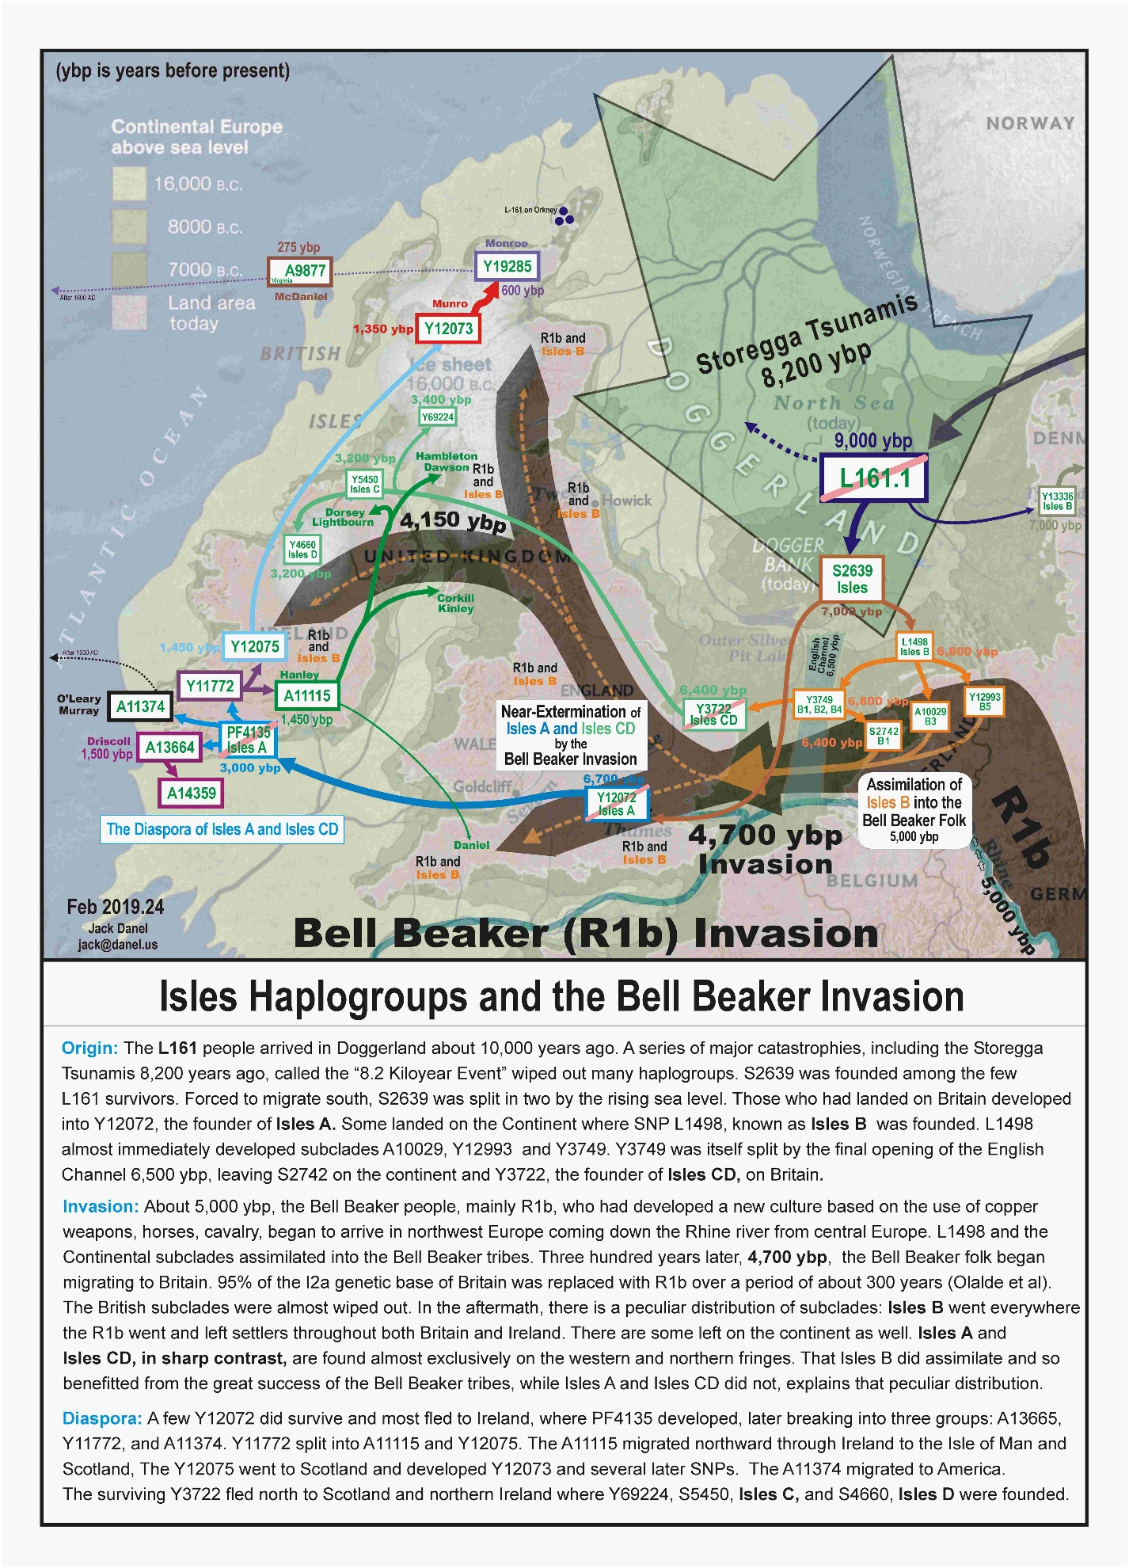

**500 years of catastrophe**

All Europe suffered. The population dropped by 25% from 36 million in 200 AD to 27 million in 500 AD. It took another 500 years for the population to climb back to what it was in 200 AD. It seems clear that the subgroups of L161 were not spared. The TMRCA of Isles C and D indicate some fairly serious bottlenecking. Isles A was very close to extinction.

2,000 y.a. __The beginning of a 500 year long series of catastrophies.

2,000 y.a. __Small invasions by the Angles, Saxons, Jutes, and Danes began and continued regularly for 500 years until the main invasions occurred.

1,973 y.a. __The Roman conquest (43 AD) under the Emperor Claudius began a 350 year long series of rebellions and guerilla warfare.

1,937 y.a. __The VEI 5 eruption of Mt. Vesuvius (79 AD) caused crop failures as well as burying the cities of Pompeii and Herculaneum.

1,850 y.a. __The Antonine Plague and Britain's Great Plague devastated England.

1,750 y.a. __The Plagues of Cyprian and Aurelian wreaked havoc for 20 years.

1,600 y.a. __The Roman withdrawal (410 AD) left a power vacuum that was soon filled by the invading Angles, Saxons, Jutes and Danes.

1,500 y.a. __Main Anglo-Saxon invasion. - Cerdic the Saxon became King of Wessex.

The invasions were propeled by some frigid years of crop failure - a result perhaps of the TBJ volcanic eruption (next pagagraph). The slave trade, run by the new Saxon rulers, flourished in Bristol and other places selling native Britons (including Isles B) to the European continent. This could account for most of those rare Isles B individuals found there.

In 577 AD, Cerdic's great-grandson Ceawlin completed the Saxon conquest of England with his victory at the battle of Deorham in what is now the suburbs of Bristol, England. (If you are of British stock, Ceawlin is your approximately 40th great-grandfather.)

1,500 y.a. __The enormous Tierra Blanco Joven - "TBJ" eruption and "AD 536 Events"

The eruption of the Ilopango volcano in El Salvador had disasterous effects by causing the extreme climate cooling of A.D. 535-536 and crop failures for two decades of famine killing millions worldwide. New findings would make it the second-largest volcanic eruption in the last 260,000 years.

(Mt. Toba, 73 kya, was the largest. The next three are tied for second place: TBJ, Oranui, and Whakamaru of New Zealand's Taupo volcanic zone,.

1,500 y.a. __The Plague of Justinian killed at least 25 million Europeans

1,450 y.a. __The Diaspora of Isles A

The 500 year long series of catastrophies from 2,000 to 1,500 years ago drove Isles A to the brink of extinction as is shown by the shockingly low TMRCA of 950 years. By 500 A.D. there may have been only a few families of Isles A left alive, mostly in County Cork and Bantry Bay in southwest Ireland. Then, somehow, their luck changed. Several new SNP groups, A13364, A11374, and Y11772 were quickly produced, survived, and dispersed, indicative of a favorable environment and rapid population expansion.

  A13364, the Driscolls, stayed in Cork to become the biggest group. A11374 stayed in the area for centuries, but later migrated to America. A11772 split and both groups migrated north. Y12075 moved to Scotland and became the Munro/Monroe family. A11115 settled on the Isle of Man, Northern Ireland, Scotland, and Wiltshire, south of Bristol, England. (The last survivor of this last group emigrated from Bristol to Virginia in 1635 so that Wiltshire group is now, so far as we have evidence, extinct in the British Isles.)

**The current situation**

Haplogroup L-161 is a tiny group that comprises less than 1% of the European population. It is found predominately - more than 95% - in the British Isles. For that reason, the label "Isles" has become attached.

The branches of Haplogroup I that have led to the modern L161 subclades are:

M170—I

— ⤷—➤ M438—I2

——— ⤷—➤ P37—I2a1a

————— ⤷—➤ M423—I2a1a2

——————— [⤷—➤ Y3104 —I2a1b2 removed by ISOGG 2018, retained by Yfull ]

———————⤷—➤ L161—I2a1a2a

—————————⤷—➤ S2639—I2a1a2a1 —Isles AB

—————————————￬  ⤷—————➤ Y12072 I2a1a2a1b ➤ PF4135 - Isles A I2a1a2a1b1

————————————— ⤷———————➤ L1498 - Isles B I2a1a2a1a

——————————————— ⤷—➤ Y3734 - I2a1b1a1a1b3

—————————————————￬  ⤷—➤ Y5450 - Isles C - I2a1b1a1a1b3a

————————————————— ⤷———➤ Y4665 - Isles D - I2a1b1a1a1b3b

Isles A is concentrated around Cork and is present, but rare in Ireland, Isle of Man, and Scotland.

Isles B is now found all across the British Isles and to a very minor degree on the continent.

Isles C is located mostly in the north of England, Scotland, Ulster and western Ireland.

Isles D is relatively strong in the north or western parts of Ireland, especially around Rathcroghan.

The I Group as a whole has a very different current distribution. Most are in Europe sandwiched between Haplogroup R1a on the east and R1b on the west. It is not at all clear how that came to be. There are many diverging opinions.

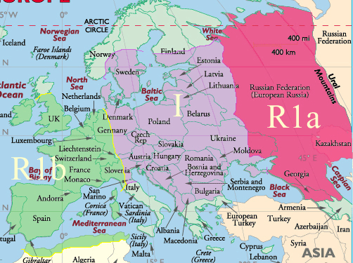

**Haplogroup List**

|  |  |  |  |  |
| --- | --- | --- | --- | --- |
| **Haplogroup** | **Emerged \***  **kya** | **Location, approximate** | **SNP** | **SNP Date kya** |
| A00a Perry | bef. 270 | Western Cameroon | L1149 | 270 |
| A0-T | bef. 200 | Omo Kibish, Ethiopia | L1085 "Omo?" | 235.9 |
| A1 | 170 | Afar Ethiopia | P305 *H. sapiens idaltu* | 161.3 |
| A1b | 150 | East Africa | P114 *H. s. sapiens* | 133.4 |
| BT | 140 | Ethiopia | M91 | 130.7 |
| CT | 100 | East Africa | M168 | 88 |
| CF | 80 | Ur-Shatt | P143 | 68.5 |
| F | 70 | Ur-Shatt | M89 | 65.9 |
| GHIJK | 65 | Mesopotamia | F1329 | 48.8 |
| HIJK | 60 | Mesopotamia | F929 | 48.5 |
| IJK | 55 | Mesopotamia | L15 | 48.5 |
| IJ | 50 | Baghdad | M429 | 47.2 |
| **I - Cro-Magnon** | 45 | Kurdestan | M170 | 42.9 |
| I1 | 40 | Ukraine refugium | M253 | 27.5 |
| I2 | 40 | Anatolia | M438 | 27.5 |
| I2a1a** | 25 | Ukraine refugium | P37.2 | 18.7 |
| I2a1a2** | 20 | Ukraine refugium | M423 | 18.5 |
| I2a1a2** | 15.8 | Ukraine refugium | **Y3104** (L161, L621) | 13.4 |
| **L161.1 (I2a1a2a*)** | 13.5 | Moldova | **L161.1** (S2639, Y13338/1) | 10.6 |
| Isles AB [(hg tree)](https://www.facebook.com/photo.php?fbid=10207404609147725&set=gm.788905107880514&type=3&theater) | 10 | Doggerland | **S2639** | 6.9 |
| **Isles A** | 7 | East Anglia ➤ Cork | **Y12072 ➤ PF4135** ➤ Y12073(A2) ➤ Y19285 | 6.7 |
| **Isles B** | 7.2 | Rhine River Delta | **L1498** ➤ Y3749 ➤ Y3722 ➤ Y3734 | 6.6 |
| **Isles C** | 6.5 | Dal Riata | **Y5450**➤ Y18393(C1) & Y5451(C2) | 3.4 |
| **Isles D** | 4.2 | Rathcroghan Ireland | **Y4660(D)** ➤ Y5280 | 3.2 |

* The 'emerged' date in this table is my estimate of the date the "Dunbar group" began its journey to separation. It is the date of the 'spark' that started events moving forward. That date must be, by definition, before any archaeologically or genetically calculated dates. The SNP dates are from [**www.yfull.com**](https://yfull.com/tree/)   
  
** The alphanumeric designators for haplogroups are listed by the ISOGG and are subject to change every year, so they are useless over time. The actual SNP name does not change, so that is the preferred designator

**Timeline**

250,000 y.a. __AMH, Anatomically Modern Humans begin to develop. (y.a. = years ago, ice ages, warm ages)

195,000 y.a. __H. sapiens fossils formed at the Omo site in Ethiopia [54]

110,000 y.a. __The "Last Glacial Period" begins and lasts until about 10,000 y.a. with warmer interludes [34]

70,000 y.a. ___Mount Toba VEI 8 eruption nearly causes extinction of Homo Sapiens [49]

43,000 y.a. ___Homo sapiens occupied Kent's Cavern in Devonshire England

32,000 y.a. ___Weichsellian ice age ends, Dennecamp warm period begins. Humans spread farther into the north and west.

30,000 y.a. ___M170 - Haplogroup I founded southeast of the Black Sea [Map of Human expansion]

30,000 y.a. ___Gravettian culture (30,000 - 20,000 BC) spread from Ukraine to Spain by various subclades of Haplogroup I,

28,000 y.a. ___M253 - Haplogroup I1 founded probably in the Ukraine Refugium

26,500 y.a. ___Oruanui VEI 8 eruption [51] The largest eruption since Mt. Toba caused the "Last glacial Maximum" - LGM?

26,000 y.a. ___Maximum ice coverage (LGM). Population living in refugia

25,000 y.a. ___Neanderthals extinct [52]

21,000 y.a. ___M438 - Haplogroup I2 and L460 - Haplogroup I2a founded in the Ukraine Refugium

20,000 y.a. ___End of LGM. Meiendorf warm period begins, allowing populations to occupy parts of Europe

20,000 y.a. ___P37 - I2a1 founded in the Ukraine refugium spreading quickly up the Danube all the way to France.

19,000 y.a. ___Oldest Dryas ice age [40] begins, extreme cold, producing a treeless Europe similar to Arctic tundra

18,000 y.a. ___FTDNA suggests a major extinction (97%) period reducing entire haplogroup I population to just 8 haplotypes

18,000 y.a. ___Surviving populations retreat to the various refugia

15,800 y.a. ___M423 branched off P37 - east in the Ukraine Refugium

14,670 y.a. ___End of Oldest Dryas ice age; the Bolling-Allerod interstadial, a warm, moist period begins abruptly [35]

14,500 y.a. ___M26 - Sardinian branches off P37 - west in southern France

14,000 y.a. ___Post-glacial repopulation of Southern England begins

13,400 y.a. ___Y3104 branches off M423, somewhere northwest of the Black Sea

13,000 y.a. ___L621 - Dinaric branches off P37 - east, perhaps near the Danube delta

12,800 y,a, ___The "Younger Dryas" little ice age begins lasting 1,300 years

11,660 y.a. ___End of the "Younger Dryas"

11,660 y.a. ___End of paleolithic and beginning of mesolithic. [48] Beginning of Preboreal warm period.

10,600 y.a. ___L161 branches off Y3104 or from M423 somewhere in northern Europe [1], and moves into Doggerland

10,500 y.a. ___Post-glacial repopulation of Ireland begins in Cork. [13] They were mostly I2a tribes from the Iberian Refugium.

8,200 y.a. ____"8.2 kiloyear events", the Storegga tsunamis and Flooding of Doggerland [2][3][4]

8,200 y.a. ____Beginning of a 400 year long cold climate disruption

8,200 y.a. ____English Channel opened - L161 survivors driven south to the new shorelines in the Dogger Banks area

7,500 y.a. ____Atlantic climate period begins, warmer than the present.(7,500-5,000 y.a.)

7,000 y.a. ____Y13336 Alghaffar branches off L161 and migrates eastward

7,000 y.a. ____S2639 founded and soon split into Isles B on the continent and Isles A on Britain in East Anglia

6,500 y.a. ____Mesolithic / Neolithic transition - The "secondary products revolution" [12]

6,000 y.a. ____Farming introduced into England

5,370 y.a. ____TMRCA of continental group of Isles B

5,000 y.a. ____End of Atlantic very warm climate period; beginning of the Subboreal normal climate period

5,000 y.a. ____Bell Beaker R1b folk arrive in the Rhine river delta bringing copper technology and domesticated horses.[31]

5,000 y.a. ____Windmill Hill culture-East Anglian tribe begin constructing Stonehenge [6]

4,800 y.a. ____Mt. Pleasant henge constructed in Dorset. [5]

4,740 y.a. ____TMRCA Isles B British group

4,700 y.a. ____The Bell Beaker invasion of Britain occurs for over 300 years replacing 97% of the native Y dna groups

4,500 y.a. ____The Beaker folk begin the Bronze Age in Britain [32], with copper mining in Cork [11] and tin mining in Cornwall

4,300 y.a. ____Eruption of Hekla 4 Volcano in Iceland. "Ireland was thirty years waste".

4,050 y.a. ____Seahenge constructed in Norfolk [7]

3,600 y.a. ____Construction ended at Stonehenge as a new culture becomes dominant

3,400 y.a. ____Isles C - Y5450 founded in Dal Riata and Isles D - Y4660 founded near Roscommon, Ireland

3,000 y.a. ____Eruption of Hekla 3 in Iceland - 18 yr. temperature drop in the northern hemisphere, probable famines.

3,000 y.a. ____PF4135 founded in Cork Ireland

2,800 y.a. ____Iron Age begins in Britain

1,850 y.a. ____The great Antonine Plague [20][21], the Plagues of Cyprian and Aurelian - 120 years of plagues [24]

1,500 y.a. ____Anglo-Saxon invasion, slave trade flourishes [10]

1,500 y.a. ____Isles A fragments into multiple SNP groups: A13664, A11374, Y11772, Y12075, A11115, A14359

1,480 y.a. ____Plague of Justinian [8]

1,480 y.a. ____TBJ [9] erupts. "AD 536 Events" [16] Two decades of famine killed millions world-wide.

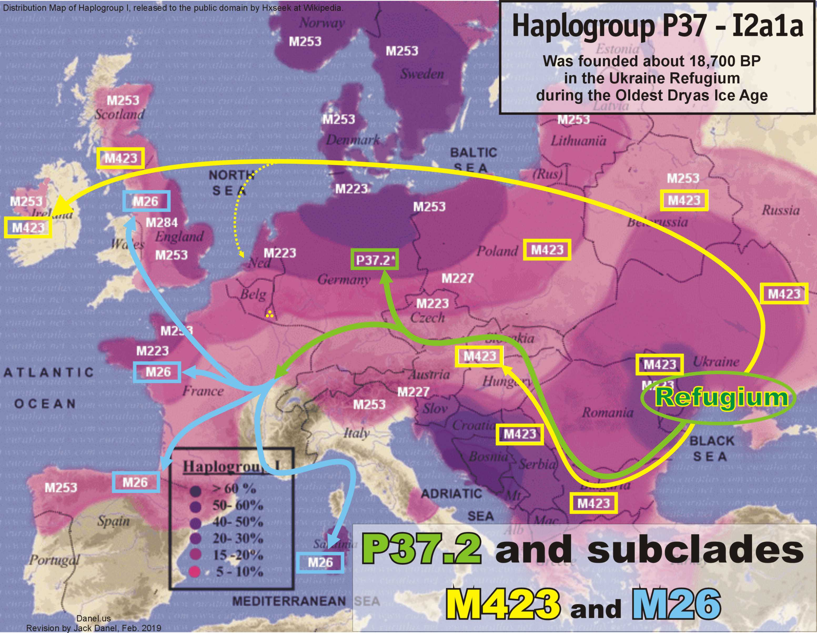

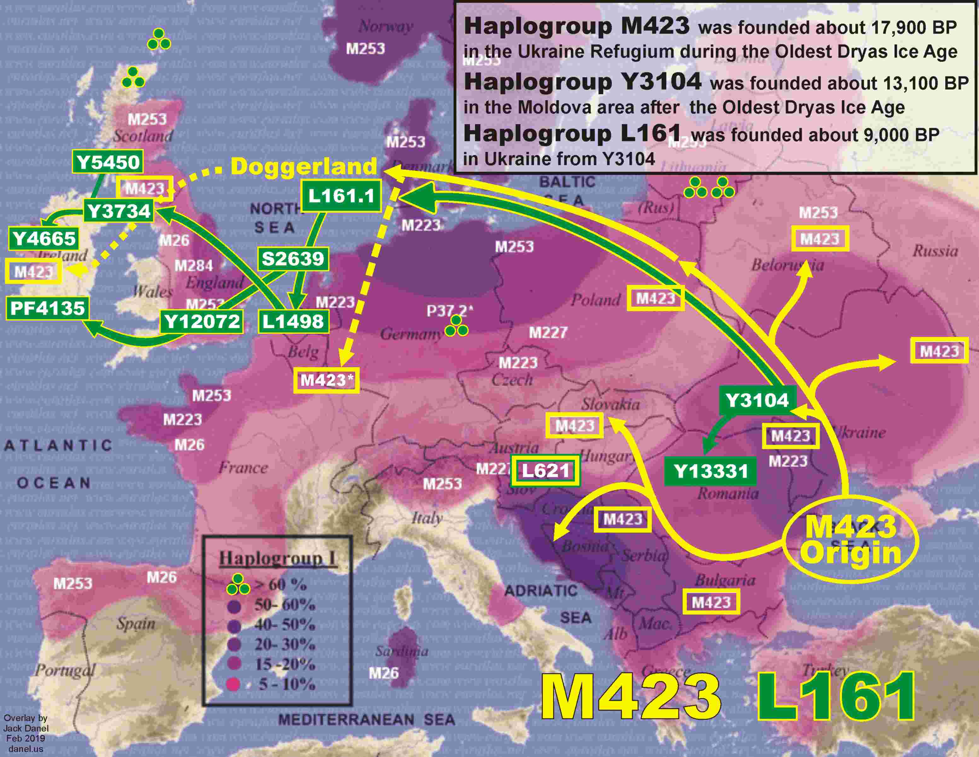

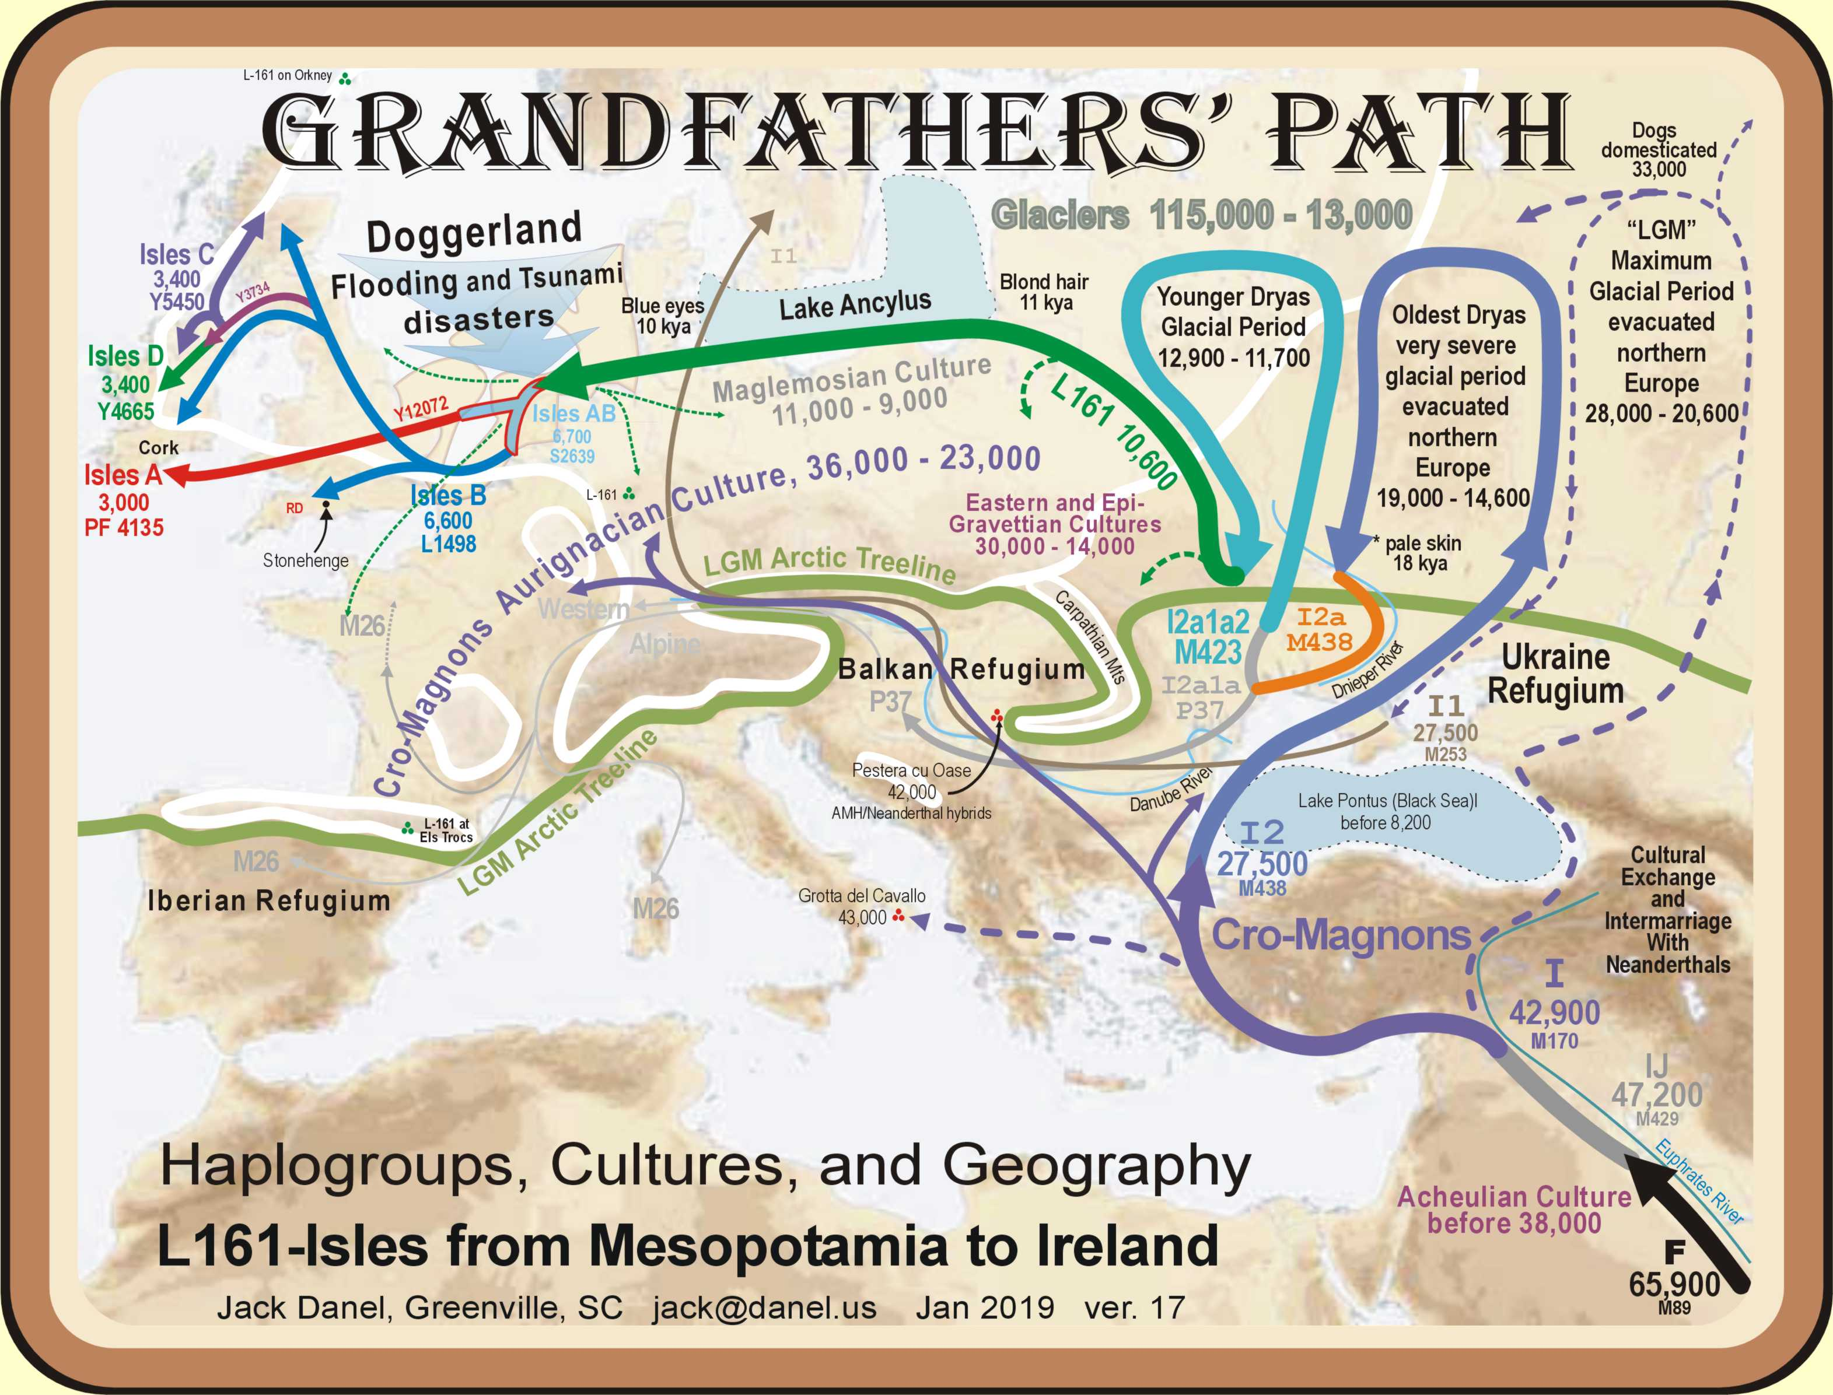

**Illustrations** (links)

[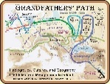](http://s168543378.onlinehome.us/z/Grandfathers%20Path%20z.jpg)

Grandfathers   
Path

[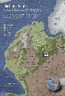](http://s168543378.onlinehome.us/z/doggerland.jpg)

Doggerland  
16,000-8,000  
years ago

[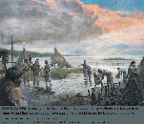](http://s168543378.onlinehome.us/z/doggerland%20storm.jpg)

Storm in   
Doggerland  
8,200 y.a.

[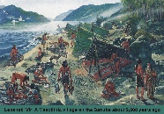](http://s168543378.onlinehome.us/z/lepenski%20vir.jpg)

Lepenski   
Vir site  
9,000 y.a.

[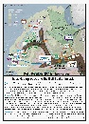](http://s168543378.onlinehome.us/z/Bell%20Beakers.jpg)

Bell Beaker  
Invasion  
4,700 y.a.

[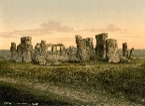](http://s168543378.onlinehome.us/z/stonehenge.jpg)

Stonehenge  
5,000-3,500  
years ago

[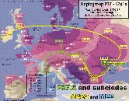](http://s168543378.onlinehome.us/z/P37%20arrows.jpg)

P37 and   
subclades  
migration

[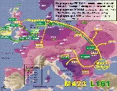](http://s168543378.onlinehome.us/z/M-423%20L-161%20arrows.jpg)

**M-423** and   
**L-161**   
migration

[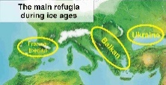](http://s168543378.onlinehome.us/z/refugia.jpg)

Three  
Refugia

[](http://s168543378.onlinehome.us/z/dominant%20european%20haplogroups.gif)

Main   
Haplogroups  
in Europe

[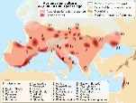](http://s168543378.onlinehome.us/z/aurignacian.jpg)

Aurignacian  
range  
47-41 kya

[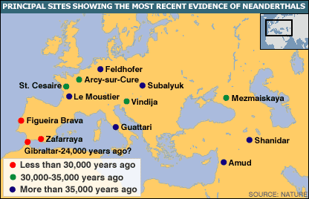](http://s168543378.onlinehome.us/z/neanderthal%20range.gif)

Neanderthal   
range  
50 kya

[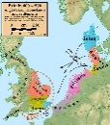](http://s168543378.onlinehome.us/z/Saxon%20Invasions.jpg)

Anglo-Saxon  
Invasion  
400-600 AD

[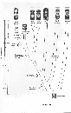](http://s168543378.onlinehome.us/z/proconsul%20tree.jpg)

Proconsul  
family tree  
(Boaz)

[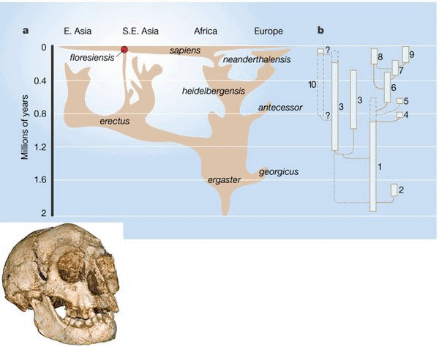](http://s168543378.onlinehome.us/z/Mara%20and%20flores.gif)

*H. sapiens*   
family tree  
(Mara et al)

[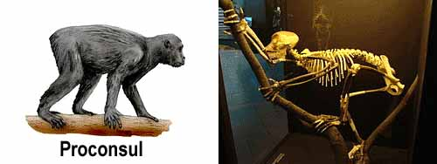](http://s168543378.onlinehome.us/z/Proconsul.jpg)

[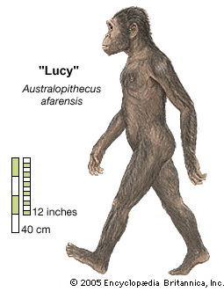](http://s168543378.onlinehome.us/z/lucy%20left.gif)

*Australopithecus  
afarensis*  
Lucy, 3.2 mya

[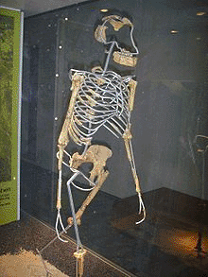](http://s168543378.onlinehome.us/z/lucy%20reconstruction.gif)

Lucy   
reconstruction

[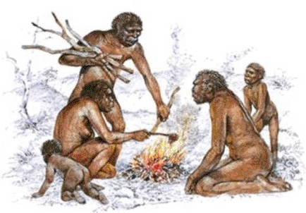](http://s168543378.onlinehome.us/z/erectus%202.gif)

*H. erectus*   
  
1.9 mya

[](http://s168543378.onlinehome.us/z/neanderthals.jpg)

Neanderthals 400 kya

[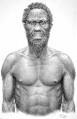](http://s168543378.onlinehome.us/z/idaltu.jpg)

*Homo Sapiens****Idaltu***  
160,000 y.a.

[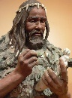](http://s168543378.onlinehome.us/z/cro-magnon%201.jpg)

Cro-Magnon  
  
45,000 years ago

[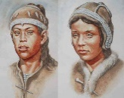](http://s168543378.onlinehome.us/z/gravettians.jpg)

Gravettians   
  
30,000 y.a.

[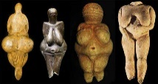](http://s168543378.onlinehome.us/z/venus-figurines-europe-paleolithic.jpg)

Venus   
Figurines  
25 kya

[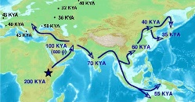](http://s168543378.onlinehome.us/z/out%20of%20africa.jpg)

Out   
of   
Africa

[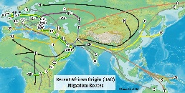](http://s168543378.onlinehome.us/z/out%20of%20africa%202.jpg)

Haplo  
routes

[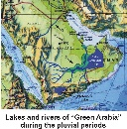](http://s168543378.onlinehome.us/z/green%20arabia.jpg)

Lakes and  
rivers in  
Green Arabia

[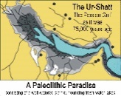](http://s168543378.onlinehome.us/z/Ur-shatt.jpg)

Migration  
to the  
Ur-Shatt

[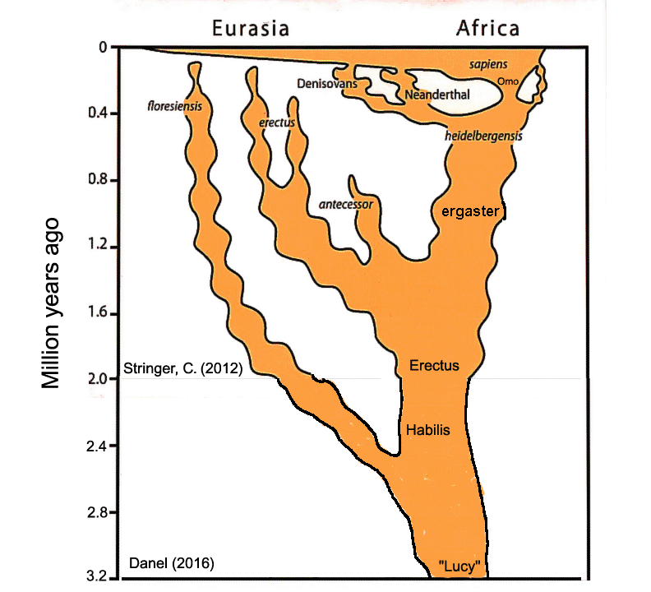](http://s168543378.onlinehome.us/z/stringer.gif)

*H. sapiens*   
family tree  
(Stringer)

[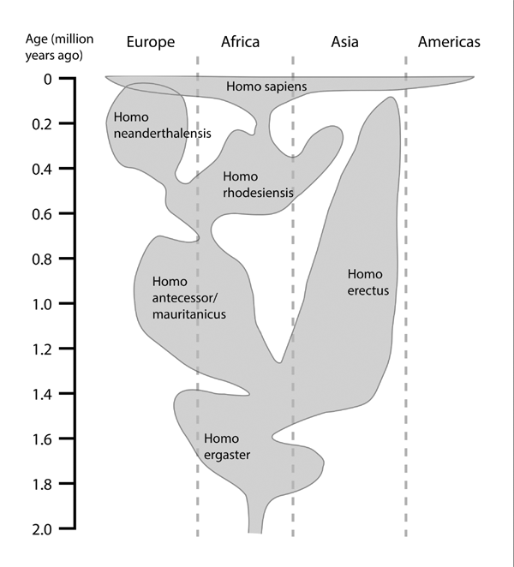](http://s168543378.onlinehome.us/z/Reid.gif)

*Homo sapiens*   
family tree  
(Reid)